FOR IMMEDATE RELEASE
Study Shows Retail Designers Should Be Looking Up
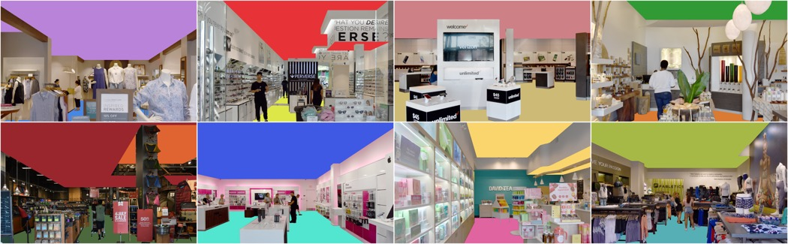
Photos courtesy of Ceilume
The ratio of visible ceiling area to floor area in retail stores varies, a new study finds. The woman’s clothing store in the upper left, for example, has 29 times more exposed ceiling than floor while the competing woman’s clothing store in the lower right has 60 percent more exposed ceiling than floor. The study suggests the importance of ceilings as a designable surface.

GRATON, CA, 2020-02-18 – A new study shows that ceilings have a far greater visual presence than floors in retail design. A sampling of randomly chosen stores at a new shopping mall showed that a customer’s first view of a store interior reveals, on average, five times as much ceiling area as it does floor area.
The study was conducted in a recently-built open-air mall in Los Angeles, CA. Twelve stores were chosen at random. Photographs were taken from each store’s entrance and framed to capture the first impression a customer has upon entering the stores. The visible areas of floor and ceiling were calculated from the photos and a ceiling to floor ratio calculated.
Not surprisingly, much of the floor views were blocked by merchandise, displays, counters, and other fixtures. Retailers seeking to maximize floorspace for merchandise obscured most of the floor. While some ceilings were partially blocked by signage, the average ceiling was still prominently on display. A women’s clothing store with numerous mannequins and racks of clothing had barely any floor visible from the doorway, with more than 29 times as much ceiling in evidence; stores with relatively wide, open aisles still displayed roughly twice as much ceiling as floor.
The findings suggest that the high visibility of ceilings gives them a strong potential to impact the aesthetics of retail environments. The overhead area can be treated as a designable surface that contributes to customer experience and sales.
Some retailers have already discovered this, installing ceilings that help set the image they seek to project. Popular jewelry chain Alex and Ani, for example, uses dark colored ceiling panels with dimensional relief. These thermoformed acoustic panels from Ceilume provide a branding consistency to their stores and have a faceted surface that references the geometric motifs of their jewelry. The dark color lowers the reflection of ambient light and intensifies the directional lighting to illuminate the merchandise and make it sparkle.
A summary of the research paper can be downloaded at bit.ly/ceiling-floor-ratio.
--------------
About Ceilume: Ceilume is the leading manufacturer of thermoformed ceiling and wall tiles and panels. The company’s roots go back to when “Mid-Century was Modern” and the pioneers of modular ceilings. The family-owned business is located in California’s wine country and occupies a historic apple-packing warehouse. With an eye on the future, Ceilume’s research and development continues to improve interior finish systems to meet changing environmental, performance, and aesthetic needs. For more information, see www.ceilume.com/pro.

Photos: www.ceilume.com/pro/press.cfm
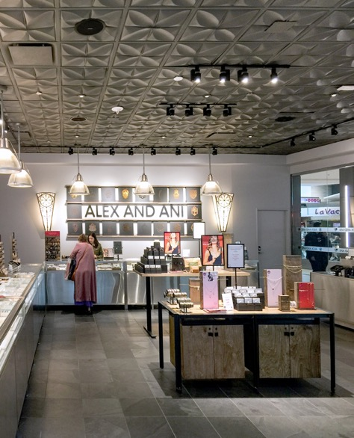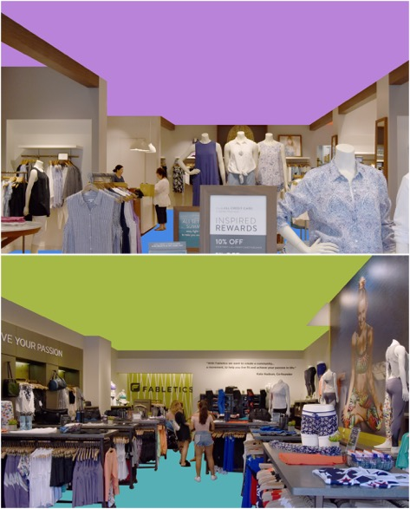
Left: From the entry to this Alex and Ani store, a shopper sees approximately 50% more ceiling area than floor area. The national jewelry chain uses a dark color Ceilume thermoformed ceiling in many of its locations to provide both mood and branding.
Right: The ratio of visible ceiling to floor area can vary substantially even within a product category. The visible ceiling in the top image is 29 times larger than the floor; the visible ceiling in the lower image is 1.6 times larger than the floor. Designers must select a ceiling that is appropriate to a store’s merchandising strategy and branding.
###

