FOR IMMEDATE RELEASE
Case Study: Budget Classroom Remodel Finds Fun in the Ceiling
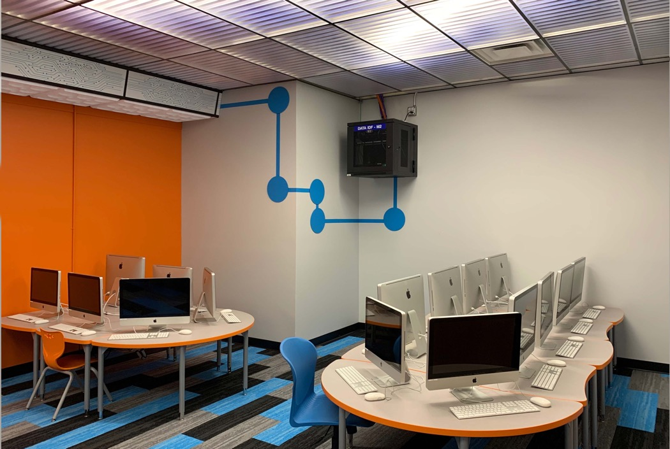
All photos courtesy of Arbor Park School District 145 except as noted.
The computer lab for first and second graders at Morton Gingerwood Elementary School was transformed from an outdated room to a 21st Century learning space on a tight budget, by a creative application of paint, carpet, and translucent ceiling tiles. The luminous ceiling has economical LED strips above the frosted panels and diffuses light throughout the room with minimal glare.
GRATON, CA, 2020-02-11 – Two aspects of school remodeling are generally predictable: the schedule is short and the budget is tight. Fortunately, school staff and teachers can bring other assets to the process: resourcefulness and creativity that make the mission possible. At Arbor Park School District 145, in the Chicago suburbs, they were able to bring outdated rooms back to life and make exciting learning spaces by the clever application of carpeting, paint, and intriguing ceilings made of Ceilume thermoformed acoustic panels.
The computer lab for first and second graders at Morton Gingerwood Elementary School had old computers and even older layout and finishes. David Termunde, M.Ed., the district’s Chief Technology Officer, replaced the computers, but felt more was needed to support the learning experience. “We had a new principal,” he recounts, “and I said, ‘What can we do to make this room 21st century?’” On the last day of school, maintenance gutted the room. Next, they created a colorful paint scheme, saving money by pairing the job with other paint work in the school. They bought curvy, interesting tables from a budget-conscious home furnishings store, and three colors of carpet tiles to create a lively pattern on the floor.
After removing the worn-out white mineral fiber ceiling panels, Termunde decided an alternative type of ceiling would help transform the room. He selected Ceilume thermoformed acoustic panels based on his experience using them in the offices and server rooms at his former business. The lightweight panels fit conventional 2’x2’ and 2’x4’ suspended ceiling grids and are available in a wide variety of finishes and dimensional styles.
Termunde selected Southland, a ribbed pattern with a contemporary look. He used a frosted, semi-transparent type that hides the ducts and pipes above the lab’s ceiling but transmit lights from the inexpensive, utilitarian 8-foot LED strips he installed above the ceiling. The lamps are at zigzag angles, “just for fun, to make it feel like you’re at a store at the mall, not so office-y. First and second graders are way down near to the floor, so when they look up, it looks really cool.” He also installed opaque white panels in another contemporary pattern, Roman Circles, on the soffit along the room’s orange-painted wall, making the soffit look like some high-tech device.
“I read articles in ed-tech magazines about redesigning spaces, and no one pays attention to the ceiling. They’ll paint halls, put in carpet tiles, and buy new chairs, but the ceiling will still look old, outdated, and faded, and it just doesn’t look good.”
The redesign of the computer room has been appreciated by the students. “You can see their excitement,” Termunde relates. “‘We’re going to the computer room today.’ We want them to feel like it was made just for them.”
The thermoformed ceiling has been working well for the district. “The panels are waterproof,” Termunde notes. “We have had leaks in the ceilings, and the Ceilume panels didn’t get ruined. Maintenance likes them because they’re easy to install, probably the easiest part of the entire remodel. Now, anytime we get to do a room, it’s, ‘what can we do with the ceiling?’”
Termunde has already taken this creative and cost-saving approach to Arbor Park Middle School where they switched over to Microsoft computers and gave every student a Microsoft Surface Go tablet. He felt a traditional lab computer with rows of computers wasn’t conducive to the new curriculum. Termunde transformed the old room with a strong visual theme. With a miniscule remodeling budget, light gray walls replaced boring beige and one Skype-blue wall acknowledging how the students connect online with classrooms around the world. New tables were sourced for $50 from the bankruptcy of a nearby department store.
Microsoft logos constructed from colored vinyl sheets decorate the windows, and a logo formed in colored carpet tiles at the center of the room provides a place where kids can lie on the floor or sit on cushions with their devices. From that spot, they can look upwards into the clear Ceilume Southland ceiling panels that form the central section of the ceiling. “Every kid that goes in there asks, ‘why is the ceiling clear?’ I say it’s just for fun,” Termunde explains. (He is thinking of putting a picture of a cloud above the clear ceiling panels and telling the students, “That’s where The Cloud is.”)
“A lot of schools think they need an architect or contractor to come in for remodels,” comments Termunde, “when basically, Maintenance can do it and save thousands.”
--------------
About Ceilume: Ceilume is the leading manufacturer of thermoformed ceiling and wall tiles and panels. The company’s roots go back to when “Mid-Century was Modern” and the pioneers of modular ceilings. The family-owned business is located in California’s wine country and occupies a historic apple-packing warehouse. With an eye on the future, Ceilume’s research and development continues to improve interior finish systems to meet changing environmental, performance, and aesthetic needs. For more information, see www.ceilume.com/pro.

Photos: www.ceilume.com/pro/press.cfm

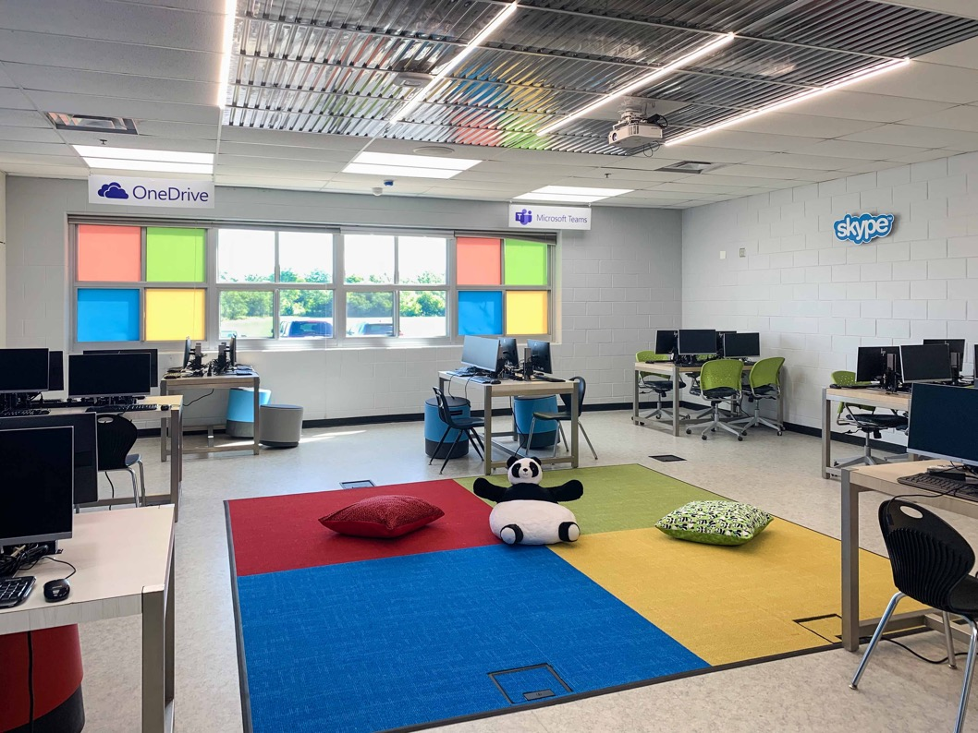
The 1990’s computer lab at Arbor Park Middle School became the 21st century Microsoft Dock Lab by re-thinking its purpose. Physically, all it took was paint, a partial replacement of the floor tile with colored carpet tile, and partial replacement of the ceiling with clear Ceilume ceiling panels. The new docklab allows students to plug their tablets into a bigger screen with a keyboard and mouse, or to just sit on the floor and use the tablet by itself. The lighting is a little less intense in the central area under the clear ceiling to prevent glare on the tablets.

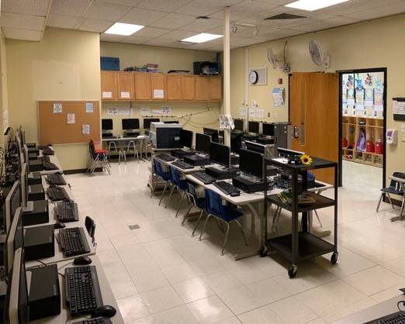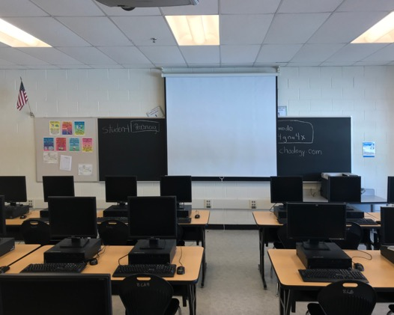
Prior to remodeling, the Morton Gingerwood Elementary School (left) and Arbor Park Middle School (right) computer labs were technically and pedegogically obsolete and uninspiring classrooms.
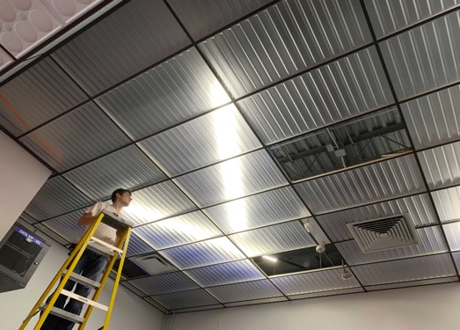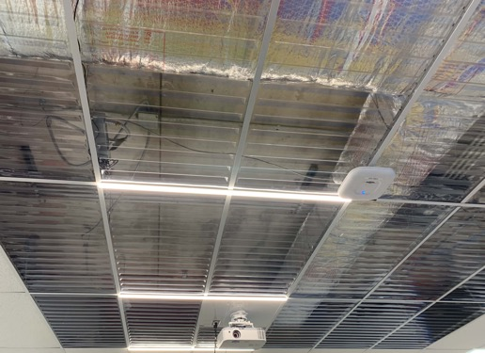
Left: Visual excitement was generated in the elementary school by arranging the new LED fixtures in zigzags above frosted ceiling panels. Installation of the lightweight thermoformed panels was performed by staff. Right: Clear panels in the middle school computer lab allow views of above-ceiling mechanical equipment and structural members, a metaphor for the computer “architecture” and an invitation to students to expand their creative vision.
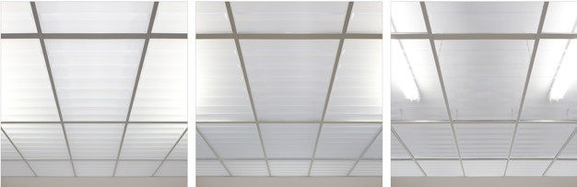
Ceilume makes three grades of light-transmitting panels for luminous ceilings. Left: Translucent panels diffuse light from above-ceiling fixtures. Center: Frosted panels allow blurry views of above ceiling lighting plus more efficient light-transmission. Right: Clear panels allow all above-ceiling features to be seen. Image courtesy of Ceilume.
###

