FOR IMMEDATE RELEASE
Case Study:
Music Studio Clears Air with Upbeat Ceiling
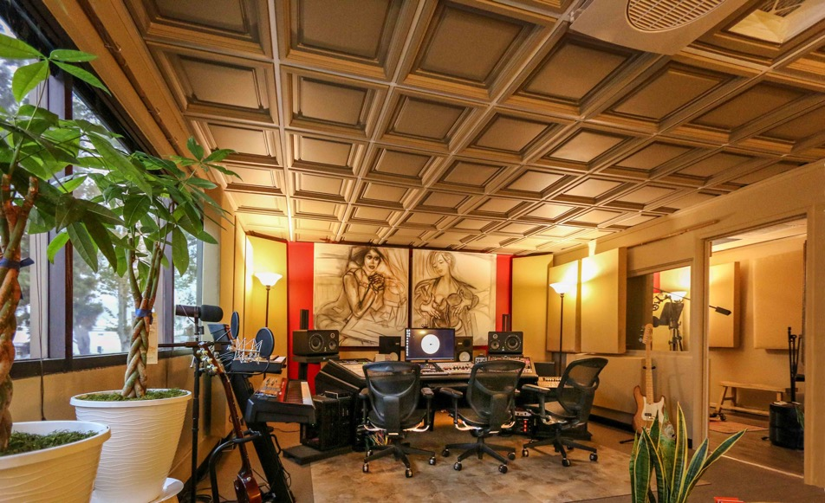
All photos courtesy of OC Recording Company
This recording studio in Orange County, California replaced its old, flaky mineral fiber acoustic ceiling with a lightweight thermoformed acoustic ceiling, preserving the studio’s sound quality while improving its air quality.
GRATON, CA, 2020-03-10 -- The owner of OC Recording Company in Santa Ana, California was completely over his old acoustic ceiling panels. Asaf Fulks, an audio engineer and music composer for TV and movies, says that he’d simply had enough of the flaky mineral fiber ceiling panels that were shredding at the corners and shedding fibers that would fall on the equipment he uses to record, mix and master music.
Fed up, too, with the stuffy indoor air quality in the room, Fulks decided it was time for an upgrade. He ripped out the twenty-year-old ceiling panels and the itchy fiberglass insulation above them. Then, he set out to find a new ceiling that would be visually exciting and create a unique space for artists, music producers, and industry executives to come and make musical magic happen.
While searching online, Fulks learned about Ceilume. “Their decorative, molded panels look awesome -- clean, crisp and artistic. They combine a touch of old-fashioned flavor with modern details. Since they’re made of thermoformed rigid vinyl, I knew they wouldn’t flake or release particles like ordinary ceiling panels,” says Fulks. Ceilume panels are also GreenGuard Gold certified for indoor air quality, free from mold and allergens, waterproof, and easy to clean and maintain.
Achieving great sound in the room was a paramount consideration for Fulks. “To fine tune the room, it was important to have a Noise Reduction Coefficient of at least NRC=0.50,” he explains. From the acoustic test data on the manufacturer’s website, he discovered he could get the required performance with Ceilume’s ultra-thin 0.013-inch thick panels topped with their Soniguard itch-free batt insulation. Made from polyester fibers similar to that used in upholstery, the batts are itch free and does not release airborne fibers.
From the manufacturer’s wide array of patterns, faux finishes, and colors, Fulks selected the deeply molded Westminster panels to create height with the coffered ceiling. The highlights and shadows from daylight entering through the windows added playful textures. He chose Latte for the color to complement the existing finishes and bold original artwork. He found that it also caused less glare on the mixing equipment screens than there had been with the previous white ceiling. Finally, Fulks opted to leave the existing ceiling suspension grid white because he enjoyed the color contrast between the grid and panels.
Once the materials arrived, Fulks chose a do-it-yourself installation. “I’m not a handy person,” he laughs. However, he was able to install the entire 360-square feet ceiling in under a day. “It was a one man job,” he says; “These panels are so much easier to work with than the mineral fiber ones I had before. Most of the panels just popped right into the grid and for those at the edges that had to be trimmed, the only tools I needed were scissors and a tape measure.”
“I’m very happy with the sound within the room.” he says, adding that the new ceilings seem to have made the sound more exciting. “And importantly, the air quality has improved since installation of the new panels.” That’s music to everyone’s ears.
--------------
About OC Recording Company:
The OC Recording Company is a leading record label, music publisher, recording studio and accredited audio school in Orange County, California, founded in 2005 by recording artist, songwriter, music producer, audio engineer, inventor, author and educator Asaf Fulks. Paintings in the studio are by Yakira Shimoni Fulks.
About Ceilume:
Ceilume is the leading manufacturer of thermoformed ceiling and wall tiles and panels. The company’s roots go back to when “Mid-Century was Modern” and the pioneers of modular ceilings. The family-owned business is located in California’s wine country and occupies a historic apple-packing warehouse. With an eye on the future, Ceilume’s research and development continues to improve interior finish systems to meet changing environmental, performance, and aesthetic needs. For more information, see www.ceilume.com/pro.
Photos: www.ceilume.com/pro/press.cfm
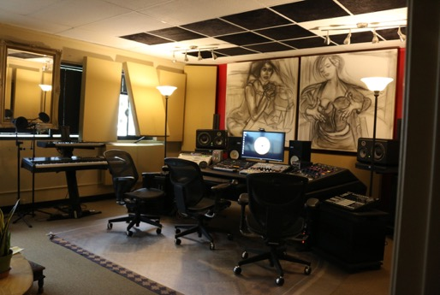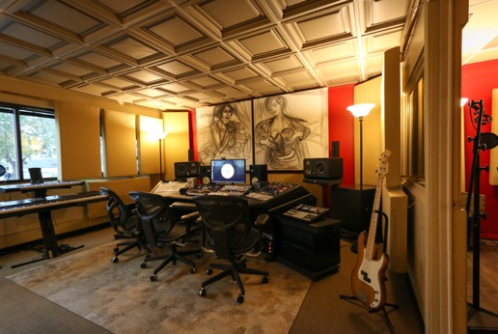
LEFT: Before, the mineral fiber ceiling panels were shredding at the corners and shedding fibers that fell on the equipment used to record, mix, and master music, and impacted air quality.
RIGHT: After, the new Latte-colored Ceilume thermoformed ceiling causes less glare on the mixing equipment screens than there had been with the previous white ceiling, and the air quality has improved.
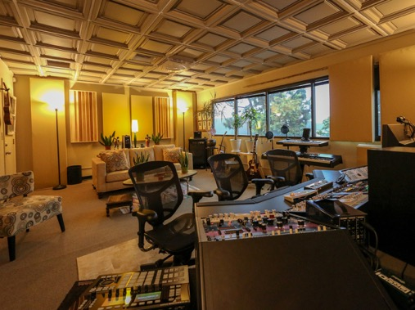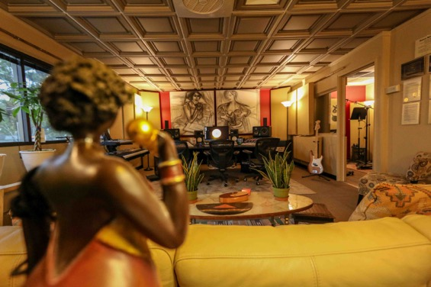
Acoustics are critical in a recording studio. A Noise Reduction Coefficient of at least NRC= 0.50 was needed to fine tune the room, and was achieved with Ceilume panels topped with Soniguard itch-free polyester batt insulation.
###

