FOR IMMEDATE RELEASE
Case Study:
When the Salon Needs a Makeover
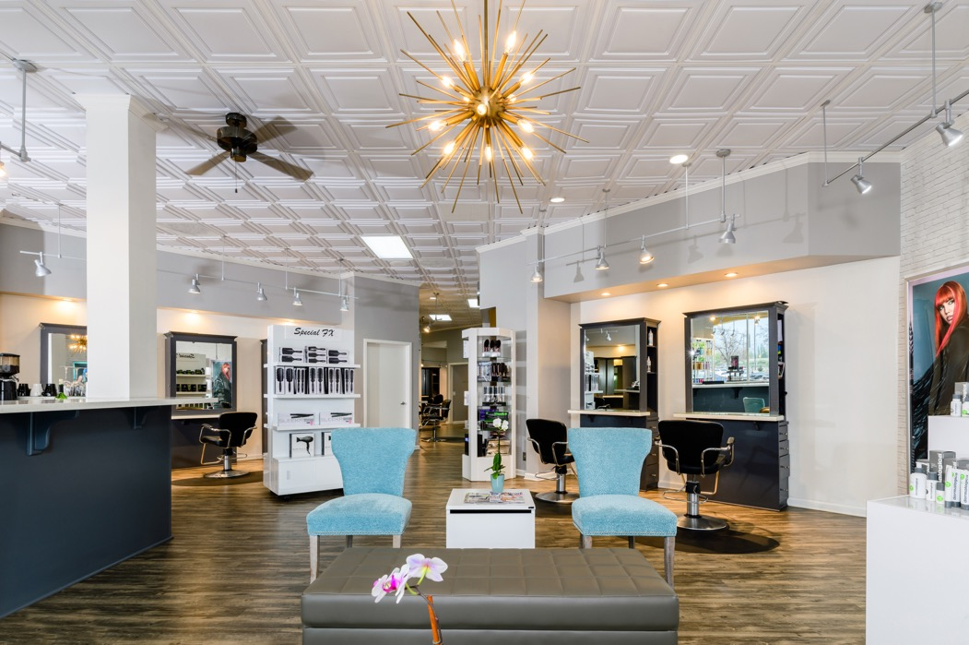
All photos courtesy of Special FX Salon
This remodel brightened and opened the space without any construction work, just paint, some new flooring, and a decorative ceiling that brought it all together.
GRATON, CA, 2020-03-25 – The Special FX Salon and Day Spa in San Jose, CA had gotten to looking dated and tired. Owner Denise Russell decided to do what salons do best: give the place an attractive new look. By improving the finishes and using some paint, she achieved a makeover that made the salon fresh-looking and in-style without needing to do construction or change the space itself in any significant way.
Russell’s business was successful, but the appearance of the salon was not keeping up with current styles. It had been 10 years since it was last remodeled, and it showed. The decor was dominated by dark cabinets and a tired looking mineral fiber dropped ceiling. “We were more traditional before,” recalls Russell. “Everything was cherrywood, the floor was like a maplewood brown, and that old-style ceiling… It felt old-fashioned.”
Russell had previously found an interior designer she trusted when Priscilla Danielle Avery of Priscilla Danielle Designs, Santa Clara, CA redecorated Russell’s home. Avery consulted on the salon makeover (although Avery says Russell really did the job herself). “I made recommendations,” Avery states modestly. “We tried to update the finishes. We just wanted to give it a happier a vibe, to be welcoming and bright and fun.”
“I like that open space concept,” explains Russell, “even though I have a lot of walls in there for the stations. I was looking for a more modern appearance. I love the gray and white look.”
They painted the walls white and light gray, with white trim details. The cherrywood cabinetry became medium gray, the darkest tone in the room. They replaced the flooring with a more contrasty woodgrain that livens up its appearance.
Then Avery made an unexpected suggestion, “Let’s do something with the ceiling.” The salon had the usual suspended ceiling: old mineral fiber panels that were discolored from age. Changing the ceiling made total sense to Russell. “That old ceiling just looked so ugly,” she recalls.
Avery suggested a different, more decorative type of panel that could be easily installed in the existing ceiling grid, thermoformed Ceilume panels. She had used them previously in other projects and thought this was “a quick and reasonably-priced way to clean up the whole space.”
Ceilume makes lightweight, three-dimensional panels in a wide range of styles from traditional to completely contemporary. (Also, a plus for salons where there may be a lot of product spraying into the air, they are washable and stain resistant.)
Russell browsed the patterns on the Ceilume website. “There are a lot of styles you can pick from. I chose this style, Stratford, because it was more timeless, more simple. Since we only remodel every 10 years, I thought it would not go out of style.”
After watching a video about how to install them, she was convinced and ordered them, straight from the company, herself. The ceiling was installed by her handyman, who was able to trim the panels where needed without any special knowledge or tools.
“The ceiling made huge difference,” Russell states emphatically. “It was really cost-effective, but it doesn’t look like it. It looks much more expensive than it was. I love them. The white looks clean and opens up the space. As far as I’m concerned, the ceiling just made the whole space.”
They added peacock blue chairs in the waiting area for a burst of color, and made a few similar furniture updates. And that was all it needed.
Since remodeling, the salon has thrived. It has been recognized as Best in Silicon Valley by the influential newspaper, the San Jose Mercury News, and voted Neighborhood Favorite by the social media app, Nextdoor.
“I think it looks much better,” says designer Avery. “It’s much more streamlined. It looks more modern and more fresh, all of those things you want when you go into a salon.”
--------------
About Ceilume: Ceilume is the leading manufacturer of thermoformed ceiling and wall tiles and panels. The company’s roots go back to when “Mid-Century was Modern” and the pioneers of modular ceilings. The family-owned business is located in California’s wine country and occupies a historic apple-packing warehouse. With an eye on the future, Ceilume’s research and development continues to improve interior finish systems to meet changing environmental, performance, and aesthetic needs. For more information, see www.ceilume.com/pro.

About Special FX: Special FX Salon & Day Spa, a top salon and spa in San Jose, CA, is committed to providing clients stunning beauty services in an upscale, luxurious setting. The Special FX experience is creative, friendly and professional. Our passion for education inspires our team – more than 20 fashion-forward hair stylists – to stay on the cutting edge of trends and techniques. We have created a stylish and calming atmosphere that allows our clients to escape from their daily responsibilities while enjoying the full range beauty and day spa services.

Word file and photos: www.ceilume.com/pro/press.cfm
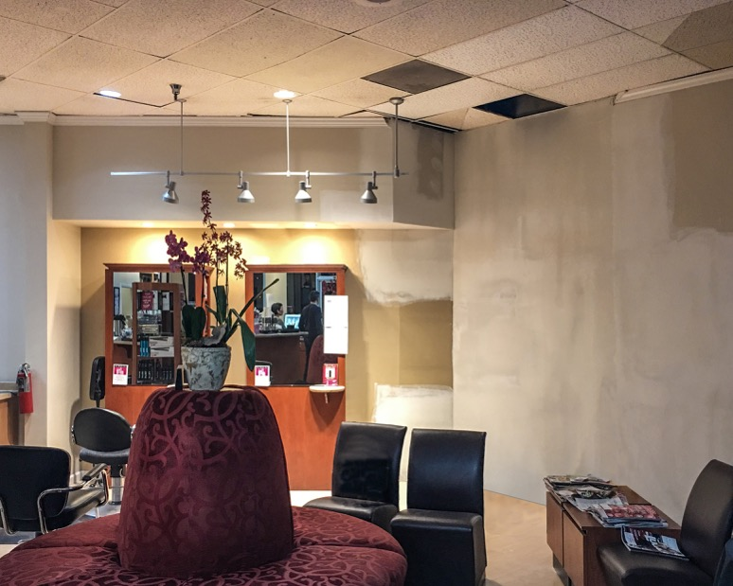
Before the makeover, the salon was dominated by dark furniture and cherrywood cabinets, a color scheme that had become dated and tired, topped by a mineral fiber ceiling that showed its age badly. The newer white ceiling panels, installed temporarily during remodeling, show how much the old ceiling had yellowed with age.
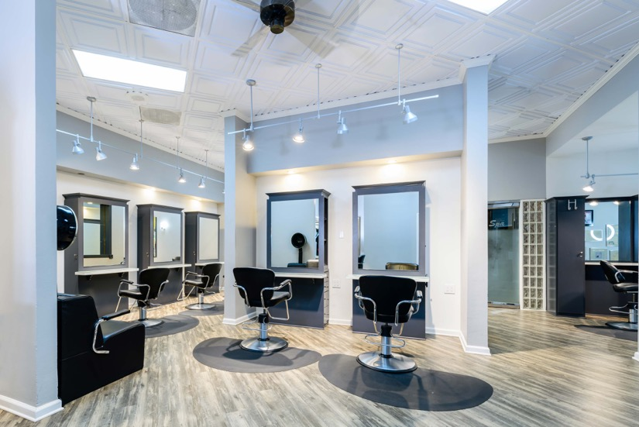
The new look is bright and open, and bespeaks a business that knows fashion. The decorative ceiling of Ceilume thermoformed panels creates the perception of an airy, lofty room. “As far as I’m concerned,” vows owner Denise Russell, “it just made the whole space.”
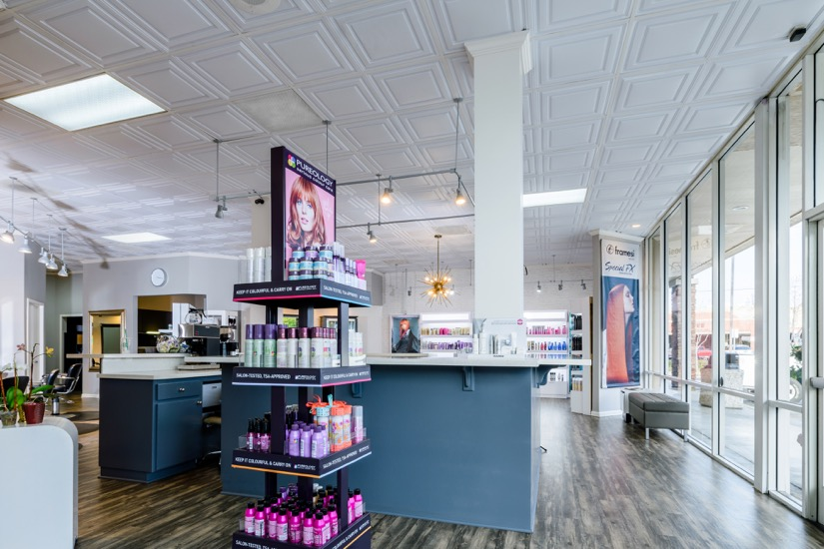
Strong, directional daylight shining through the storefront emphasizes the brightness of the room, with added visual interest from the pattern of highlights and shadows created by the relief of the ceiling panels.
###

