FOR IMMEDATE RELEASE
Recycling Milestone Reached by Ceilume Ceilings
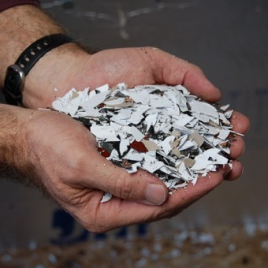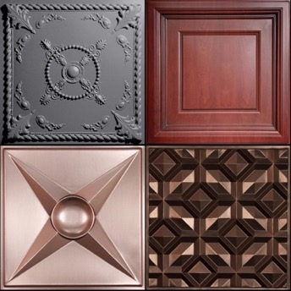
Ceilume’s new closed-loop system recycles scrap from its manufacturing process and from clients (left). The company now offers 100% recycled random gray products and 98% recycled content faux finishes (right).
GRATON, CA, 2020-Apr-15 – Ceilume recycled over 100 tons of vinyl in the first year of its program to reuse its scrap in a closed loop process. The leading manufacturer of thermoformed ceiling and wall panels and tiles, Ceilume is on track to double this amount in the coming year, according to Ed Davis, president of Empire West, Ceilume’s parent company.
“Ceilume is a family-owned business, so we have a personal stake in protecting the environment for the next generation,” Davis avers. “We started the company over 50 years ago with a commitment to being good stewards of our resources.” He cites, as an example, how the company collects all its scrap and then processes it into small chips that can be used as feedstock for new plastic products.
When China banned importation of recyclable plastic in 2018, Davis says, Ceilume “realized we had to take direct responsibility for our scrap.” After an investment in research and development, the company found it could reprocess thermoplastic scrap into a material that could be used for new ceiling panels that met the firm’s quality assurance standards.
Davis explains, “Our ceiling and wall panels are made with a very high-grade rigid vinyl that is free from deleterious additives. When we used to send it to commercial recyclers, our scrap would be mixed with materials from other sources that diminished the properties of the plastic. By using our own scrap, we are now upcycling the material from what it would have been in the general waste stream.” He reflects that, “some environmentalists are concerned about vinyl, and they have good reason to be; much of the plastic being used becomes junk that contributes to the global problem of single-use plastic waste. With our process, however, we can recycle the vinyl repeatedly without loss of quality.” He adds that this benefit is in addition to the renowned durability and service life of Ceilume’s ceiling and wall panels.
Because Ceilume manufactures panels from white, black, and other colors of vinyl, their recycled scrap gets intermingled and produces a “Random Gray” panel color that varies from batch to batch and even within individual panels. Still, many designers like the product’s appearance and recognize that variation also occurs in architectural materials such as wood and stone. Ceilume also applies laminates to the recycled material to create faux metal and woodgrain panels with 98% recycled content. Their panels and tiles have three-dimensional relief and are offered in more than 40 patterns to suit almost every architectural style.
Demand for the recycled products has outpaced the supply of available scrap, so the company is expanding its take-back program to recycle scrap returned by customers. Davis says that there is, “little scrap generated by installing Ceilume’s products. While ordinary acoustic ceiling panels are prone to damage during handling and have short service life, Ceilume’s panels are easy to install, flexible, strong, and impervious to water, so they last a long time. What little scrap is created can usually be given to municipal recycling programs.” Larger quantities, however, can now be returned directly to Ceilume for recycling.
For example, the Anaheim, CA Public Library recently redecorated two of its branch libraries and returned approximately 5000 sq. ft. of old ceiling Ceilume panels. The panels, just 0.013” thick, are lightweight and nest compactly for economical shipping. Davis quips, “We send our panels out into the world, but we like it when them come home for a visit. Then, after a short but transformational stay, we send them on their way again to grace the ceilings and walls of other buildings. I guess you can say, we are like proud parents.”
- - -
About Ceilume: Ceilume is the leading manufacturer of thermoformed ceiling and wall tiles and panels. The company’s roots go back to when “Mid-Century was Modern” and the pioneers of modular ceilings. The family-owned business is located in California’s wine country and occupies a historic apple-packing warehouse. With an eye on the future, Ceilume’s research and development continues to improve interior finish systems to meet changing environmental, performance, and aesthetic needs. For more information about the company, see www.ceilume.com/pro. For more information on the company’s sustainability, see www.ceilume.com/pro/environmental.cfm.

Photos: www.ceilume.com/pro/press.cfm. All images courtesy of Ceilume.

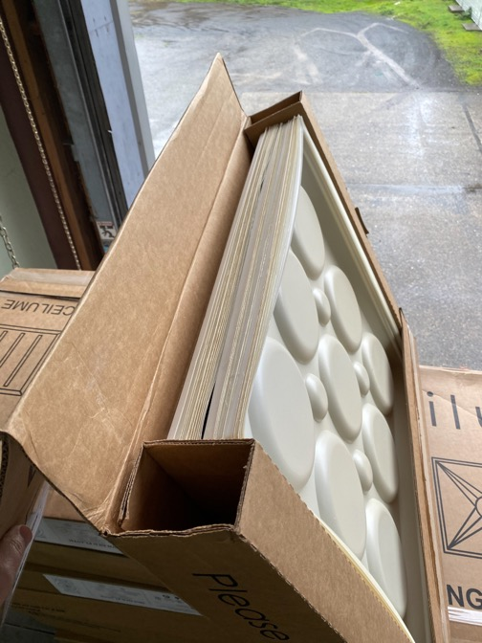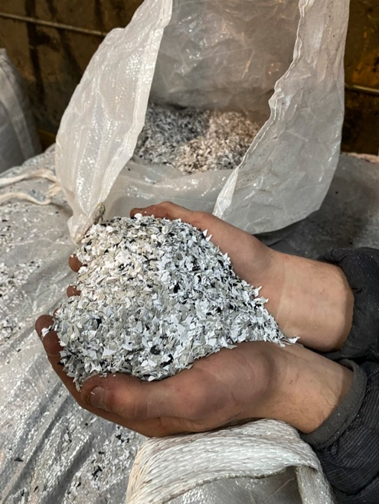
Used panels are collected from customers after their service life is over (left) and mixed with the limited amount of waste produced by Ceilume’s thermoforming process. They are chipped (right) for recycling.
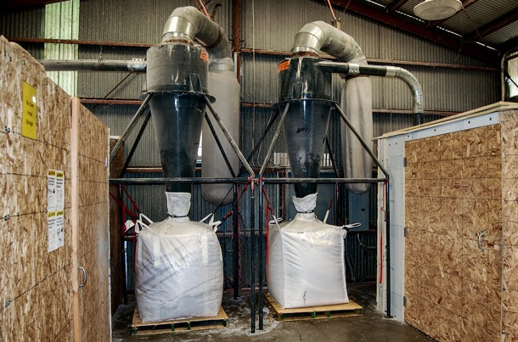
The high quality thermoplastic material is collected (left) and melted (right), and can then be formed into new products without degradation of the product’s quality or performance.
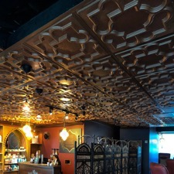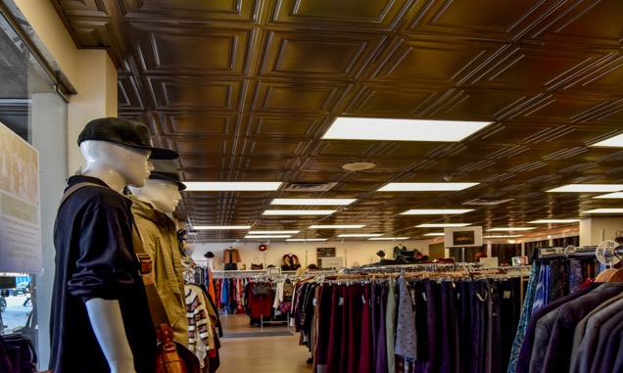
Ceilume thermoformed ceiling panels with high recycled content help designers and building owners achieve both aesthetic and sustainability goals.

###

