FOR IMMEDATE RELEASE
(770 words. A 300 word version is appended.)
Case Study: The Ceiling is a Member of the Wedding
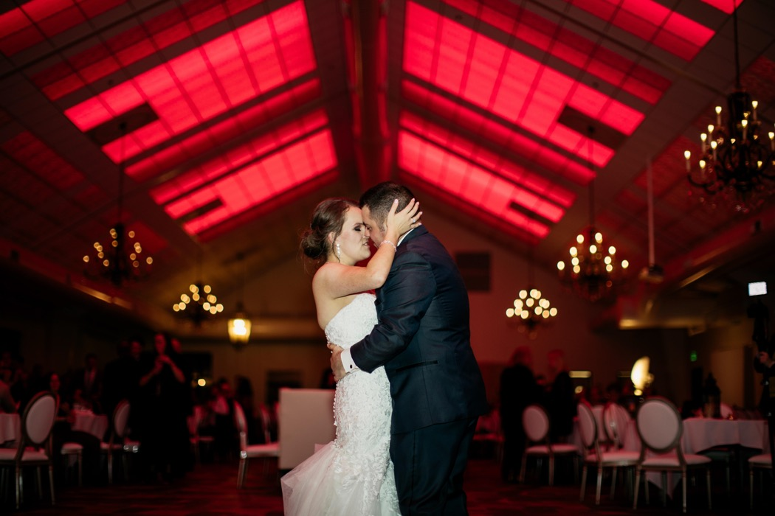
Photo by Brian Boassany
The color-changing luminious ceiling of Bavaria Downs becomes part of the wedding’s design.
GRATON, CA, 2020-06-16 -- The ballroom at Bavaria Downs was designed for weddings, and its luminous ceiling is part of the festivities. Using color-controlled LED lighting and translucent thermoformed ceiling panels from Ceilume, the popular Chaska, MN event and wedding venue changes its look to suit the occasion. The broad, pitched ceiling can mimic a vast skylight on a beautiful blue afternoon or match the bridesmaid’s gowns. It can even be synced to the sound system.
When conceiving the new ballroom for Bavaria Downs, designer Ed Hawksford knew right from the beginning that he wanted to do something special with the ceiling. “I wanted the impression of a Lalique glass ceiling from the 1920’s, backlit with color-changing LEDs.” The owner had been thinking about a large field of skylights, but even one narrow row of skylights proved to be prohibitively expensive, and would not really give the look and function he wanted. Hawksford suggested a luminous ceiling that was an ingenious merging of traditional style and contemporary technology, saved money, and added versatility.
Even though the ceiling is sloped, it uses a conventional 2-foot x 2-foot T-bar suspension grid seen so often in flat ceilings. The central portion of the ceiling is laid out in a series of luminous sections made of translucent Ceilume Doric style acoustic panels, a geometric design with numerous angled, light-catching facets. The sections are 14 feet wide, meeting at the peak. They are separated by 2-foot wide strips of opaque white panels.
The lower parts of ceiling are opaque Sand-colored Ceilume Florentine panels. An ornate, deeply-detailed floral design reminiscent of 19th Century decorative plaster, they add a note of traditional style to the room. Hawksford describes the overall intent of the ceiling was “to make this building feel conservatory-like.”
Above the ceiling, color-changing LED fixtures are mounted above the translucent Ceilume panels, pointing downwards towards the room. 16-foot long LED strips run perpendicular to the ridgeline of the ceiling, 6-8 strips per bay. They are positioned just 20 inches above the translucent panels.
The space between the ceiling and the insulated roof above it has limited height. Lighting designer Scott Wexler, president of Wex-Tech, was concerned that LED lights so close to the panels would not be evenly diffused, and could cause hotspots on the luminous ceiling. To test it, Wexler constructed a simple lightbox using a 24-inch x 24-inch cardboard carton, and duct-taped the thermoformed panel over the end of it. He found, to his surprise, that he could bring the light source to less than six inches away from the Ceilume panel and still get even, diffused light.
The backlit translucent panels create a lush field of color above the room. The color can be changed for a range of effects. It can match the afternoon blue sky, or the orange-reds of sunset, depending on the time of the event. “If the bride’s got a color scheme,” Hawksford points out, “we can theme the ceiling to match her colors. The lighting system can also be integrated with the sound system, so it can work like an old disco ceiling.”
Hawksford selected Ceilume panels specifically because they allowed him to keep the fire-suppression sprinklers above the ceiling, without having to penetrate the luminous panels and spoil the ‘skylight’ effect. Ceilume ceilings are approved for use beneath sprinklers because they are ‘drop-out’ panels. In the event of fire, heat softens the thermoformed panels so they deform and drop out of the ceiling grid, allowing the sprinklers to activate.
Hawksford recalls that the fire marshal who had to approve the design was extremely strict. “This was the toughest fire marshal I’ve ever dealt with.” Hawksford submitted Ceilume’s fire-testing documentation and, he says, that “proved it.” The fire marshal allowed sprinklers above the thermoformed panels, while insisting on sprinklers penetrating through adjacent mineral fiber panels. Ceilume thermoformed panels meet Class A fire safety requirements and are Greenguard Gold certified for indoor air quality.
The ceiling has proved to be a popular success, and something of a sales tool in booking events into the venue. “It’s a bonus: look, you get this beautiful upgrade,” explained former Director of Venue Operations, Georgia Meyer. “Clients look at it as a décor they don’t have to invest in. It brings a value plus.”
Typically, the ceiling will be colored to match the wedding’s scheme during the ceremony and speeches. “When the dancing starts,” added Meyer, “we let it just roll and run, this spectacular light show that is included. The reaction from clients and guests is just fantastic.”
- - -
About Ceilume: Ceilume is the leading manufacturer of thermoformed ceiling and wall tiles and panels. The company’s roots go back to when “Mid-Century was Modern” and the pioneers of modular ceilings. The family-owned business is located in California’s wine country and occupies a historic apple-packing warehouse. With an eye on the future, Ceilume’s research and development continues to improve interior finish systems to meet changing environmental, performance, and aesthetic needs. For more information, see www.ceilume.com/pro.
Photos: www.ceilume.com/pro/press.cfm
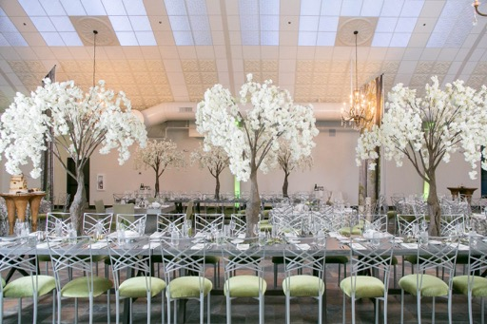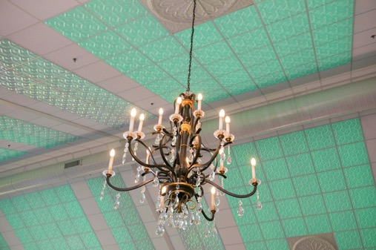

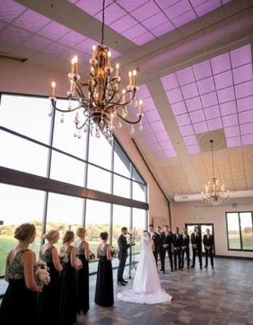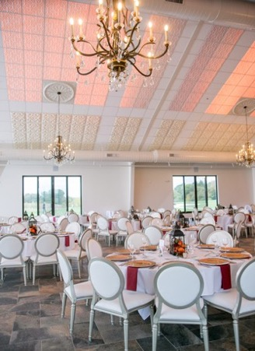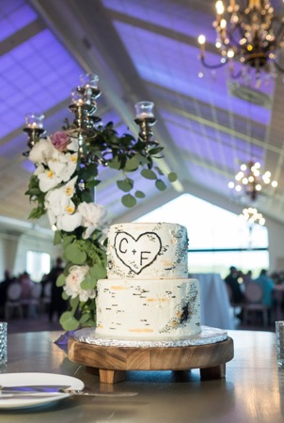
All photos courtesy of Bavaria Downs except as noted.
A system of color-changing LEDs above the ceiling throws a color wash onto the translucent Ceilume ceiling panels. The luminous ceiling can match the blue sky, the sunset, or the bridesmaids’ gowns.
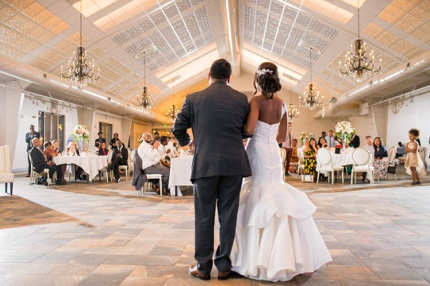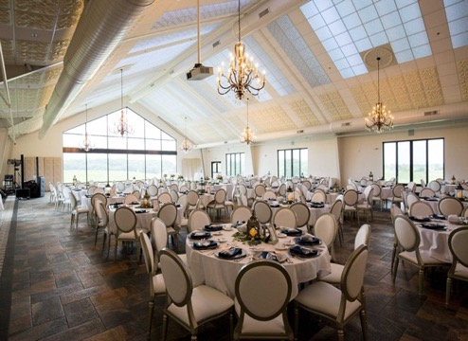
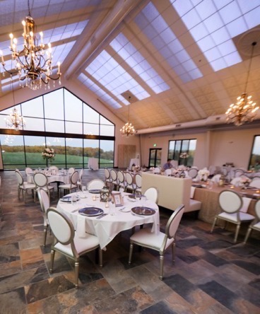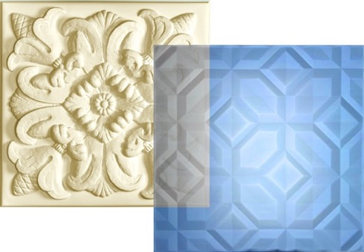
Right: Translucent Ceilume Doric design transmits colored light – blue in this case - through a faceted geometric pattern. The Sand colored Florentine panels add a note of traditional style, their deep relief captures dramatic highlights and shadows. Photo by Ceilume.
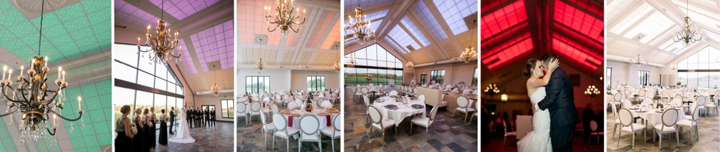
- - -
Case Study: The Ceiling is a Member of the Wedding
(300 Words)
GRATON, CA, 2020-01-07 -- The ballroom at Bavaria Downs was designed for weddings. One of its biggest attractions is a luminous ceiling that plays an active part in the festivities. Using colored LED lighting and translucent thermoformed ceiling panels from Ceilume, the Chaska, MN venue’s ceiling changes its look to suit the moment. Designer Ed Hawksford says, “If the bride’s got a color scheme, we can theme the ceiling to match her colors. The lighting system can also be integrated with the sound system, so it can work like an old disco ceiling.”
Luminous portions of the ceiling use Ceilume’s translucent Doric panels, a geometric design with angled, light-catching facets. The ceiling’s perimeter uses the company’s opaque Sand-colored Florentine panels with an ornate, deeply-detailed floral motif. Panels are installed in a conventional 2-foot x 2-foot T-bar suspension grid.
Above the ceiling, color-changing LED strips point downwards over the translucent panels. Lighting designer Scott Wexler, president of Wex-Tech, tested the panels and found he could bring them to within six inches of light fixtures and still get diffused illumination without hot spots.
Hawksford selected Ceilume panels because they allowed him to keep the fire-suppression sprinklers above the ceiling, without penetrations spoiling the ‘skylight’ illusion. Ceilume panels are approved for use in ‘drop-out’ ceilings. In a fire, the heat softens the thermoformed panels so they deform and drop out of the ceiling grid, allowing the sprinklers to function. The panels meet Class A fire safety requirements and are Greenguard Gold certified for indoor air quality.
The ceiling has proved to be something of a sales tool in booking events into the venue. “It’s a bonus: look, you get this beautiful upgrade,” explained former Director of Venue Operations Georgia Meyer. “Clients look at it as a décor they don’t have to invest in. It brings a value plus.”
###
