FOR IMMEDATE RELEASE
Hotel Restaurant Adds a Touch of Luxury
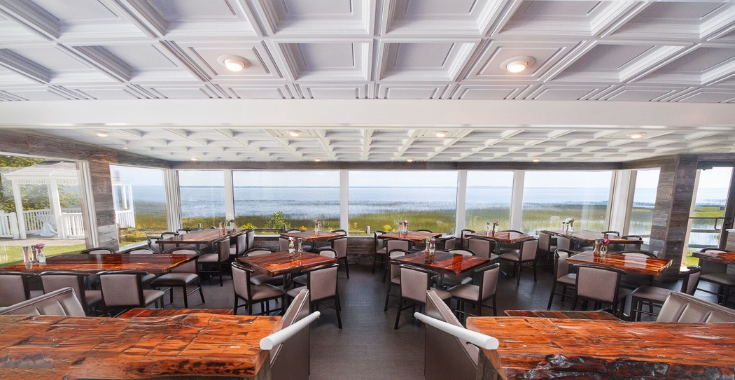
Photos courtesy of the Terrace Bay Hotel
The Terrace Bay Hotel restaurant, The Freshwater Tavern, was remodeled to create a modern gastropub look that mixes modern and rustic elements with coffered Ceilume ceiling panels that add a touch of elegance.
GRATON, CA 2020-09-30 -- When Jen and Jarred Drown bought the Terrace Bay Hotel in 2016, it had a storied, almost 100-year history, but it was looking rather tired. They were determined to restore the popularity of its restaurant and then upgrade the hotel into something approaching a luxury resort. They created an aesthetic that complements rustic elements of stone and reclaimed barn-wood with cool modern furniture and pure white coffered ceilings.
Located on the northern tip of Lake Michigan, it had been a gathering place for dining and dancing since it opened as the Terrace Gardens dance hall in 1922, was destroyed by fire and rebuilt twice, and added a small hotel in the 1950’s that expanded to moderate size in the 70’s, when it became the Terrace Motor Inn. Along with additions and expansion, it had been renovated numerous times, but it was ready for another one.
The Drowns knew the hotel’s restaurant was underperforming, and thought that an updated look could jump-start it. “We wanted a cool, modern look for the restaurant, a modern gastropub kind of feel. We were bringing in a little bit of rustic elements but didn’t want to turn into an all-out rustic tavern. We did a reclaimed barn wood look on the walls, with custom made reclaimed barn wood tables, and the Ceilume ceiling tiles to help give us more of that modern look.”
Drown found Ceilume’s thermoformed, three-dimensional ceiling products through extensive searching online, and was surprised by the range of available styles. They selected white Madison style, a coffer pattern with deep relief, and added borders of white Cambridge tiles, a complementary square pattern with less relief. “A lot of people do the plain black tiles,” Drown comments, “try to make their dropped ceiling disappear and then it’s all about the lighting. But I saw a few different styles and I said, ‘Man, that actually adds something. That’s not like, ‘that room would be nice except it had a dropped ceiling,’ that’s actually a preferred look over a standard ceiling.”
The restaurant renovation was a success, bringing new business and increased attention to the property. The effect is modern and warm, with a kind of livable elegance. The Drowns plan to continue renovating, extending the livable feeling established in the restaurant to the rest of the hotel. They have already used Ceilume ceiling panels in some guest rooms and corridors to create a unifying visual motif throughout the facility.
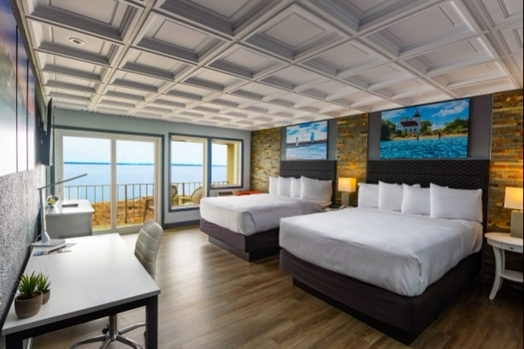
Guest rooms at the Terrace Bay Hotel are being renovated to reflect the design motifs of the restaurant. The deep coffers in the ceiling capture shadows and highlights that draw attention to the dramatic views of Lake Michigan.
--------------
About Ceilume: Ceilume is the leading manufacturer of thermoformed ceiling and wall tiles and panels. The company’s roots go back to when “Mid-Century was Modern” and the pioneers of modular ceilings. The family-owned business is located in California’s wine country and occupies a historic apple-packing warehouse. With an eye on the future, Ceilume’s research and development continues to improve interior finish systems to meet changing environmental, performance, and aesthetic needs. For more information, see www.ceilume.com/pro.

Photos: www.ceilume.com/pro/press.cfm
###

