FOR IMMEDATE RELEASE
Case Study: It Doesn’t Look Like A Hospital
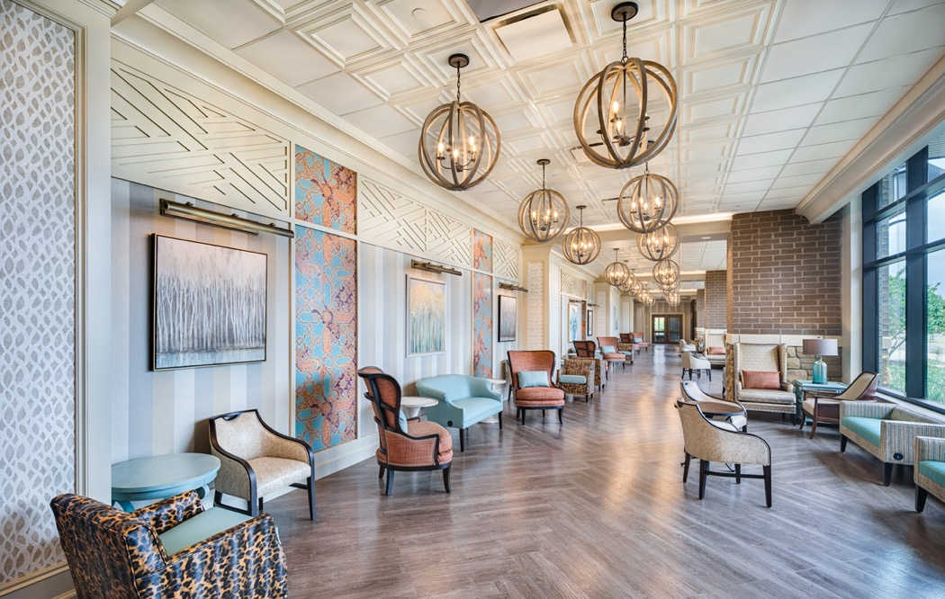
Photo by Chad Mellon Photography
The Center for Advanced Healthcare at Brownwood, in The Villages, FL, is designed to feel more like an elegant home or a hotel than a hospital.
GRATON, CA, 2021-1-21 -- A hospital does not have to look austere, intimidating, or forbidding. It can be clean without appearing sterile, professional without being impersonal. It can feel more like a resort or hotel. The Center for Advanced Healthcare at Brownwood (CAHB), a new 234,000 square foot ambulatory care hospital in central Florida’s master-planned retirement mega-community, The Villages, has waiting rooms that are called Living Rooms, and the design is intended to suggest an elegant hotel.
The healthcare center’s hospitality feel is underscored by its relationship to the adjoining Brownwood Hotel and Spa. The 150-room hotel not only accommodates business and personal travelers, but also provides medical hospitality for patients and their families coming to CAHB for treatment. The two buildings are deliberately different in interior design – for wayfinding purposes, among other reasons – but are nonetheless two sides of the same design coin and share certain aesthetics. The healthcare center’s color palette, for example, matches the hotel’s spa. The hotel and CAHB both blend traditional and contemporary elements to create their individual, unique styles, and both make extensive use of three-dimensional acoustic ceilings from Ceilume to provide texture, complement other decorative motifs, and add notes of elegance.
Located in Brownwood, one of three town centers of The Villages, the CAHB was designed and built concurrently with the hotel, and opened in May 2020. It was a collaboration between The Villages’ design group led by Tracy Morse (one of the three managing members of the family that founded The Villages) and ESa (Earl Swensson Associates), which provided master planning, architectural, and interior design.
The mandate was to make the healthcare center feel like a residence or a hospitality project. “When one requires medical care away from home,” says ESa senior interior design manager Jarred Bobo, “I feel that an environment ‘like home’ would make me feel better.” Welcoming hominess is specifically mandated in The Villages’ mission statement, too.
Bobo’s strategy to evoke that feeling of home is a bold conjoining of elements both traditional and contemporary, “a blend of many styles that work well together, that make it appear that the interior design may have evolved over time. Even though most everything in The Villages is new, the goal is to make everything there appear to have been constructed years ago.”
The stylistic theme of the healthcare center is the spirit of the Floridian Cowboy, which is consistent with the hotel and the entire Brownwood town center. It comes out in the use of rustic wood accents in flooring and lighting, as well as some more direct references, such as vinyl upholstery in a cow hide print, or embossed in a paisley that recalls a cowboy’s bandana. Complementing that theme is “a vernacular of style elements,” explains Bobo, “including Chinese Chippendale, formal millwork treatments for columns and pilasters, and both rustic and contemporary elements.”
The waiting areas on three floors of the CAHB, called Living Rooms, are comfortable, slightly casual and filled with light via generous glazing. A coffered ceiling pattern provides a note of elegance and offers a bit of traditional balance to the contemporary elliptical chandeliers. But unlike the old, heavy wood or plaster coffers they reference, these are actually conventional suspended T-bar grid ceilings, populated with lightweight three-dimensional Ceilume thermoformed panels. Ceilume’s shallow-coffer Oxford panels are bordered with flat Serenity panels, both in the Sand color. Bobo utilized them for “additional patterning and texture” instead of the usual flat mineral fiber tiles.
This combination of coffered ceiling and contemporary chandeliers is repeated in the large corridor that connects the CAHB to the hotel, as well. The thermoformed panels were installed with Soniguard acoustical backing to enhance the panels’ inherent noise-reduction properties, and they have been effective, despite the large expanses of hard-surface floors and walls. The ceiling panels are also moisture-resistant and fully washable, making them hygienic and compliant with health codes for medical facilities.
The reception area of the hotel’s medi-spa also makes use of thermoformed ceilings, but for a different, more contemporary effect, setting the lacelike Victorian style against a room dominated by rustic wood in strong lines and rectilinear shapes. Again, the feel of the space is anything but clinical, instead evoking elegant country living. Other styles and colors of thermoformed Ceilume ceilings are used in the hotel’s main lobby, bar, and the pre-function lobby outside the ballrooms.
If the mixture of styles is daring, it achieves the strategic goal of seeming to have been there for decades and evolved over time. The effect makes the spaces seem, not lived-in, but livable and more reassuring than a typical hospital environment. Leveraging the ceiling in this strategy proved to be an effective way to add texture and interest, with the wide range of available panel styles providing smart complements to several different, highly eclectic designs.
--------------
About Ceilume: Ceilume is the leading manufacturer of thermoformed ceiling and wall tiles and panels. The company’s roots go back to when “Mid-Century was Modern” and the pioneers of modular ceilings. The family-owned business is located in California’s wine country and occupies a historic apple-packing warehouse. With an eye on the future, Ceilume’s research and development continues to improve interior finish systems to meet changing environmental, performance, and aesthetic needs. For more information, see www.ceilume.com/pro.

Photos: www.ceilume.com/pro/press.cfm
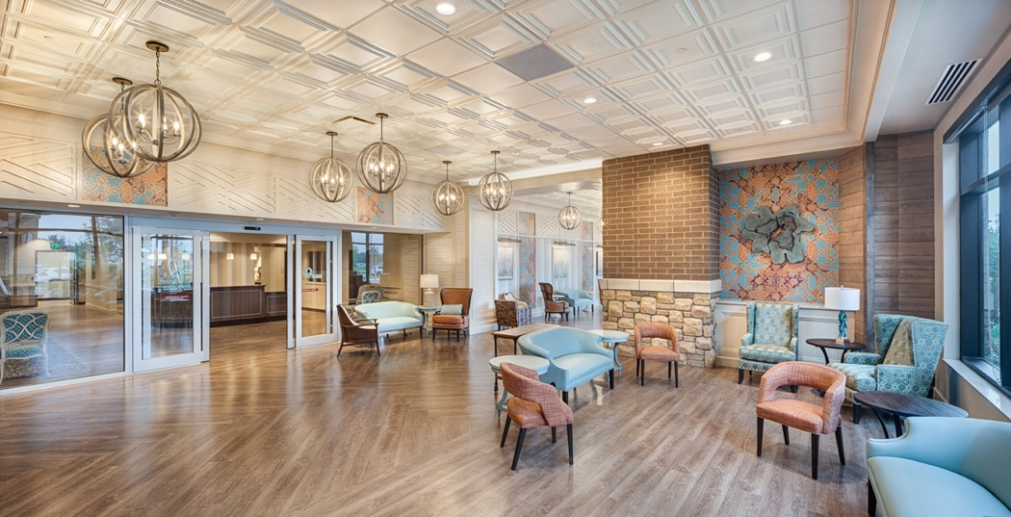
Photo by Chad Mellon Photography
The waiting rooms, called Living Rooms, feature upholstery patterns and rustic wood floors that reference the Floridian Cowboy theme, with wood-accented but distinctly contemporary chandeliers set against a more traditional coffered ceiling made of Ceilume thermoformed panels.
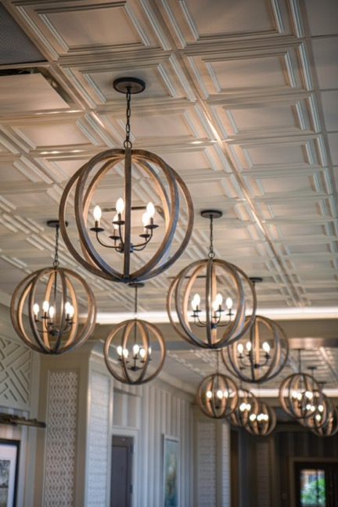
LEFT
Photo by Chad Mellon Photography
The coffered thermoformed ceiling – seen here in the corridor that connects the healthcare center to the adjacent hotel – adds a traditional aesthetic effect, while simultaneously providing all the practical benefits of a modern accessible grid ceiling.

BELOW
Photo by Attic Fire
The hotel spa reception area shares its color palette with the adjacent healthcare center, but to a very different effect, featuring extensive use of rustic wood on the walls and millwork, with a stone floor and thermoformed ceiling providing a more contemporary vibe.



