At California Skin Clinic, Looking Good Begins With the Ceiling
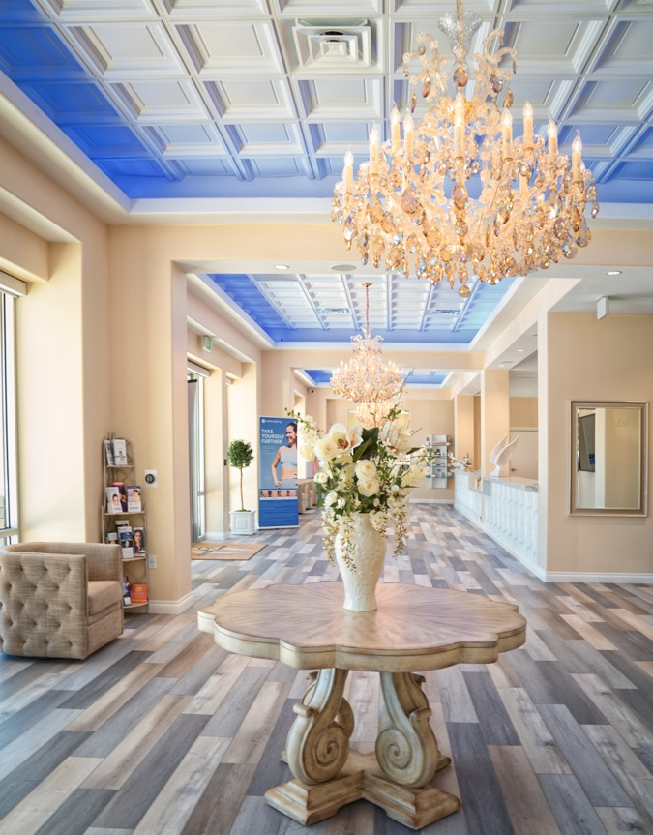
Photos by Debbie Strong Photography except as noted
Cloud 9 Medi-Spa supports its branding as a luxury clinic with crystal chandeliers and an elegant ceiling made of Ceilume thermoformed panels.
GRATON, CA. 2021-03023 -- Cloud 9 Medi-Spa, a new luxury medical skincare clinic in Southern California’s burgeoning Inland Empire, wanted to project an image of elegance, epitomized by the crystal chandeliers in its reception area. Instead of the usual flat ceiling tiles, they installed decorative ceilings made of three-dimensional Ceilume thermoformed panels. The lightweight white Madison and Stratford styles complete the statement started by the chandeliers, and provide an instant aesthetic upgrade to the rooms.
The decorative panels are used throughout the clinic. “People are reclined in their chairs and looking up quite frequently,” explains business manager John Draper, “so we wanted a Wow! factor. Ceilume certainly delivered. Everyone loves it!”
Leveraging the attractive ceiling pattern, color-changeable LED lights concealed in the soffits of the waiting rooms add a tinted glow at the perimeter that can remain a constant color, slowly dissolve from one color to another, or even put on a dynamic light show.
“These ceiling tiles really make the room look elegant. It would have been completely different with your typical drywall hard lid,” according to Draper. The ceiling panel manufacturer, Ceilume (www.ceilume.com/pro), is a family-owned business located in California’s wine country, whose roots go back to “when Mid-Century was Modern.” Their affordable ceilings are hygienic because they are impermeable to water, stain-resistant, and fully washable, allowing them to be installed throughout Cloud 9, in the reception and waiting areas, corridors, and even treatment rooms. The coffered looks that Cloud 9 selected are just two of the 50 styles and 16 colors and decorative finishes possible.
“We knew that these ceilings were going to be the difference between having a typical medical clinic, or having a destination that would attract our clientele,” says Draper. “People can't take their eyes off the ceilings.”
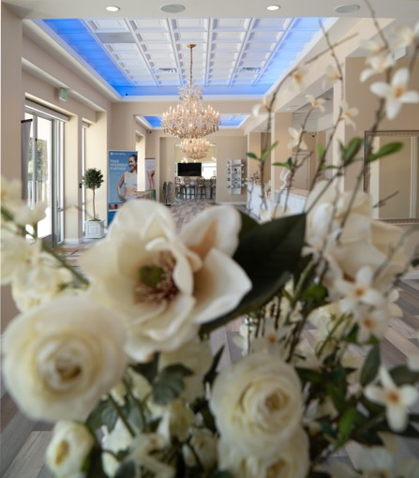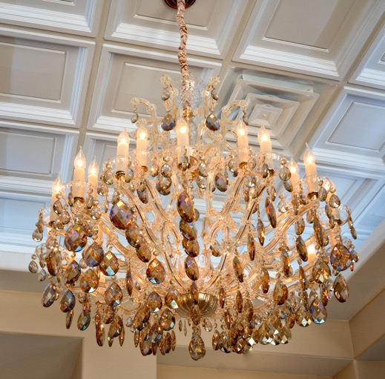
The deep relief ceiling adds elegance and a sense of grandeur that completes the statement of the chandeliers.

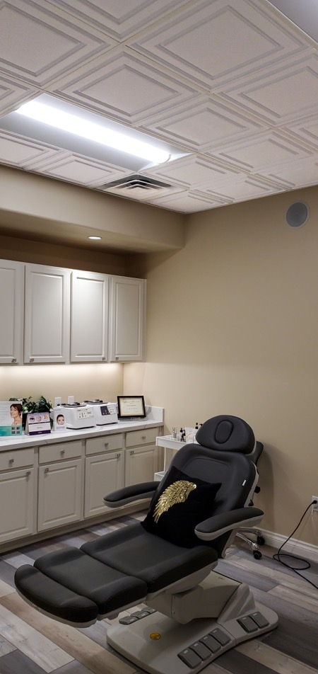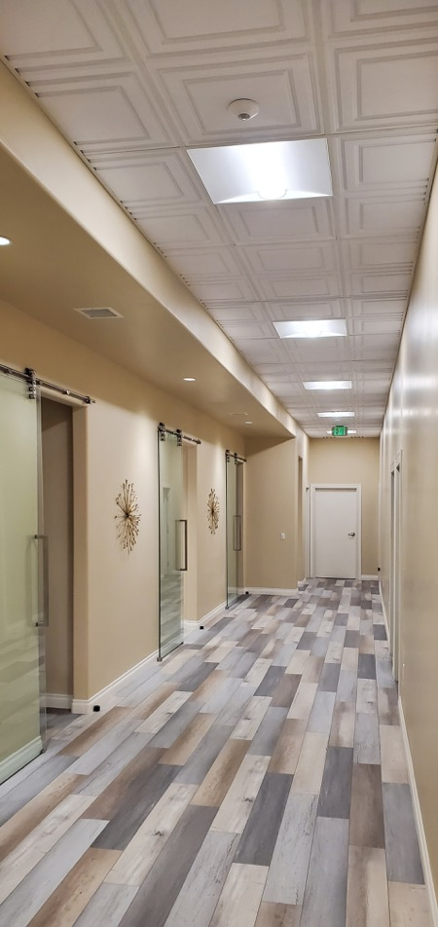
The lightweight decorative ceilings are stain-resistant and fully washable, a hygienic product that can be used throughout the clinic.
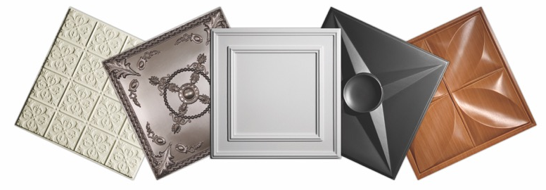
Photo courtesy of Ceilume
Ceilume thermoformed ceilings are made in more than 50 styles, with 7 colors, 6 faux-wood and -metal finishes, and 3 light-transmitting options possible.

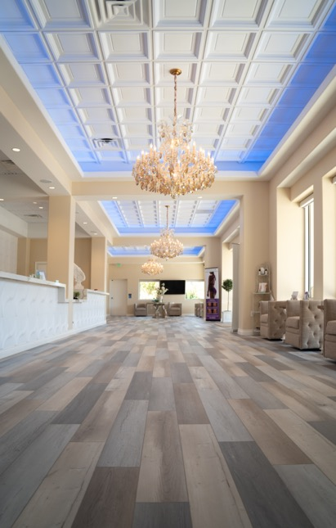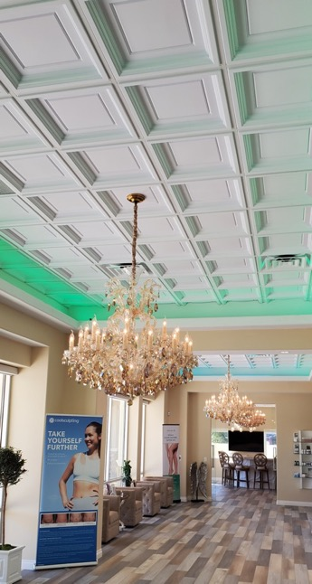
“We knew that these ceilings were going to be the difference between having a typical medical clinic, or having a destination with a Wow! factor,” says business manager John Draper.
###

