PRODUCT NEWS - FOR IMMEDATE RELEASE
Testing the Strength of a Good-Looking Ceiling
Good appearance is part of a ceiling’s performance.
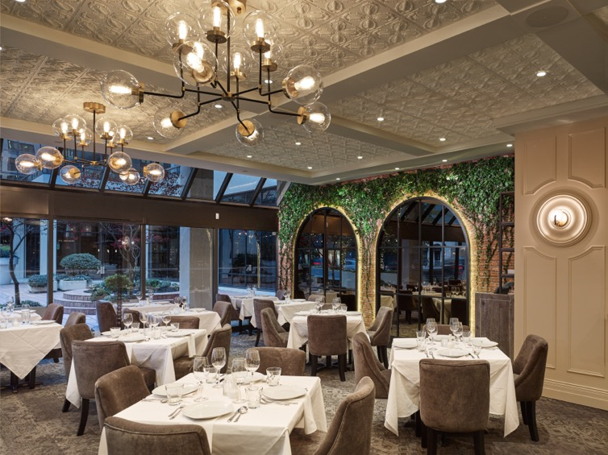
Test data can help determine whether thermoformed acoustic ceiling panels such as these are a more durable alternative to common mineral fiber acoustic panels. Photo by Martin Knowles
GRATON, CA, 2021-06-17 -- The service life of an interior finish is typically determined by how well the material maintains its beauty when exposed to ordinary wear. Many types of ceiling panels, for example, “ugly out” and need replacement long before they are structurally worn out. When materials require premature replacement, they burden landfills, increase consumption of raw materials, and impose unnecessary costs on building owners.

While examples of damaged suspended ceilings are all-too-common, reliable data on ceiling durability and cleanability has been difficult to find. Recently, however, third-party laboratory tests were conducted to determine the performance of commonly-used mineral fiber acoustic panels in comparison to thermoformed acoustic panels. The research used industry-standard tests as defined in ASTM C367 – Strength Properties of Prefabricated Architectural Acoustical Tile or Lay-in Ceiling Panels. It evaluates four criteria to provide insight into how well panels will resist damage during installation, maintenance, and ordinary use:
- Hardness: The force required to press a steel sphere into a panel has a direct correlation to hardness and usually indicates impact and abuse resistance. Thermoformed panels resisted 66 times more force than mineral fiber.
- Friability: Specimens are placed in a rotating tumbler, then taken out and weighed at prescribed intervals. Specimens that lose the most mass are more friable and prone to damage, especially at corners and edges. The mineral fiber samples lost over 13% of their total mass in twenty minutes. Thermoformed panels lost nothing. Friability is especially a concern with mineral fiber materials because airborne fibers, including silica fibers, can cause respiratory and other health problems.
- Sag: Panels are exposed to elevated temperature and humidity, then returned to ambient room conditions and measured for sag. Thermoformed panels exhibited less than 1/10-inch of sag. Mineral fiber had more than 3/4-inch of sag because they have a propensity to weaken as they absorb moisture. A 3/4-inch sag would be clearly visible at normal suspended ceiling heights.
- Transverse Strength: Panels are tested in a hydraulic testing machine and the load is recorded at which panels break or are unable to resist more load. The greater the modulus of rupture (flexural strength), the less likely a panel is to be damaged in the field. Mineral fiber broke at a load of 5.6 lbf. Thermoformed vinyl did not break, and had a modulus of rupture 16 times greater than mineral fiber.
The data supports findings that mineral fiber panels are relatively fragile, prone to damage when handled, and sag when exposed to humidity and moisture.
The strength properties of thermoformed panels indicate that they are durable enough to install without damage, retain their appearance despite repeated handling for maintenance, and withstand the types of abuse that can be expected in most commercial buildings. Their resilience to moisture enables them to be washed and, since they do not shed fibers, allows them to be used in food handling, data processing, and healthcare facilities, and in wet or humid areas.
Strength, durability, and cleanability are not the only factors to consider when selecting a ceiling product. The products in this test program, however, have similar acoustic, fire safety, light reflectance, and other performance characteristics.
Testing was sponsored by Ceilume, a leading manufacturer of thermoformed ceiling panels. Since performance varies from brand to brand of similar products, it is worthwhile to request test reports from manufacturers being considered and make direct comparisons. The full laboratory report of this test program can be downloaded at http://bit.ly/ceiling-strength.

--------------
About Ceilume:
Ceilume is the leading manufacturer of thermoformed ceiling and wall tiles and panels. The company’s roots go back to when “Mid-Century was Modern” and the pioneers of modular ceilings. The family-owned business is located in California’s wine country and occupies a historic apple-packing warehouse. With an eye on the future, Ceilume’s research and development continues to improve interior finish systems to meet changing environmental, performance, and aesthetic needs. For more information, see www.ceilume.com/pro.

About ASTM:
ASTM International is a globally recognized leader in the development and delivery of voluntary consensus standards. Over 12,000 ASTM standards are used around the world to improve product quality, enhance health and safety, strengthen market access and trade, and build consumer confidence. For information about ASTM C367, see www.astm.org/Standards/C367.htm.

Photos: www.ceilume.com/pro/press.com. Photos courtesy of Ceilume except as noted.
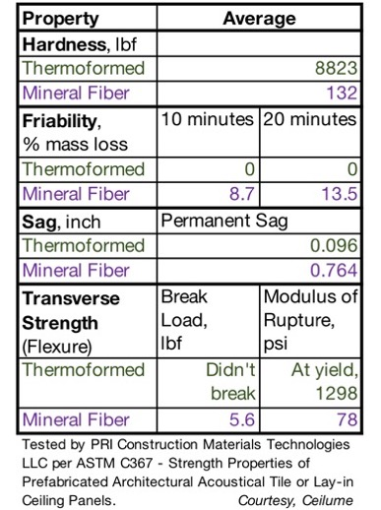
TABLE: In third party testing, the strength properties of thermoformed panels proved to be superior to mineral fiber in all four categories tested in accordance with the ASTM C367 standard.
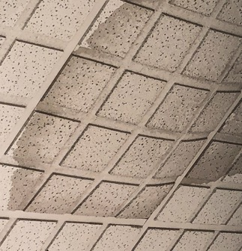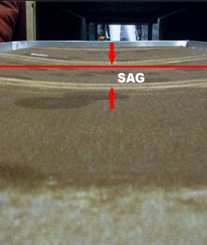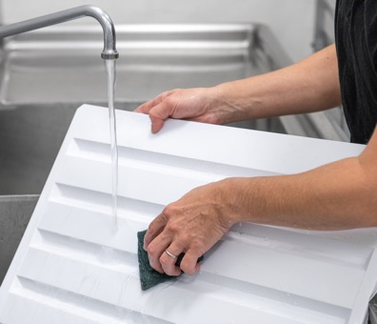
Left and Center: Mineral fiber ceiling panels absorb moisture and lose strength, resulting in sagging. Moisture also promotes staining, odor, and fungal growth. Right: Thermoformed panels are impervious to water and not prone to sagging. They also resist water-borne stains and are washable. (Photo by Ryan Bent)
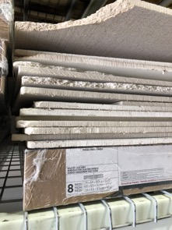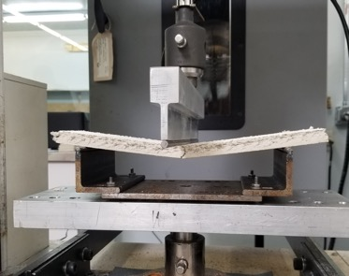
Left: Field experience indicates that mineral fiber ceiling panels are fragile and can be damaged by ordinary shipping and handling.
Right: ASTM C367 tests confirmed that mineral fiber ceiling panels break at relatively low loads.
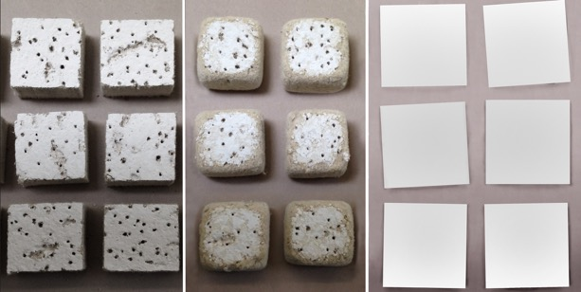
The ASTM C367 tumbling tests demonstrates how mineral fiber ceilings (left) erode and shed fibers (center) when handled. Thermoformed ceiling panel (right) do not contain fibers and are not damaged during testing.
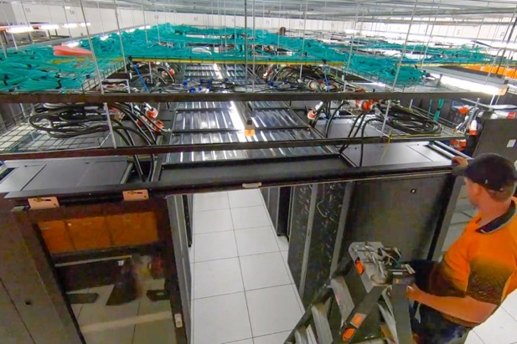
Thermoformed ceiling panels can be used in areas where airborne fibers are not acceptable, such as this computer server room, and in healthcare facilities and food preparation areas.
###

