FOR IMMEDIATE RELEASE
Bar Topping Ceilings
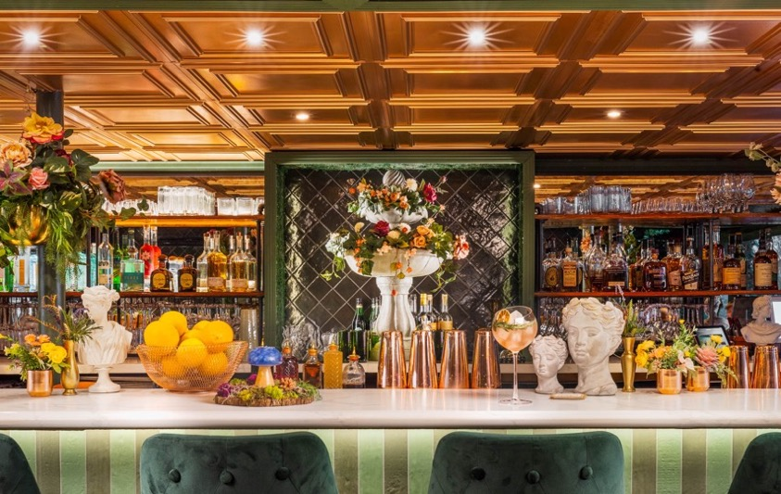
Photo © Kevin Brost, courtesy House of Form
The bar at 36 Below, Pheonix, AZ, is topped off with thermoformed Cambridge panels from Ceilume in a metallic copper finish that complements the green hues of the furnishings and wall coverings.
GRATON, CA – After toasting, "Bottoms-Up," drinkers tilt their heads back and turn their gaze towards the ceiling. Perhaps that is why drinking establishments pay extra attention to how they top off a bar. Moreover, a ceiling is usually the largest and most visible surface in a room, and goes a long way toward creating the look and ambiance of an establishment.

Thermoformed ceilings are an increasingly popular type of ceiling that can help create just the right personality for a bar. For example, Ceilume, the leading manufacturer of thermoformed ceiling panels and tiles, offers 49 decorative styles with molded relief that range from modern geometric patterns to classical coffers and replicas of old stamped metal panels. They come in 16 colors, faux wood and metallic finishes, and unique light-transmitting materials.

More than just a pretty face, Ceilume ceilings offer performance characteristics not available from other ceiling products. For example, they are lighter in weight and easier to install than other ceilings. Their acoustical properties can be tuned to create the desired ambient sound level. And, because they are waterproof and washable, they can be installed over exposed kitchens and food preparation areas.

Ceilume panels and tiles can be used in new designs or renovations, installed in standard suspended ceiling grids, and applied directly to the bottom gypsum board or other flat ceiling substrates. They are also more affordable than many ceiling products, to keep the room’s cover charges low.
----------
Photos: www.ceilume.com/pro/press.cfm
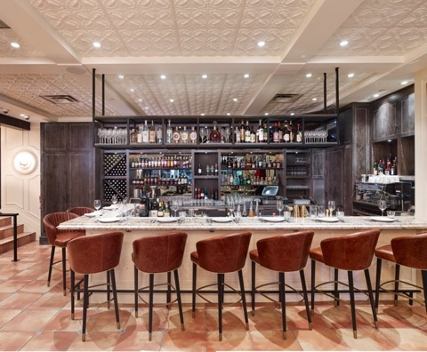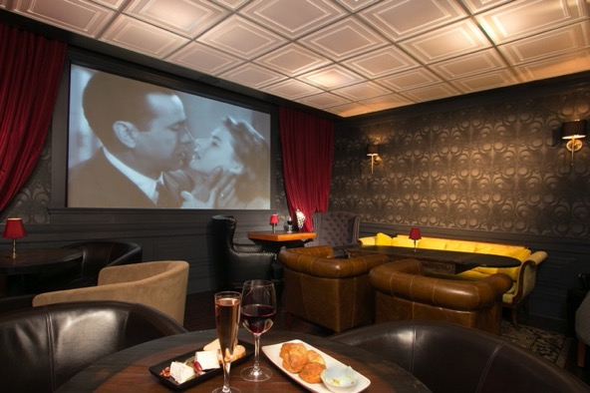
LEFT: Photo © Martin Knowles Photo/Media DOWNLOAD CASE STUDY
The bar at Italian Kitchen in Vancouver, BC is also a food preparation station, so the ceiling had to meet health department requirements for cleanability. The thermoformed Orleans ceiling panels from Ceilume are washable, and are used throughout the restaurant.
RIGHT: Photo courtesy Gi Paoletti – Designer
The soft glow of a luminous ceiling creates an ambiance of mystery at the Noir Lounge, San Francisco. Translucent Stratford panels from Ceilume are installed beneath LED lights.

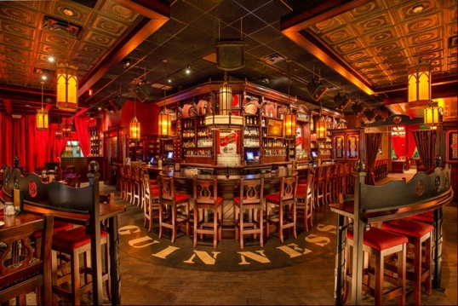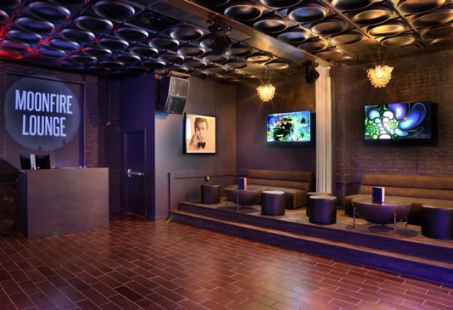
LEFT: Photo courtesy of www.irishpubconcept.com.
Evangeline panels from Ceilume, in a suspended ceiling grid, are the contemporary way to create a traditional look at the Five Roses Pub, Rosemont, IL.
RIGHT: Photo courtesy of Austin VIP Interiors.
When D.J.s spin vinyl in the Moonfire Lounge, Austin, TX, they do so under a ceiling that is also made of vinyl. The black Regency panels from Ceilume repeat the shape of both old LPs and the club’s lunar namesake.
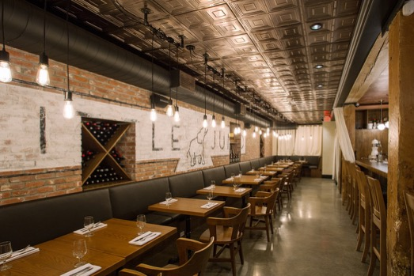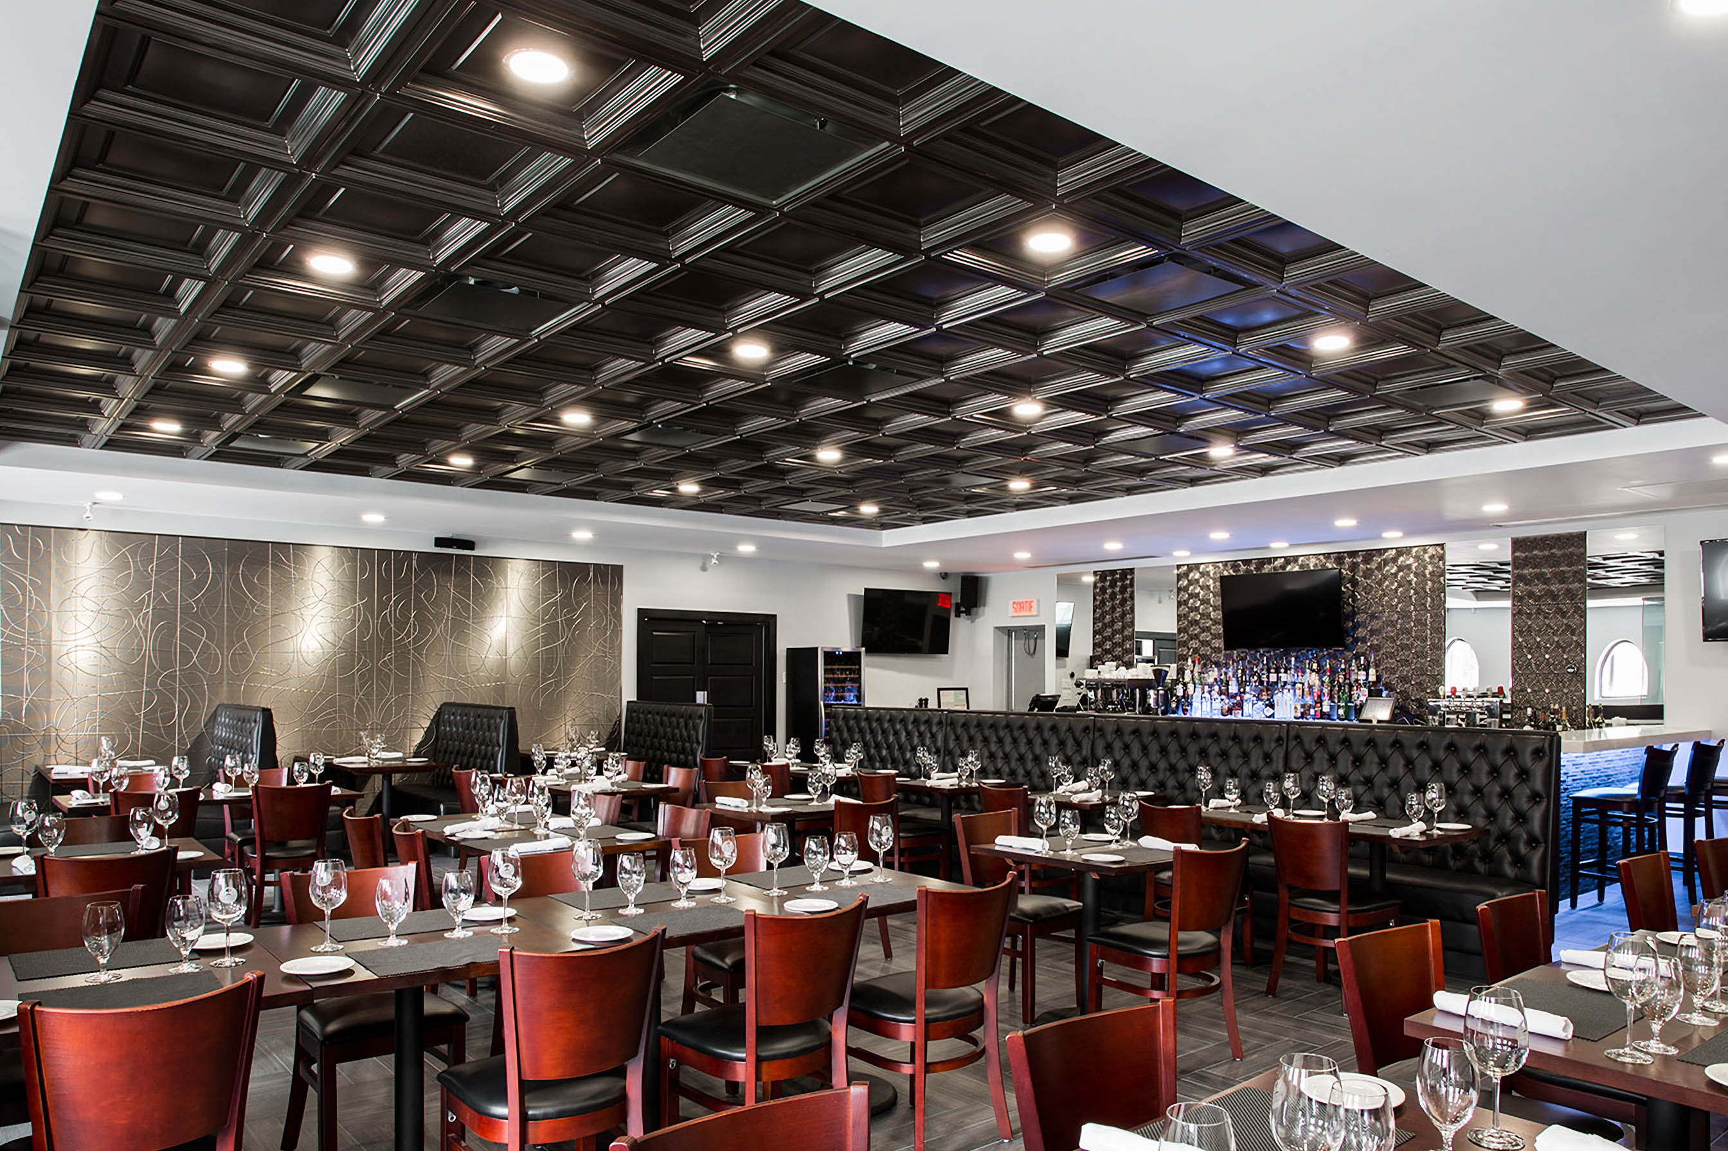
LEFT: Photo courtesy of Live By Design DOWNLOAD CASE STUDY
The Little Jumbo bar and restaurant in Vancouver, British Columbia created a 1920’s New York Speakeasy look with a thermoformed ceiling made by Ceilume. The metallic faux finish panels in a style called Jackson resemble 100-year-old tin ceilings but are easier to use.
RIGHT: Photo courtesy Restaurante Di Menna
A classical coffered ceiling from Ceilume contributes to the Italian flavor of Restaurante Di Menna, St. Leonard, Quebec.
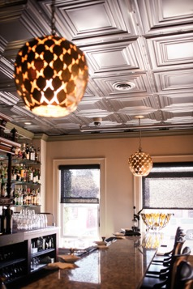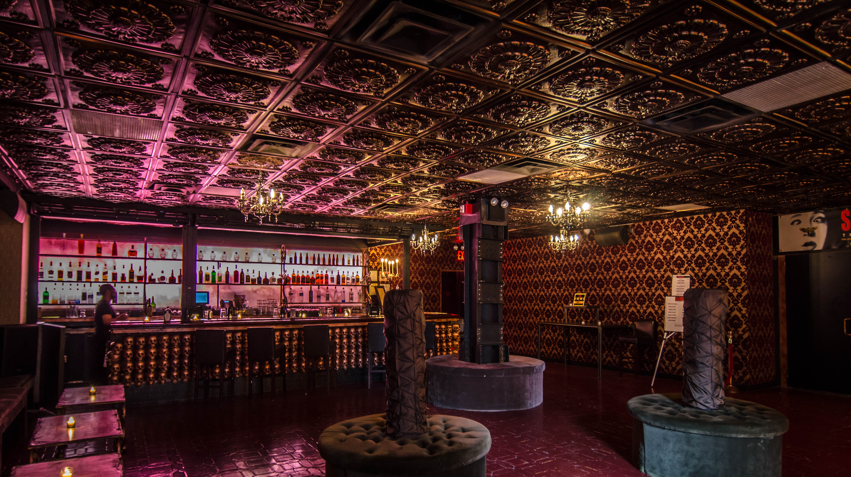
LEFT: Photo courtesy MarQueen Hotel
The Tin Lizzie Lounge offers “Giggle Juice and Lite Bites” in the historic MarQueen Hotel, Seattle WA . The faux tin ceiling reinforces the lounge’s name and contributes to the cozy ambiance.
RIGHT: ©Farouk Cherchali
The Gothic look of this New York City haunt is created by attention to ceiling and wall finishes and colored lighting.
-------------------

About Ceilume: Ceilume is the leading manufacturer of thermoformed ceiling and wall tiles and panels. The company’s roots go back to when “Mid-Century was Modern” and the pioneers of modular ceilings. The family-owned business is located in California’s wine country and occupies a historic apple-packing warehouse. With an eye on the future, Ceilume’s research and development continues to improve interior finish systems to meet changing environmental, performance, and aesthetic needs. For more information, see www.ceilume.com/pro.

###

