FOR IMMEDATE RELEASE
Swimming Pool and Spa Ceiling Trends
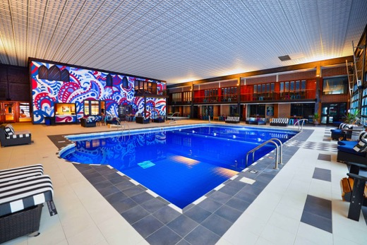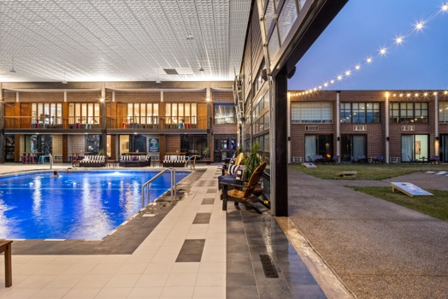
Photos courtesy of The Highlander Hotel
The pool at the Highlander Hotel in Iowa City, renovated with a new thermoformed ceiling, became a destination for locals and an extra revenue stream that helped keep the hotel in business during the Covid-19 travel slump.
LEFT: An eye -popping psychedelic mural is part of the hotel’s retro “60s theme.
RIGHT: New garage-type doors create an indoor-outdoor vibe and provided a convenient way to install ceilings over the pool.

GRATON, CA, 2022-02-02 – A visually attractive ceiling has significant impact on the pool users’ experience. Pool ceilings can be vast, uninterrupted surfaces and, because users look upwards while swimming on their backs, soaking in a tub, or reclining on the deck, ceilings can be more conspicuous than are ceilings in other types of spaces.
Ceilings also the best option for reducing noise in an indoor pool environment. People splashing and playing make pools noisy environments. The water surface plus the hard decks, walls, and glazing around the pool reflect sound to increase the intensity of the noise and create reverberations that interfere with speech and hearing. Some ceiling products, however, can absorb most of the sound impinging on them and are the best candidates to control noise.
The right ceiling must be compatible with a pool environment. It should be impervious to water and high humidity, the sagging and mold growth that often occurs in damp locations, stains caused by leaks and condensation, and the aggressive attack of pool chemicals.
Product Options
Suspended (drop) ceilings are widely used because they can economically cover the expanse of a pool and conceal mechanical services above the ceiling. A suspended ceiling typically consists of a T-bar grid that is suspended by wires and populated with acoustic ceiling panels. Painted steel T-bar rusts all too easily in a humid environment. Better, more corrosion-resistant grid options include T-bars made of anodized aluminum, fiberglass composite, or extruded plastic.
The most commonly used ceiling panels are made from mineral fiber. Despite their popularity, they are not the best fit for pool applications. Typical mineral fiber panels offer moderate-to-good control of noise, but are vulnerable to moisture-related damage, prone to staining, and are easily dented or broken by impacts such as a high-flying water-polo ball. Special grades of mineral fiber, suitable for humid conditions, are available for a premium price.
Metal panels are also available, although steel products are not recommended for pools because of corrosion potential. Some perforated aluminum panels with an anodized or painted finish are suitable for above-pool use. However, metal panels can have razor-sharp edges that could be hazardous if a panel got knocked out of the grid – by a ball used in pool sports, for example. To prevent accidents, all types of over-pool ceilings panels should be secured in place with hold-down clips.
Another appropriate option is a thermoformed ceiling: thin, lightweight, three-dimensional panels available in a wide variety of both contemporary and traditional styles and in a range of colors. Thermoformed panels are impervious to water, stain-resistant, washable, and durable. At least one brand of thermoformed panels has been specifically tested for staining by pool chemicals and found to be highly resistant. In standardized strength testing, the panels did not chip or abrade, and tend to flex upon impact instead of breaking.
Sound and Light
Thermoformed panels provide noise reduction in a different way than mineral fiber panels. The lightweight thermoformed ceiling uses the viscous mass of air above the suspended ceiling to dampen vibration. For situations where acoustic control is most needed, the panels can be micro-perforated and installed with a backing to obtain a high noise reduction coefficient (NRC) of 0.85.
In the past, general lighting fixtures had to be located around the pool perimeter where they could be easily accessed for frequent replacement. Light was often directed upward to reflect off the ceiling to create uniform, glare-free lighting. For energy efficiency, ceiling surfaces should have a light reflectance value (LRV) over 90%.
Some designers are rethinking this approach now that LED fixtures can last for decades before replacement is required. They are installing light-transmitting ceiling panels (instead of opaque panels) beneath economical LED strip lights, thus creating luminous ceilings. Translucent and frosted panels create an even, diffused light that minimizes glare. The LEDs can be programmed to change colors to suit the mood of pool and spa parties or other events.
Light fixtures above pools and near pool decks need to be rated for wet or damp environments. In some jurisdictions, however, this requirement is waived if the fixtures are high enough above the water level. In these instances, putting the light fixtures above a luminous ceiling increases their height and may allow use of lower-cost fixtures rated for drier environments. A qualified engineer or electrician should be consulted before taking this approach.
Installation Challenges
Pools can present a special challenge for ceiling installation or renovation. Over the pool deck, ceilings can be installed from ladders or lifts. Ceilings directly over the pool, however, can be difficult to get to, especially if the pool is full. Even if the pool is empty, a sloping bottom can interfere with ladder stability, and taller ladders are needed to reach the height of the ceiling from the depth of the pool. For relatively narrow pools, some kind of platform or scaffold spanning its width can be engineered.
The new owner of the Highlander Hotel in Iowa City found another solution for installing new ceiling panels over its indoor pool. The pool renovation plan included removing the windows along one side of the natatorium and replacing them with garage-style glazed doors that would allow indoor-outdoor activities. During construction, while the wall was opened up, they brought a bucket lift truck alongside the building. It extended the bucket through the garage door openings and over the pool so the installer could easily pop the lightweight thermoformed panels into the grid.
The renovated pool has become the hotel’s biggest attraction. With its decorative thermoformed ceiling and a two-story tall psychedelic-style mural by a local artist, the pool area has become an attractive venue to relax and recreate. The hotel has been successfully selling day-passes to local families – use of the pool and a room to change in – for birthday parties and celebrations, and just plain getaway days. As a result, the hotel has become a resort destination for locals. With travel business so brutally impacted by the Covid-19 pandemic, the extra revenue stream became a welcome supplement to the hotel’s bottom line.
--------------
About Ceilume: Ceilume is the leading manufacturer of thermoformed ceiling and wall tiles and panels. The company’s roots go back to when “Mid-Century was Modern” and the pioneers of modular ceilings. The family-owned business is located in California’s wine country and occupies a historic apple-packing warehouse. With an eye on the future, Ceilume’s research and development continues to improve interior finish systems to meet changing environmental, performance, and aesthetic needs. For more information, see www.ceilume.com/pro.

Photos: www.ceilume.com/pro/press.cfm
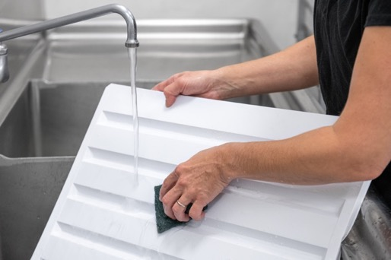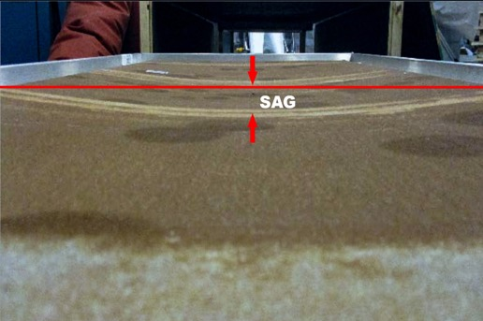
Photo by Ryan Bent Photo: PRI Construction Materials Technologies, LLC
LEFT: A pool-compatible ceiling should be impervious to water and resistant to staining by pool chemicals, such as this thermoformed panel, which is stain-resistant and fully washable.
RIGHT: Common types of mineral fiber ceiling panels sag in humid environments such as natatoriums and spas. Tests such as ASTM C367 – Strength Properties of Prefabricated Architectural Acoustical Tile or Lay-in Ceiling Panels should be used to compare the performance of various products.
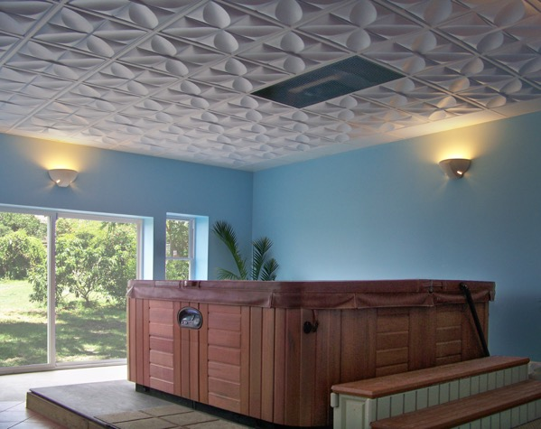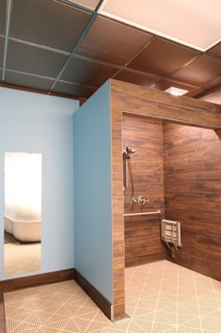
Photos courtesy of Ceilume
LEFT: The right ceiling contributes to the overall ambience of a hot tub experience.
RIGHT: Areas adjacent to a pool or spa, such as this shower room, may also require durable and moisture-resistant ceilings.
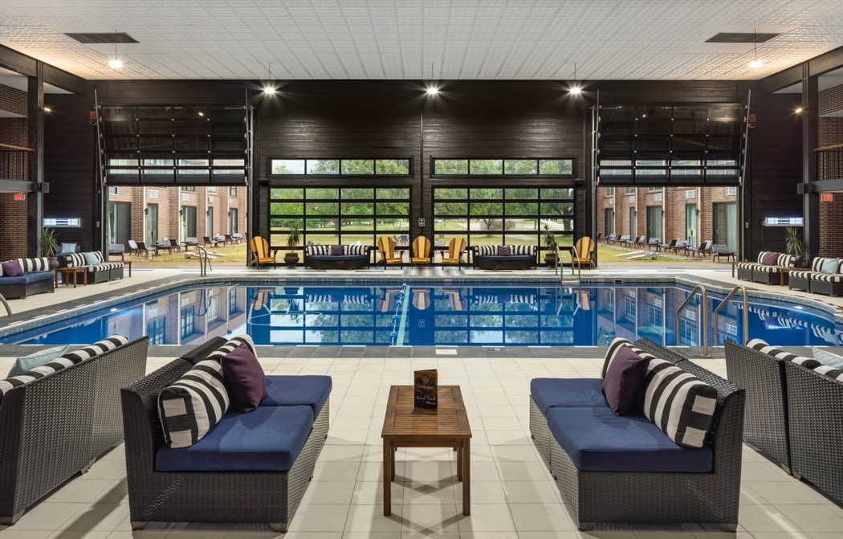
Alternative View of Highlander Hotel.
###

