FOR IMMEDATE RELEASE
Recycling the Ceilings comes Naturally for a Lending Library
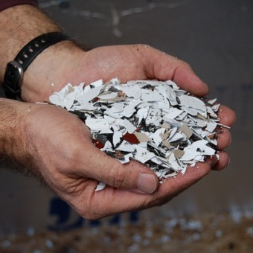 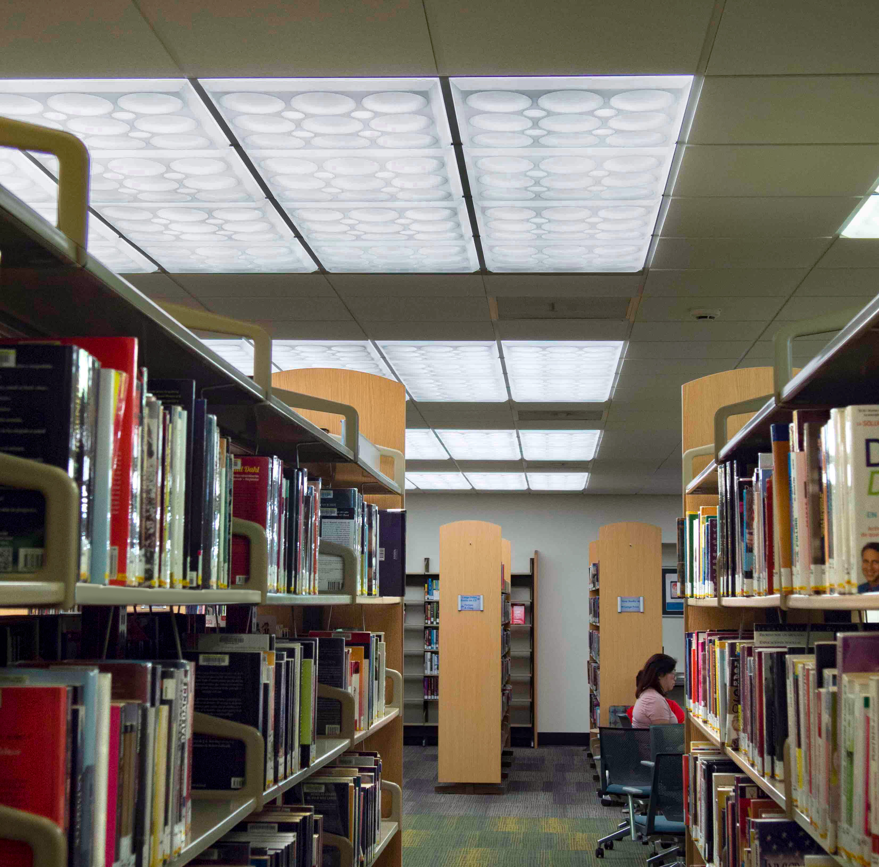 LEFT: Ceilume’s new closed-loop system recycles scrap it takes back from customers like the Anaheim Public Library.
RIGHT: The remodeled Anaheim Public Library branches use translucent ceiling panels from Ceilume as part of a new, energy-efficient lighting upgrade.
GRATON, CA, 2022 March 11 – The Anaheim, CA Public Library has an intrinsic understanding of recycling; its books go out into the world and are then returned so other can use them. It was only natural, then, to apply the same principle to building materials removed from two of its branch libraries during recent remodeling.
The library returned approximately 5000 sq. ft. of old thermoformed ceiling to its manufacturer, Ceilume, so the vinyl panels could be recycled into new ceilings. Ed Davis, president of Ceilume, quips, “We send our panels out into the world, but we like it when them come home for a visit. Then, after a short but transformational stay, we send them on their way again to grace the ceilings other buildings. I guess you can say, we are like proud parents.”
Since beginning its closed-loop recycling program three years ago, the amount of vinyl Ceilume has recycled has increased to over 200 tons a year. This reduces the firm’s use of petrochemicals, keeps materials out of landfills, and improves the sustainability of the products. When China banned importation of recyclable plastic in 2018, Davis says, Ceilume “realized we had to take direct responsibility for our scrap.” After an investment in research and development, the company found innovative methods for reprocessing its own thermoplastic scrap into a material that meets the firm’s quality assurance standards for new ceiling panels.
Davis explains, “Our ceiling panels are made with a very high-grade rigid vinyl that is free from deleterious additives. When we used to send our scrap to commercial recyclers, it would be mixed with materials from other sources that diminished the properties of the plastic. By using our own scrap, we are now upcycling the material from what it would have been in the general waste stream.”
He reflects that, “some environmentalists are concerned about vinyl, and they have good reason to be; much of the plastic being used becomes junk that contributes to the global problem of single-use plastic waste. With our process, however, we can recycle the vinyl repeatedly without loss of quality.” He adds that this benefit is in addition to the renowned durability and service life of Ceilume’s ceiling and wall panels.
Because Ceilume manufactures panels from white, black, and other colors of vinyl, their recycled scrap gets intermingled and produces a gray panel color that can vary slightly from batch to batch. Still, many designers like the product’s appearance and recognize that variation also occurs in architectural materials such as wood and stone. Ceilume also applies laminates to the recycled material to create faux metal and woodgrain panels with 98% recycled content. Their panels and tiles have three-dimensional relief and are offered in more than 40 patterns to suit almost every architectural style.
Demand for the recycled products has outpaced the supply of available scrap, so the company is expanding its take-back program to recycle scrap returned by customers. Davis says that there is, “little scrap generated by installing Ceilume’s products. While ordinary acoustic ceiling panels, made from mineral fiber, are prone to damage and have short service life, Ceilume’s panels are easy to install, flexible, strong, and impervious to water, so they last a long time. What little thermoplastic scrap is created can usually be given to municipal recycling programs.” Larger quantities, however, can now be returned directly to Ceilume for recycling. The panels are as thin as 0.013” thick, lightweight, and nest compactly for economical shipping.
“Ceilume is a family-owned business, so we have a personal stake in protecting the environment for the next generation,” Davis avers. “We started the company over 50 years ago with a commitment to being good stewards of our resources.” The company’s recycling program continues to expand as it finds new uses for the reclaimed material.
As for the Anaheim Library, its remodeled branches have new Ceilume ceilings as part of a luminous ceiling that provides better quality illumination. The suspended ceiling panels are installed under new LED light fixtures that make the library more energy efficient. The new panels are washable and should remain looking great for years to come. But when their due date arrives, they can be checked-in back at the Ceilume factory and returned to circulation.
- - -
About Ceilume: Ceilume is the leading manufacturer of thermoformed ceiling and wall tiles and panels. The company’s roots go back to when “Mid-Century was Modern” and the pioneers of modular ceilings. The family-owned business is located in California’s wine country and occupies a historic apple-packing warehouse. With an eye on the future, Ceilume’s research and development continues to improve interior finish systems to meet changing environmental, performance, and aesthetic needs. For more information about the company, see www.ceilume.com/pro. For more information on the company’s sustainability, see www.ceilume.com/pro/environmental.cfm.

Photos: www.ceilume.com/pro/press/, Courtesy of Ceilume.
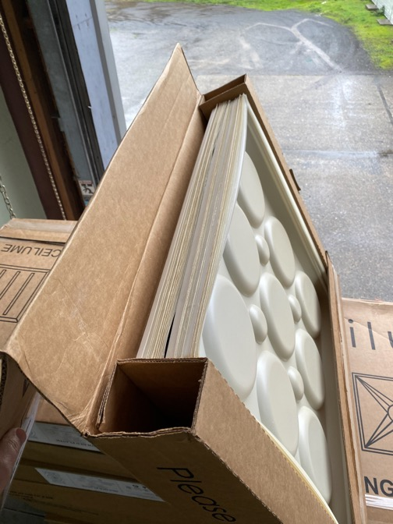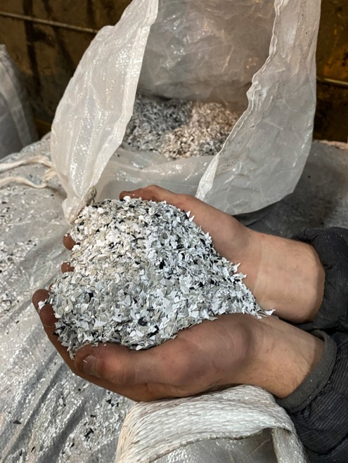
LEFT: Used ceiling panels from the Anaheim Public Library were returned to Ceilume, their original manufacturer.
RIGHT: Returned panel plus scrap from Ceilume’s factory operations are ground into chips that can be melted and made into new sheets of high quality vinyl.
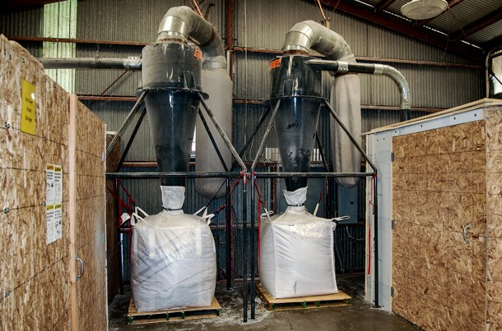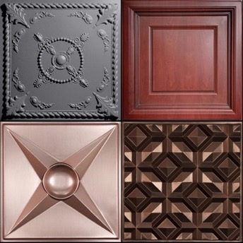
LEFT: The high quality thermoplastic material is collected, melted, and then formed into new products without degradation of the product’s quality or performance.
RIGHT: Ceilume’s recycled material produces a 100% recycled gray colored panel that many designers like. It can also be laminated with a faux finish to create 98% recycled wood-grain and metallic looks.
###

