FOR IMMEDIATE RELEASE

Case Study: Where Fitness is Looking Up, The Ceiling Stands Out

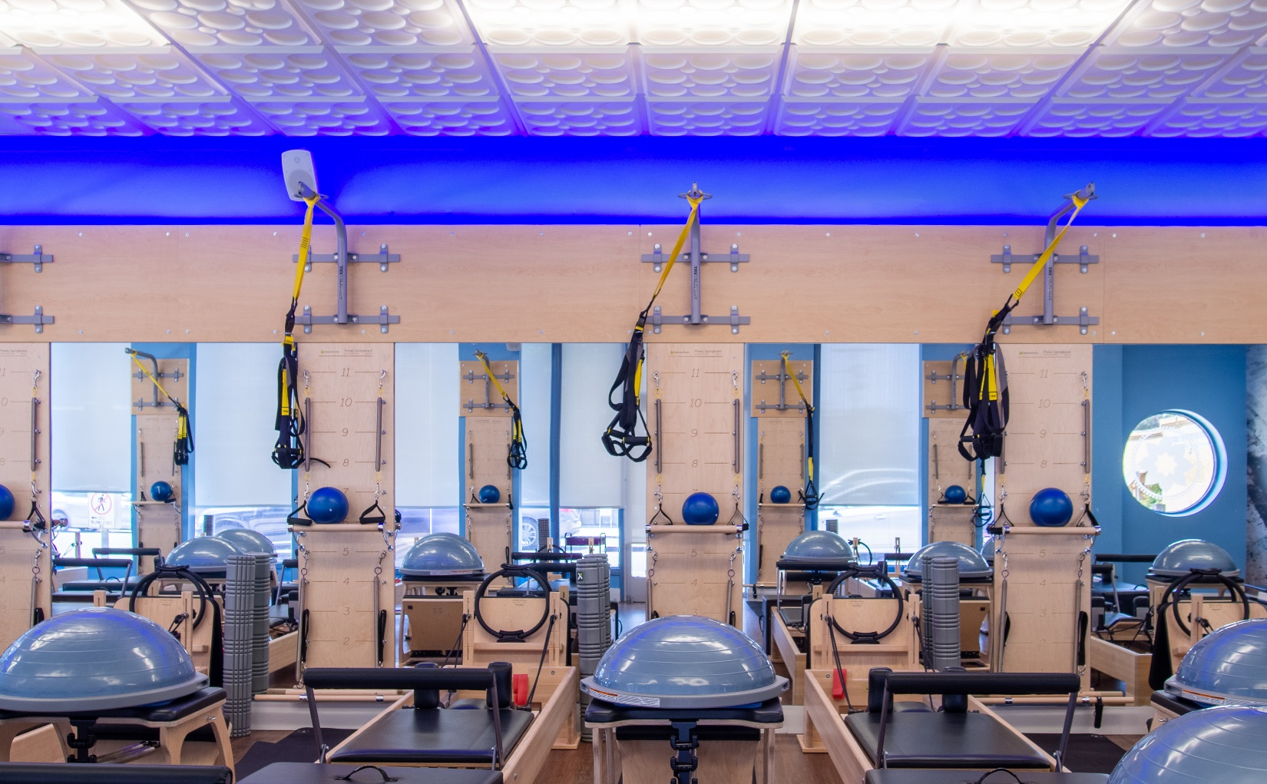
Photo by Ceilume.
A chain of Club Pilates exercise studios in Southern California have created a signature décor built around a
Ceilume decorative thermoformed ceiling with a blue glow lighting up the edge.

GRATON, CA, 2022-June-08 -- The ceiling is often the most visible surface in a room, but even more so in a Pilates workout studio, where many of the exercises are performed while staring upwards.

“With customers lying on their backs when they’re exercising on Pilates equipment,” explains Club Pilates franchisee Katya Stromblad, “I want them to look at something nice. That Roman Circle design is pretty cool.”

She is referring to the white Ceilume thermoformed ceiling panels, made in a decorative pattern called Roman Circle, which she describes as the signature of her burgeoning chain of Club Pilates franchises in Southern California. Three of her five current studios, and a sixth studio under construction, feature the Roman Circle design with a narrow border in another style, Polyline, to frame the central ceiling.
Her first studio, in Culver City, opened in 2017 and set the design style for what was to come. The room is dominated by the exercise equipment made of blond wood with blue and black elements. Matching wood panels on the walls are interspersed with tall mirrors and a full-height photomural. The strip of wall above the wood panels is painted a vibrant blue, crowned by the white, three-dimensional ceiling.

The ceilings were designed by Stromblad’s stepfather, who is not an architect, “just very handy and creative,” says Stromblad. “He measures it all out, because he doesn’t trust the contractor to do it properly. He drew out the whole ceiling for the contractor, mapped out every single panel. He’s the one who found the Ceilume panels online, and who decided which ones to get.”

Lighting for the workout space also has to be compatible with customers lying on their backs looking upwards. In the first studio, light is supplied by 2’ x 4’ LED fixtures placed intermittently in the ceiling grid. Illumination level is kept low in these studios, creating a cool, relaxed atmosphere.

Success led to a second studio, in the Tarzana neighborhood of LA’s San Fernando Valley, opened in 2018. Renovating a former dry-cleaning store, Stromblad recreated the look but made some improvements. Instead of LED fixtures punctuating the decorative ceiling, she found a minimalist modern chandelier that casts all its light upwards for gentle, indirect illumination reflected off the decorative ceiling. The chandeliers effectively side-light the panels, deepening the light and shadow effect in the three-dimensional pattern and improving eye-relief across the expanse overhead. She also improved the blue-stripe effect on the upper wall by installing a color LED strip facing upward on the top edge of the wood wall panel, casting a blue glow on the wall and ceiling perimeter, adding to her signature look.

For unified style, the ceiling pattern is continued throughout the non-workout spaces of the studio - the reception area and the merchandise store - though minus the blue glow.

Her new studio in West Los Angeles, opened in early 2022, features an even more creative solution to lighting. When she was designing the space – a corner storefront on one of West LA’s main commercial thoroughfares – she found out that the chandeliers were no longer being made. “It’s very hard to find hanging lights that won’t shine right into people’s eyes,” Stromblad relates. Instead, she installed rows of translucent ceiling panels amidst the opaque white panels. (Ceilume panels are made in 13 opaque colors and finishes, and three light-transmitting options offering different levels of diffusion: clear, frosted, and translucent.) LED strips above the ceiling send pleasantly diffuse illumination into the room below. Using translucent panels in the same Roman Circles pattern, the new luminous ceiling is easy on the eyes and provides a comfortable level of light in the room.

Her studios, with their unique aesthetic, have been highly successful. She has expanded to five locations and is adding a sixth, currently under construction, that includes the signature decorative ceiling.

About Ceilume
Ceilume is the leading manufacturer of thermoformed ceiling and wall tiles and panels. The company’s roots go back to the pioneers of modular ceilings, when “Mid-Century was Modern.” The family-owned business is located in California’s wine country and occupies a historic apple-packing warehouse. With an eye on the future, Ceilume’s research and development continues to improve interior finish systems to meet changing environmental, performance, and aesthetic needs. For more information, see ceilume.com/pro.

Media Contact
Steve Miller, pr@ceilume.com, 1-818-399-6596

High Resolution Images
ceilume.com/pro/press.cfm

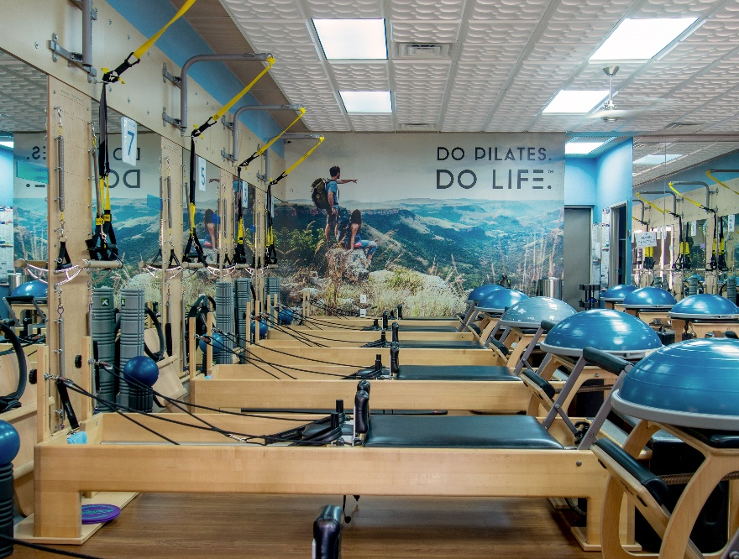
Photo by Ceilume.
The first studio in the chain, in a Culver City shopping center, set the basic style for all the others, with wood wall panels to match the exercise equipment, a blue accent on the upper wall, and a three-dimensional ceiling that gives the customers something pleasant to look at while working out on their backs.

…more
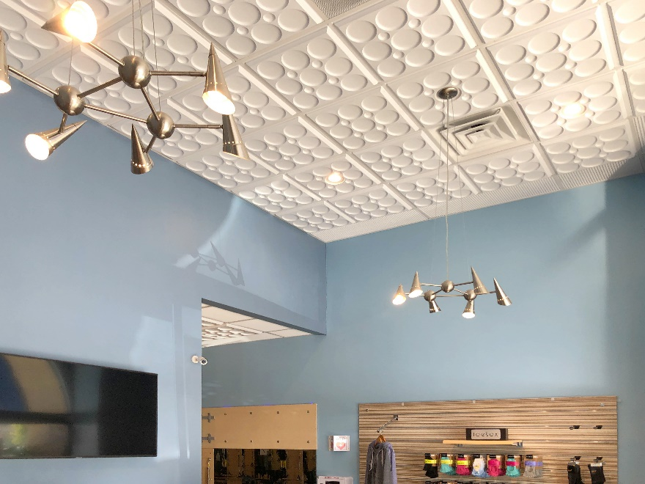
Photo by Ceilume.
At the second location in Tarzana, the decorative ceiling extends throughout the studio, including the merchandise room, which is lit by contemporary-style direct illumination chandeliers.

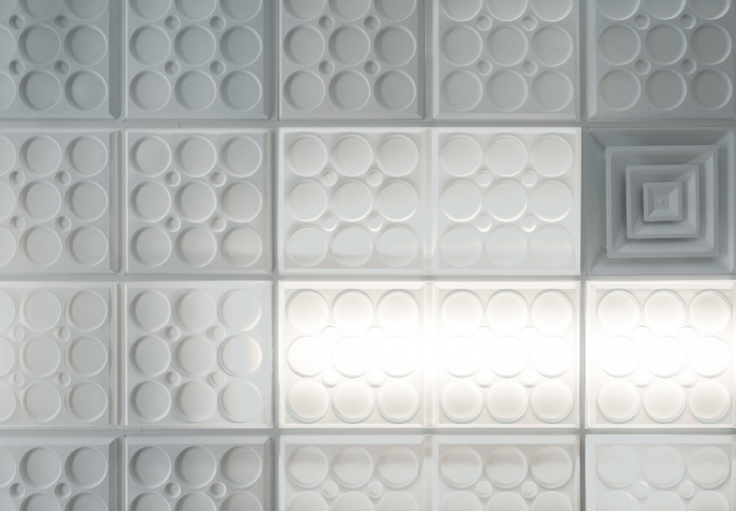
Photo by Ceilume.
Exercisers facing upwards have a more attractive, intriguing view than a flat ceiling could provide. LED strips above translucent ceiling panels provide moderate, easy-on-the-eyes lighting, and brighten the neighboring opaque white panels.

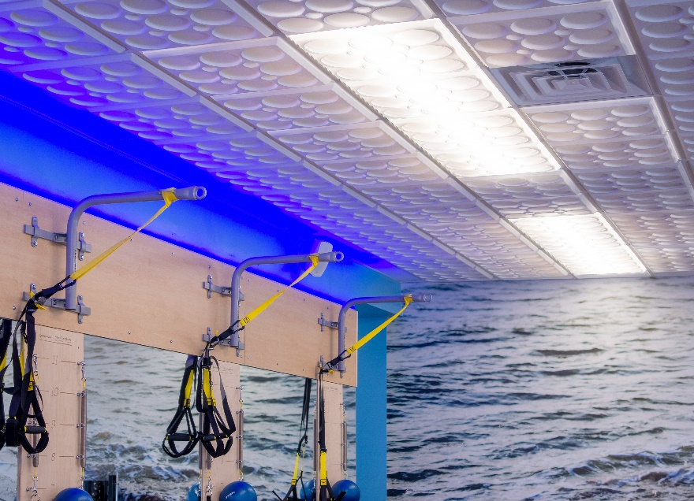
Photo by Ceilume.
Color LED strips fitted atop the wood wall panels create a deep blue glow around the upper edge of the room, part of the signature look of this Club Pilates chain.

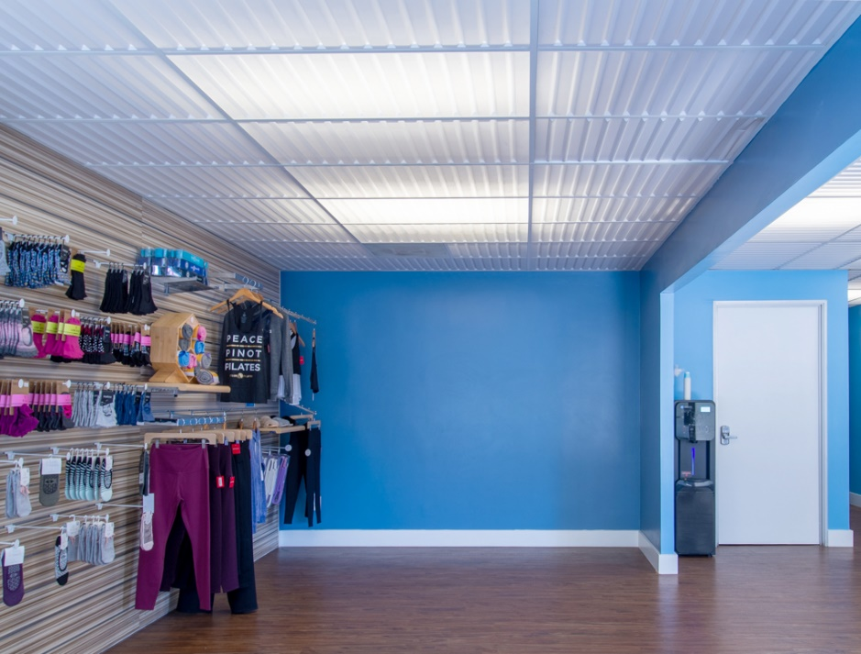
Photo by Ceilume.
Non-exercise areas of the West LA studio, such as this merchandise room, feature luminous ceilings in another contemporary decorative style, Ceilume’s Southland pattern.

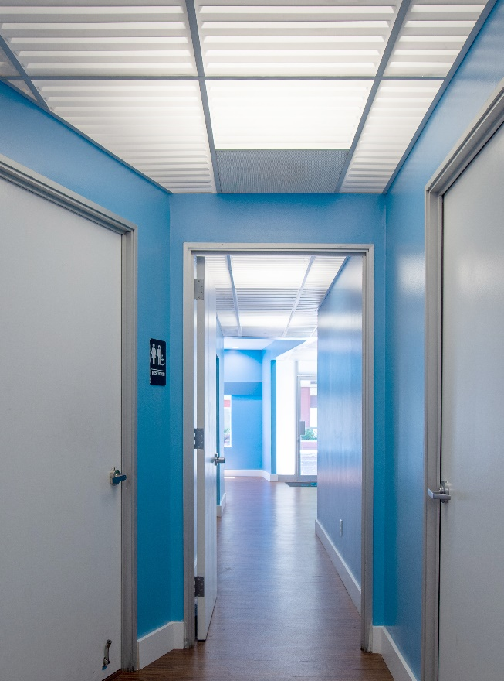
Photo by Ceilume.
The white and blue décor with luminous ceilings extends throughout the West LA studio for a unified look.

###

