FOR IMMEDIATE RELEASE

Product News
New Colors of EZ-ON Grid Covers Renew Ceilings with Style

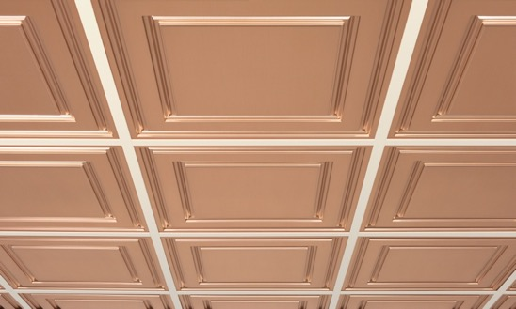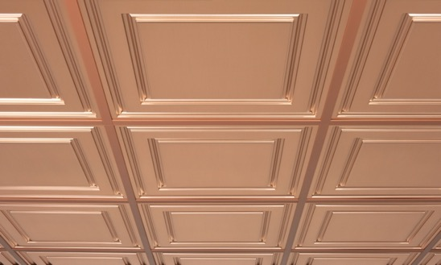
All photos by Ceilume
Before and After: (left) Ceilume’s Copper metallic finish Oxford ceiling panels laid into a common white grid.
(right) With Jasper-colored EZ-On Grid Covers, the ceiling is more unified and harmonious.

[300-word version]
EZ-On Drop Ceiling Grid Covers are now available in six colors, offering more options for renewing the appearance of suspended ceiling T-bar grids quickly and cost effectively. The new colors, Mist, Oat, Jasper, Garnet, and Onyx, join the popular White to provide tonal choices that will complement a wider range of ceiling colors and faux finishes than ever before. While grids are largely manufactured only in white or black, EZ-On Grid Covers open up a new dimension for designers to add style to a ceiling and give it a distinctive look.

Made by the manufacturer of Ceilume ceiling panels, EZ-On Grid Covers are snap-on vinyl strips that reface existing grids with a clean, new surface, rejuvenating the appearance of the ceiling system. They completely cover stained, yellowed, or damaged grids to make them look better-than-new, and present a surface that is durable and easy to maintain.

EZ-On Grid Covers can update a tired ceiling at a fraction of the time and cost it would take to paint or replace the grid. The system has only two components – one to cover grid members, the other for perimeter angles – and installs rapidly on virtually all grids with 15/16 in. (1 in. nominal) flanges. The six colors feature a satin surface that blends well with a variety of ceiling panels, whether they are rejuvenating a white or black grid, or changing the grid to enhance the color scheme of the ceiling.

Installation uses no adhesives, and no tools, special training, or pre-cleaning are required. The vinyl strips slide over the T-bar and snap into place easily. They can be installed without removing ceiling panels, and a 400-square foot room could be done by one person in about an hour.

Made from 100% recyclable rigid vinyl, EZ-On Drop Ceiling Grid Covers require no maintenance, and are easy to clean with soap and water. Impervious to moisture, they resist mold growth and are non-yellowing.

All six colors of EZ-On are available direct from the manufacturer at www.ceilume.com/ez-on.
- - -

[150-Word Version]
EZ-On Drop Ceiling Grid Covers are now available in six colors, offering more options for renewing suspended ceiling T-bar grids quickly and cost effectively. The new colors, Mist, Oat, Jasper, Garnet, and Onyx, join the popular White to provide tonal choices that will complement a wider range of ceiling colors and faux finishes than ever before. While grids are largely manufactured only in white or black, EZ-On Grid Covers open up a new dimension for designers to add style to a ceiling and give it a distinctive look.

Made by the manufacturer of Ceilume ceiling panels, EZ-On Grid Covers are snap-on vinyl strips that completely cover stained, yellowed, or damaged grids and reface them with a clean, new satin surface that is durable and easy to maintain. They can update a tired ceiling at a faction of the time and cost it would take to paint or replace the grids.

All six colors of EZ-On are available direct from the manufacturer at www.ceilume.com/ez-on.
- - -

[100-Word Version]
Ceilume EZ-On Drop Ceiling Grid Covers are now available in six colors, offering more options for renewing suspended ceiling T-bar grids quickly and cost effectively. EZ-On Grid Covers are snap-on vinyl strips that cover stained, yellowed, or damaged grids with a clean, new durable satin surface that can update a tired ceiling at a faction of the cost of painting or replacing the grids. The new colors, Mist, Oat, Jasper, Garnet, and Onyx, join the popular White to provide tonal choices that will complement a wider range of ceiling colors than ever before. EZ-On are available at www.ceilume.com/ez-on.
- - -

About Ceilume
Ceilume is the leading manufacturer of thermoformed ceiling and wall tiles and panels. The company’s roots go back to the pioneers of modular ceilings, when “Mid-Century was Modern.” The family-owned business is located in California’s wine country and occupies a historic apple-packing warehouse. With an eye on the future, Ceilume’s research and development continues to improve interior finish systems to meet changing environmental, performance, and aesthetic needs. For more information, see ceilume.com/pro.

Media Contact
Steve Miller, pr@ceilume.com, 1-818-399-6596

High Resolution Images: ceilume.com/pro/press.cfm

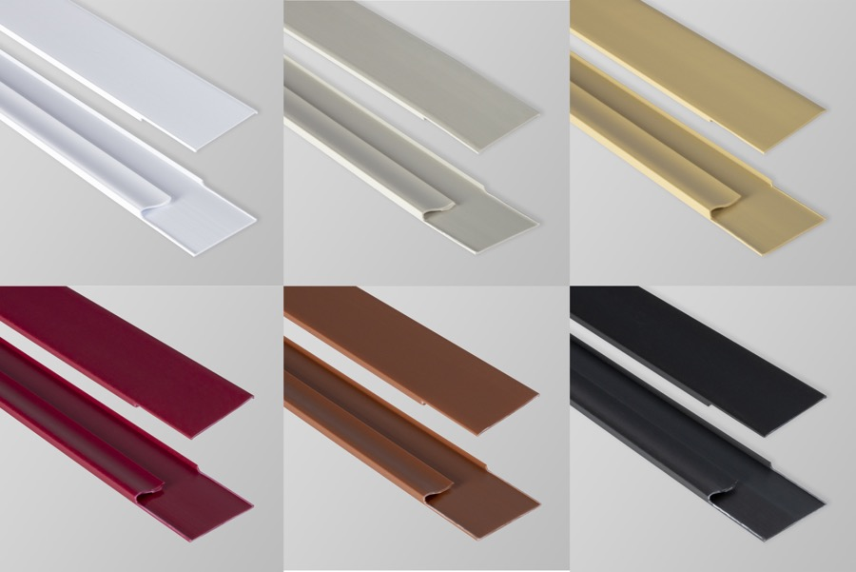
EZ-On snap-on grid covers are now available in six colors:
(Top, left to right) White, Mist, Oat (Bottom left to right) Garnet, Jasper, Onyx

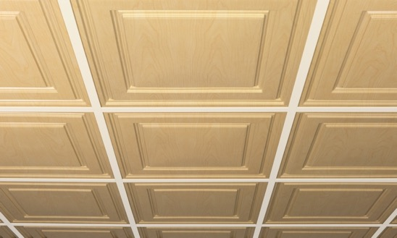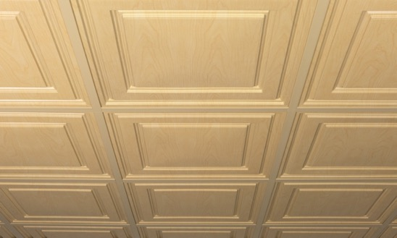
White T-bar stands out against Sandal Wood panels and draws attention to the grid. With EZ-On Oat-colored grid covers, the faux wood effect is more credible and the appearance more pleasing and natural.

###

