FOR IMMEDIATE RELEASE

A New Ceiling Brings Old World Charm
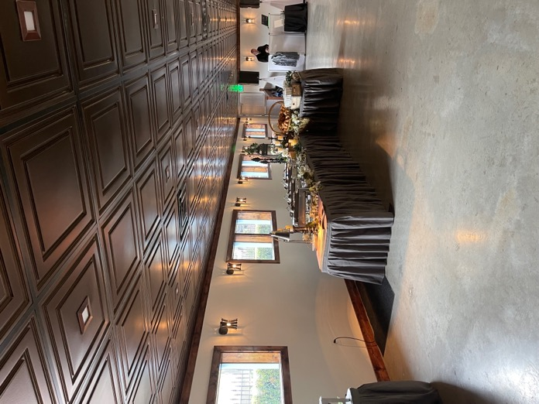
All photos by Richard Gay, courtesy of the Helendorf River Inn
The makeover of the Conference Center/Banquet Hall in the Helendorf River Inn includes a stylish dropped ceiling of Bronze-finish thermoformed ceiling tiles from Ceilume.

GRATON, CA, 2022-June-08 – The best renovations go beyond restoration or renewal, and try to achieve enhancement. That’s what Richard Gay had in mind for the Helendorf River Inn, a half-century old property in a little faux-Bavarian village nestled in the forests of Northern Georgia. In addition to updating the guest rooms, Gay wanted to improve the Conference Center/Banquet Hall so that it finally, fully embraces the alpine architecture that the town is famous for. He paid particular attention to the ceilings, and came up with two evocative solutions, one made of drywall, the other of lightweight thermoformed ceiling tiles.

Helen, GA is a town with a population of about 500, except on summer weekends, when it swells to 10,000. In the 50 years since it was re-conceived as a Bavarian village, it has become a highly successful tourist destination. Entrepreneur Pete Hodgkinson proposed the original transformation as a way to revitalize a dying mill town, and the concept was realized largely by adding Bavarian architectural gingerbread to the existing town. Hodgkinson also started the annual Helen-to-the-Atlantic Balloon Race, and spear-headed the building of the Helendorf River Inn. (The Chattahoochee River cuts through the middle of town, and the Inn is a scenic property right next to it.) Hodgkinson enlisted the participation of 30 investors who each owned one room of the hotel, although all of rooms were rented to guests. It was an instant success, with demand so great that they were booking rooms before they had furniture, and initial guests slept on mattresses on the floor.

50 years later, those original investors have dwindled to 23, and a younger generation has taken over. Richard Gay is the son of the longtime hotel manager, Dick Gay, and has assumed responsibility for the hotel’s marketing and IT needs, in support of his sister, the General Manager of the hotel. Richard has also headed up all renovation work.

In the 80’s, the original hotel was expanded to 99 rooms, both through acquisition and by new construction of the River Building, so-called because it is perched right on the edge of the river. The area underneath the new guest rooms was supposed to be a wash-through in the event of a 100-year flood, but in the 90’s, they got permission to enclose it and create a Conference Center/Banquet Hall.

The original Conference Center was a rather nondescript space, with medium-brown wood walls, a bare concrete floor, and a dropped ceiling of flat white acoustic panels with bulbous surface-mounted fluorescent lights. The only hint of style was the series of arched clerestory windows above each of the operable windows.

Gay undertook renovations to bring the hotel up to date. In addition to re-doing the guest rooms, he knew he had to make the Conference Center more saleable as a banquet facility. It needed to be grander, more distinctive, more of an inviting event space. Gay wanted to transform it into something with a sense of Old World tradition and style, reminiscent of a vintage Bavarian beer hall. Spring-boarding off the arched windows, he envisioned a series of pseudo-structural arches and domed ceilings.

The dropped ceiling was entirely removed from the larger area to make way for the vaulted ceiling. There was a line of three massive wood columns supporting the guest rooms above, which divided the banquet hall into two areas. Gay added three additional (non-structural) columns, and mirrored them across the room with faux-pilasters in the opposite wall. The arches spring between the columns and pilasters. The vaulted ceiling was fabricated by wetting and bending drywall into the shallow dome shape needed. To provide illumination, he hung black iron chandeliers down the main section of the hall.

The area on the far side of the columns had to keep its dropped ceiling, because it concealed plumbing for the guest rooms above. Gay knew he needed something to match the grandeur of the arches and vaults. “We went through the design process with an architect,” Gay recalls, “and they came up with these really fancy tin tiles, really expensive. They didn’t really fit our style.”
Gay found the solution in Ceilume thermoformed panels in the Oxford style, a pattern of concentric squares that almost looks like a coffered ceiling and perfectly evoked the old-world formality and richness he was looking for. He chose a metallic Bronze finish (one of 13 available colors and finishes) and installed black suspension grid to complement the Bronze panels. The black grid also echoes the black-iron chandeliers installed in the main section. The chandeliers could not be used in the side section because of the lower ceiling height, so Gay installed LED down-lights penetrating the thermoformed panels to light up that area.

One of the attractive aspects of the thermoformed panels is that they are impervious to water. In case of leaks from the guest rooms upstairs, the thermoformed panels could simply be washed off, and would not be stained or damaged like common mineral fiber tiles.

The wood walls were altered, with carved and distressed dark wood wainscotting only for the lowest 3 feet of the wall, and flat whitewashed wall on the upper portion. The walls immediately surrounding the windows are clad with thin brick. The concrete floor has been polished to a light sheen.

The result was a very saleable banquet hall. Events were booked before the room was completely finished, and it remained booked for every weekend in August of its first year. “People who knew the location previously,” comments Gay, “are loving it.”

About Ceilume
Ceilume is the leading manufacturer of thermoformed ceiling and wall tiles and panels. The company’s roots go back to the pioneers of modular ceilings, when “Mid-Century was Modern.” The family-owned business is located in California’s wine country and occupies a historic apple-packing warehouse. With an eye on the future, Ceilume’s research and development continues to improve interior finish systems to meet changing environmental, performance, and aesthetic needs. For more information, see ceilume.com/pro.

Media Contact
Steve Miller, pr@ceilume.com, 1-818-399-6596

High Resolution Images
ceilume.com/pro/press.cfm

Photo by CREDIT
CAPTION HERE

…more

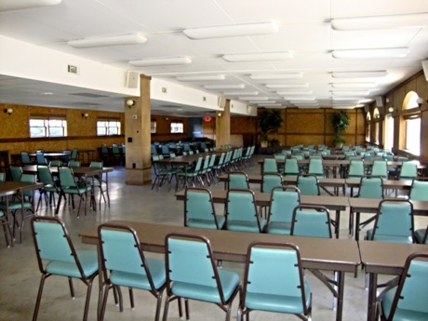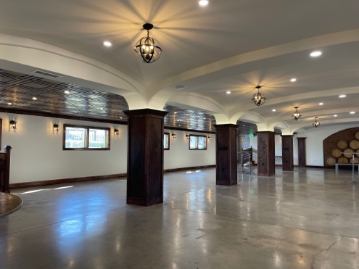
LEFT: The old Conference Center undistinctive and uninviting. RIGHT: Reimagined in the style of a vintage Bavarian beerhall, it is an architectural pleasure with arches, ceiling vaults, and a coffer-like decorative dropped ceiling.
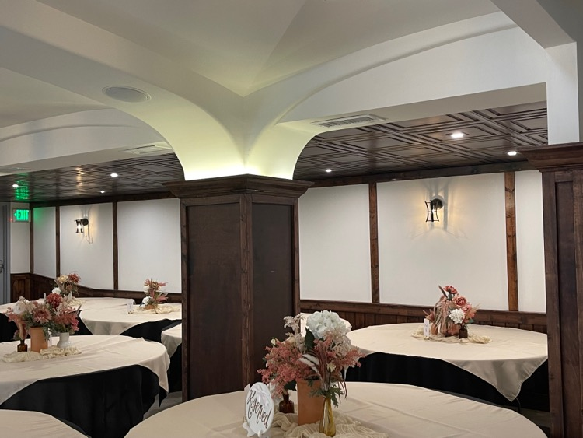
The ceiling of the side section conceals the plumbing of the guest rooms above, so it was not compatible with a vaulted ceiling. Instead, Bronze-finish Ceilume decorative drop-in tiles were used to create a bit of Old World formality.
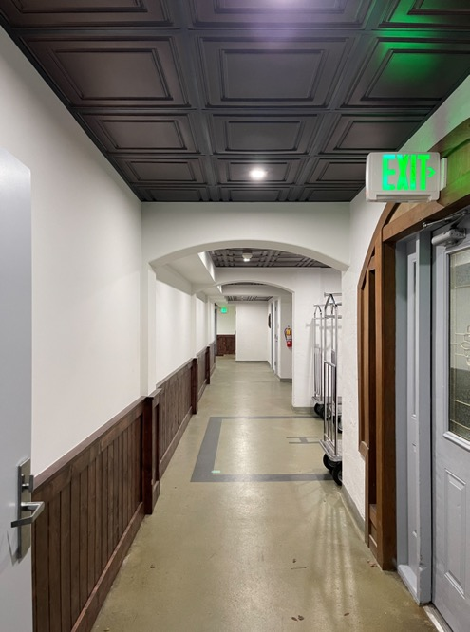
The decorative theme was extended into the access corridor, to complete the guest experience.

###

