FOR IMMEDIATE RELEASE

Case Study: The Hot, Humid and Mindful Ceiling

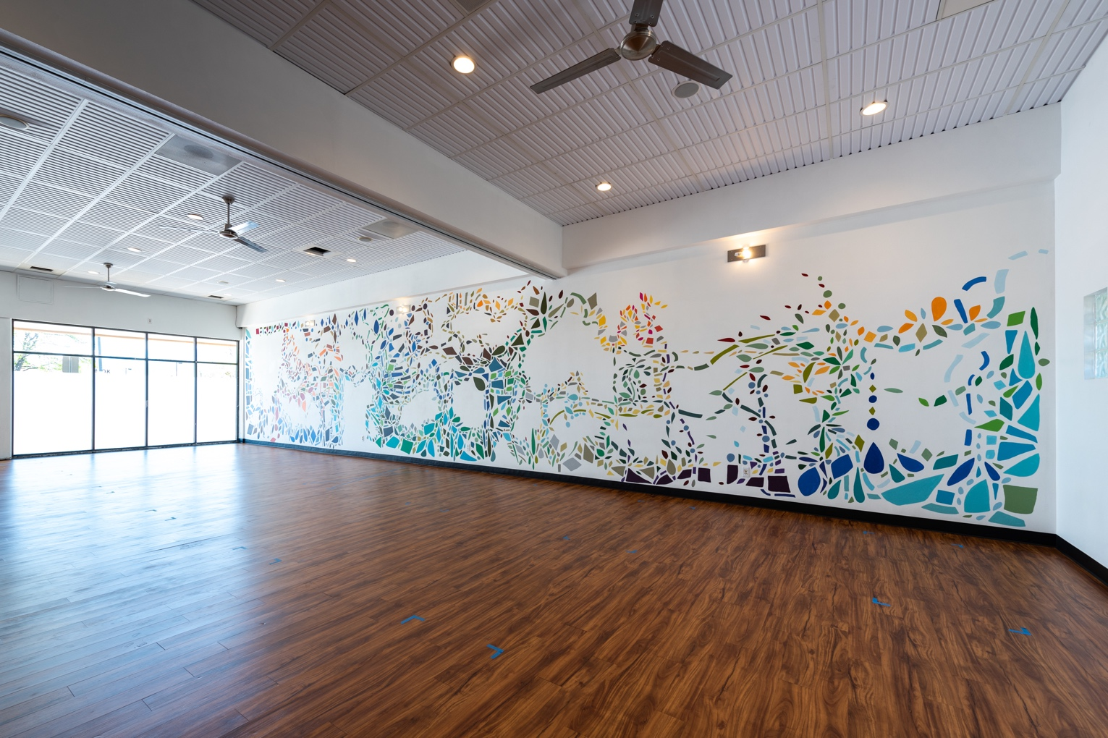
All photos by Ryan Lawrence, courtesy of Radiance Power Yoga
The Radiance Power Yoga studio utilizes a thermoformed ceiling that can handle humidity and high heat, and looks good when exercising on your back.

GRATON, CA, 2023-Feb-07 -- For an in-person service business such as a fitness studio, customer experience is everything, making the elusive element of atmosphere an important part of design. Atmosphere in the other sense is a significant design factor if the business requires humidity, high heat and good indoor air quality. In a studio that teaches hot yoga, where half the class is spent staring upwards, the ceiling has to perform in both senses. Designer and yoga teacher Jessica Finver found the perfect solution in a thermoformed drop-in ceiling from Ceilume.

Educated in architecture and trying to find her niche in a variety of design jobs, Jessica Finver became increasingly involved with yoga practice, and started teaching in 2012. After eight years, she decided to open her own studio, and in the summer of 2020, she bought a failing yoga business near her home in Boulder, CO.

The previous owners “had a very different aesthetic than I did,” recalls Finver. “I didn’t like any of the design they had. I re-did the marketing, website, and logo, but the inside of the studio still looked like them: it was yellow and orange, the colors that they loved. There was some bright gold foil on the walls. But they were not my colors. The first thing I did was paint everything white.”

In fact, she changed almost every aspect of the design except the wood plank floor of the big yoga room. Buying in at the beginning of the pandemic shutdown, and Finver figured she had two months to remake the studio before students would be allowed back inside. She invited a friend from nearby Denver, abstract artist Ellen Moershel, to paint a full-wall mural inside the yoga room. Her husband, a sustainability engineer with extensive woodworking experience, re-did the reception area and refinished much of the cabinetry in the locker-rooms. An HVAC contractor whom she’s known for decades completely redesigned the HVAC system to enable the studio to be heated to 93ºF quickly and efficiently, and boost the humidity to make the dry Colorado climate more exercise-friendly.

Her contractor pointed out that the existing mineral fiber acoustic ceiling tiles throughout the studio were a bad choice. “It’s really silly to have ceiling tiles that absorb water in your space.” When mineral fiber tiles contact moisture, they can become hosts for colonies of mold and bacteria, often identified as “water stains.” That was the last thing Finver wanted in a health-oriented environment.

Finver spent weeks searching for an alternative. She eventually saw Ceilume thermoformed tiles on Pinterest. “Then I saw a space that had them, and I liked them. Then I started seeing them everywhere. A couple of different businesses that I was in had them. They worked, and they looked good.” With water-impervious Ceilume tiles, she could use them throughout the studio including the locker rooms, even inside the shower stalls.

He contractor was “really excited about them” because of their compatibility with heat and humidity, Finver recounts. “My biggest attraction was the way they look. I like white, and I like clean, and I like that they add an element of texture to the space, so it wasn’t just white. She selected a style, “Southland” that complements an industrial look. “We do a mix of clean, modern and industrial.”

Finver’s husband installed all the tiles. Installation required significant cutting because of the many loudspeakers and recessed light fixtures. “There was one tile that had two speakers and a light,” she laughs. She called Ceilume for installation advice. They suggested getting a pair of snips, which proved to do the job easily, sometimes supplemented by a utility knife. He did the entire installation by himself in about two days.

The design had its intended effect for the business. “People love the space. They especially love the studio space, which is what’s most important to us, too. We’ve gotten a lot of comments about how clean and simple the white is, how it makes them feel calm and at ease. We have gotten a lot of comments about the ceiling, because you spend a lot of time looking at the ceiling. We do half the class lying on your back, and setting your gaze at one point is part of the process, so looking at the tile is a large part of the class. Aesthetics do make a difference for people."

About Ceilume
Ceilume is the leading manufacturer of thermoformed ceiling and wall tiles and panels. The company’s roots go back to the pioneers of modular ceilings, when “Mid-Century was Modern.” The family-owned business is located in California’s wine country and occupies a historic apple-packing warehouse. With an eye on the future, Ceilume’s research and development continues to improve interior finish systems to meet changing environmental, performance, and aesthetic needs. For more information, see ceilume.com/pro.

Media Contact
Steve Miller, pr@ceilume.com, 1-818-399-6596

High Resolution Images
ceilume.com/pro/press.cfm

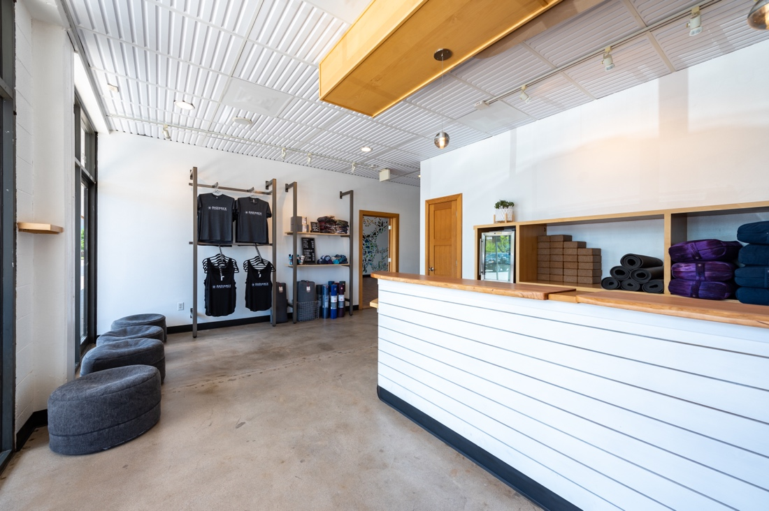
Designer Jessica Finver, the studio’s owner, characterizes the architectural style as a mixture of “clean, modern, and industrial.” Ceilume’s Southland pattern ceiling tiles are used throughout the business to achieve that look.
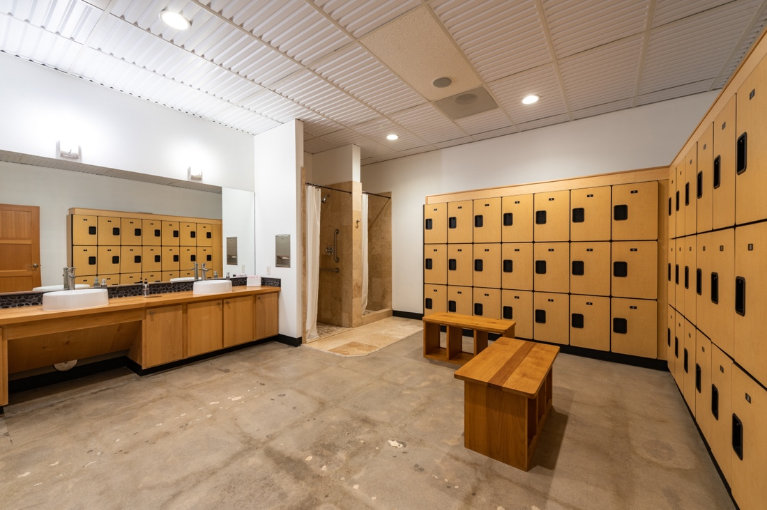
Because the thermoformed tiles are non-absorbent and washable, they could even be used in wet spaces, including shower stalls in the locker rooms.
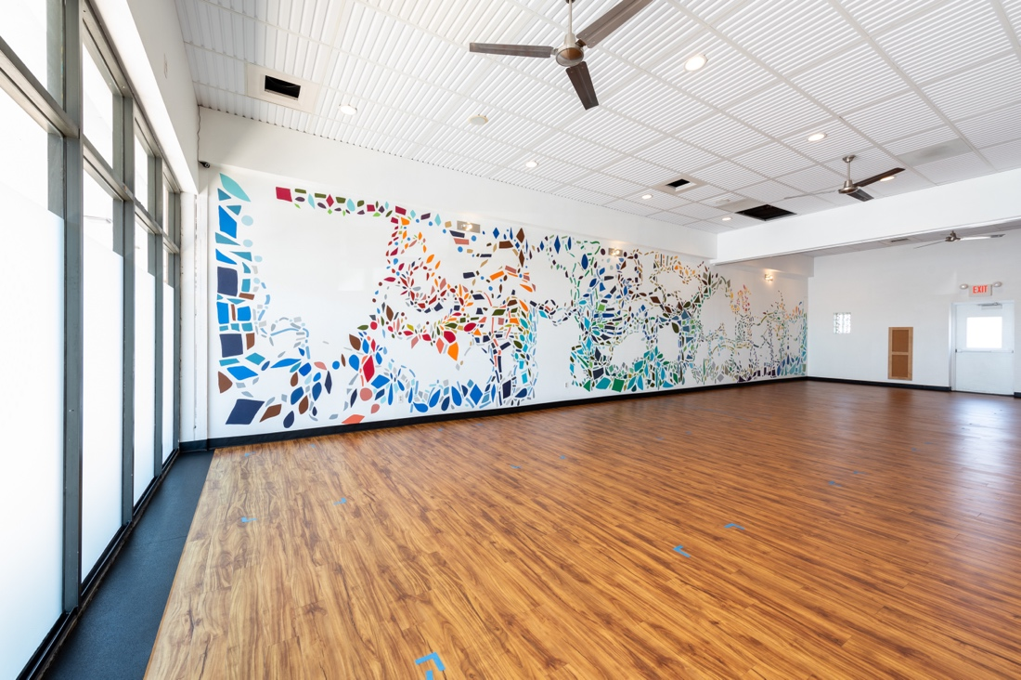
The expansive whiteness of the main studio sets off the warmth of the hardwood floor brilliantly, and makes the mural colors pop, while the ceiling texture provides eye-relief and keeps the surface interesting for exercisers who are gazing upwards.
###

