FOR IMMEDIATE RELEASE

Case Study: The Designer’s Own Ceiling

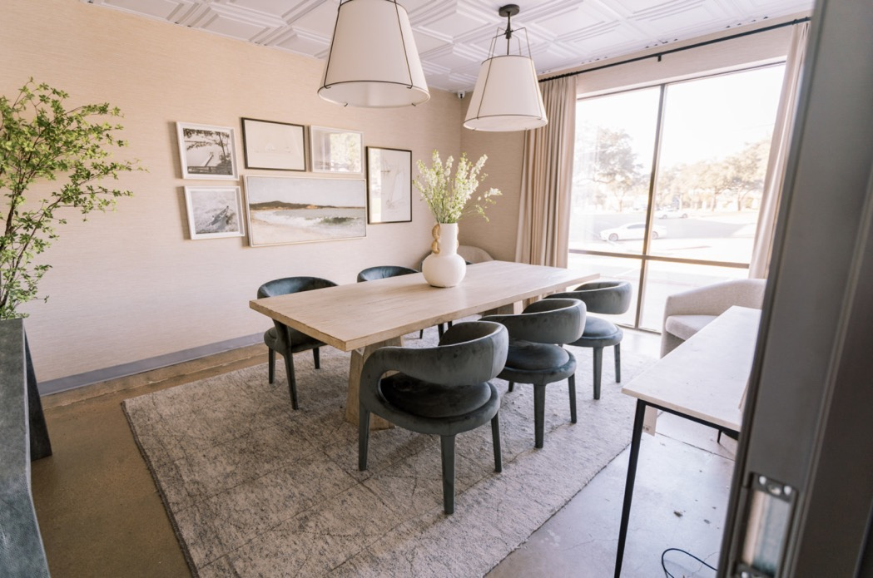
All photos by House Sprucing
The Presentation Room at House Sprucing is decorated in the design firm’s signature Traditional Modern look, including a decorative drop-in ceiling that upgrades the grid to real elegance.

GRATON, CA, 2023 April-20 -- The choices a designer makes for their own facility speak volumes. In the case of House Sprucing, a firm located in North Dallas, TX that does both residential and commercial design, their taste is on full display in their office and retail showroom. (housesprucing.com, instagram.com/house_sprucing) Visitors enter spaces that are finished and furnished with relaxed elegance, making you forget you’re in a 40-year-old commercial building. To complete the effect, they upgraded the suspended ceiling to a richer decorative look using thermoformed tiles from Ceilume.

The Presentation Room, where Heather Fujikawa and Tyson Fujikawa present designs to their clients, is a conference room with a decidedly welcoming, residential feel. It’s the look they specialize in, Modern Traditional. The style of the conference table is somewhere between contemporary office desk and dining table. The chairs around it are comfortable and modern, supplemented by easy chairs in the corners. Grass-cloth wall covering and a knobby area rug (rather than carpeting) on the floor make a visitor feel at home. The dropped ceiling is made of decorative, three-dimensional tiles in an elegant pattern reminiscent of a classic coffered ceiling.

When they took over the space, it had a typical suspended grid ceiling of old, discolored mineral fiber tiles. The grids were yellowed as well. “We wanted to create a nicer experience,” explains Tyson Fujikawa. They chose Ceilume’s lightweight thermoformed Stratford tiles, a shallow relief pattern of coffer-like squares, in pure white. “Ceilume was a great product to elevate the space and make it more modern,” Fujikawa adds.

Made in the USA from high quality rigid vinyl, Ceilume tiles are durable, long-lasting, and eye-catching. They are impermeable to water and (unlike mineral fiber), they do not stain or discolor from exposure to moisture. The Stratford style is one of over 40 patterns that complement a wide variety of looks, both traditional and contemporary. They are made in 13 colors and finishes, as well as 3 levels of translucent material for creating luminous ceilings. Ceilume tiles fit standard 2’x’2’ and 2’x4’ ceiling grids. Many styles can also be direct-adhered to ceilings (and walls) in spaces such as residences that typically do not have dropped ceilings.

To refresh the yellowed grid, House Sprucing installed Ceilume’s EZ-On Drop Ceiling Grid Covers. These satin-finish vinyl covers snap over the grid in moments, completely concealing the old yellowed enamel and providing a fresh look to complement the new tiles.

The decorative ceiling is extended into the two restrooms, as well. Because they are water impermeable, Ceilume tiles are a better choice for wet areas like restrooms, locker rooms, or showers. “We wanted to have a more elevated look in a very old space,” says Fujikawa. “We had this beautiful remodel done, beautiful wall tile, new floors, but the old ceiling tile was terrible, badly stained and discolored. If we were to have replaced them with the same type of tile, that would have totally thrown off the design. It would still look not-great, even if it was new. Ceilume was the perfect thing for us.”

Customers like the look, which helps sell the design business. “People love it,” Fujikawa relates. “They come in and say, “This is great.” One customer even picked a similar ceiling for their physical therapy studio. “They saw it in our showroom and wanted it in their new facility. We showed them the Ceilume tile and she was like 100%, because the alternative is so ugly.”

About Ceilume
Ceilume is the leading manufacturer of thermoformed ceiling and wall tiles and panels. The company’s roots go back to the pioneers of modular ceilings, when “Mid-Century was Modern.” The family-owned business is located in California’s wine country and occupies a historic apple-packing warehouse. With an eye on the future, Ceilume’s research and development continues to improve interior finish systems to meet changing environmental, performance, and aesthetic needs. For more information, see ceilume.com/pro.

Media Contact
Steve Miller, pr@ceilume.com, +1 818.399.6596
…more
High Resolution Images
ceilume.com/pro/press.cfm

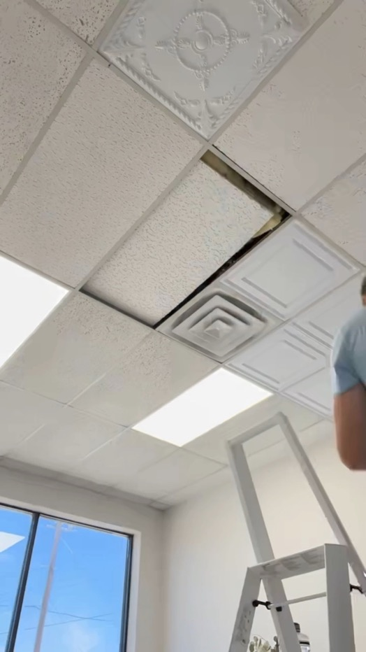
The existing ceiling in the space was made of discolored and mismatched mineral fiber tile. The grids were also yellowed. New Ceilume tiles were simply slipped into place beneath the existing tile.

…more
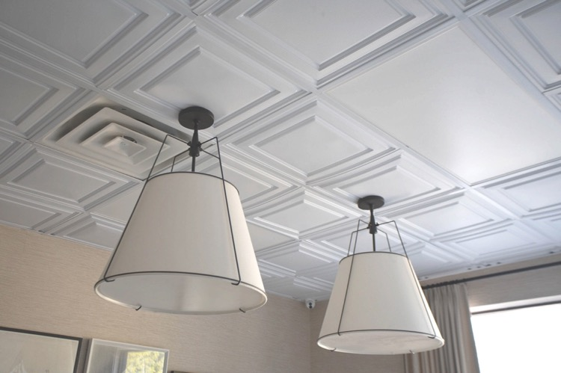
Yellowed T-bar grids were re-faced with Ceilume’s EZ-On Drop Ceiling Grid Covers that quickly snap onto existing grids.

…more
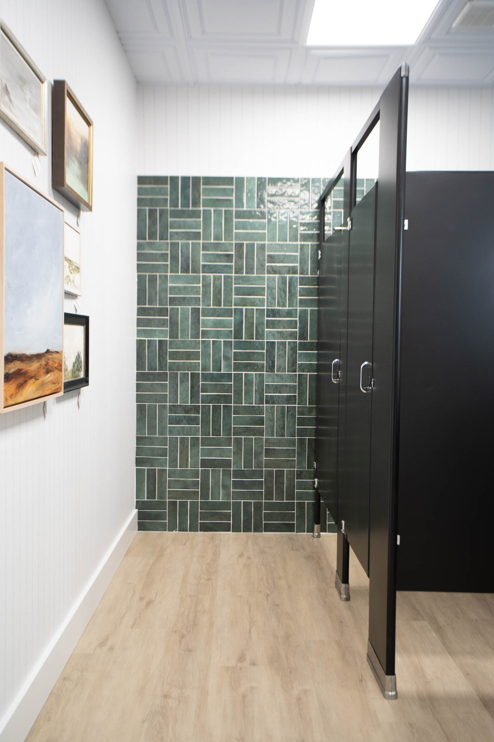
The decorative ceiling extends into the restrooms, as well. Thermoformed tiles are a good choice for wet areas like rest-rooms, locker rooms or showers because they are impermeable to water, and do not sag, stain, or support mold growth when wet.
###

