FOR IMMEDIATE RELEASE

Case Study: An Inspiring Office Ceiling

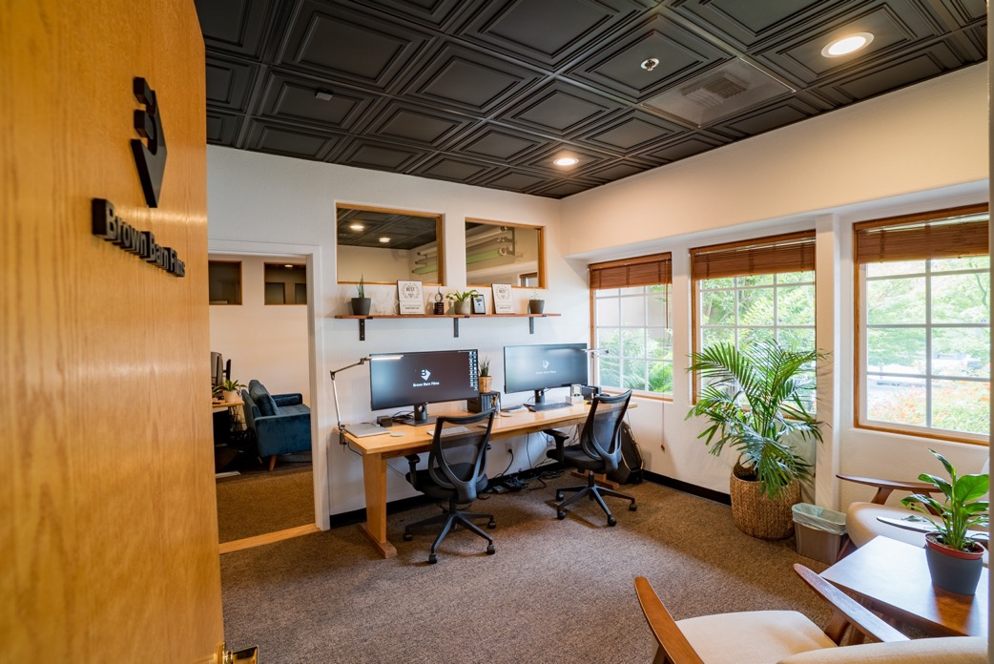
All photos courtesy of Brown Barn Films
Brown Barn Films transformed a law office into an inspiring interior with nothing but a coat of paint and a decorative ceiling.

GRATON, CA, 2023-May-30 -- Brown Barn Films needed to transform a boring office suite into a creative space that made them happy to come to work and welcomed their clients to meetings. The answer proved to be as simple as a coat of paint and new, decorative ceiling tiles from Ceilume.

The team at Brown Barn Films had been in their new production and editing suite a few months when they realized they needed to change the environment. Their 600 square feet in a 40-year-old building in Sebastopol, CA had previously been a law office, with beige walls and flat, white dropped ceilings.

Brown Barn Films founder and owner Forest Murnane relates, “We just survived in the office. We didn’t love the setup in general. We started to think, what could we do to make it more like us?”
The three rooms were apportioned to video production equipment room, editing suite, and lounge/entertaining/editing-with-clients area. “Editing is half of what we do, the other half is creative and preproduction. What we offer is almost like a small agency in addition to an editing house, so we want to have a space that can serve both those needs. And we want it to feel not like a dungeon. We wanted a space that felt creative, inspiring, modern and fresh, and we didn’t want to feel like we were showing up every day to a law office. We did it for us because we have to be here every day and we reap the benefit of it.”

They decided on a paint job to rid themselves of the stodgy beige walls. Then, thought they ought to address the ugly ceiling as well. It was a typical suspended grid with flat white mineral fiber tiles.

Their solution was simple. “We painted the walls white, and we changed tiles to black to create some stark contrast.”

The black tiles they selected were three-dimensional decorative thermoformed tiles made by Ceilume. The style they chose, Cambridge, a pattern of concentric squares that creates visual interest and adds a note of formality to the décor. They simply refaced the existing ceiling by slipping the lightweight Ceilume tiles in front of the old mineral fiber. Because they are renting the space, they chose to leave the existing mineral fiber tiles in place so they can easily restore the office to its original condition when they move out (and keep their new ceiling tiles for the next location). The Brown Barn team installed the tiles themselves with some helpful coaching from the manufacturer.

The new ceiling is Greenguard Gold certified to protect indoor air quality and is recyclable at the end of its service life.

They chose the easiest way to make the grids match the dark color. Rather than replacing them or re-painting, they snapped on black EZ-On Grid Covers over the white grids. In one day, they had a new ceiling.
Suddenly, the existing wood doors and window trim looked rich and lustrous against the white walls, and the colors of the furniture popped. The ceiling was intriguing and dramatic. The entire environment had sophistication and style.

“Clients that come to visit us are impressed,” reports Murnane. “Most people don’t usually think about the ceiling, but a lot of times we’ve had people come in and say, “Wow, your ceilings are black. It’s awesome. It’s cool. The other comment we had was from neighbors in the building. They were interested in what we did and how we did it, and wanted to figure out how they could do it, too.”

Ultimately, though, they did the renovations for themselves. “It’s somewhere that we can feel proud of, and come to every day and feel charged and excited to go to work.”

About Ceilume
Ceilume is the leading manufacturer of thermoformed ceiling and wall tiles and panels. The company’s roots go back to the pioneers of modular ceilings, when “Mid-Century was Modern.” The family-owned business is located in California’s wine country and occupies a historic apple-packing warehouse. With an eye on the future, Ceilume’s research and development continues to improve interior finish systems to meet changing environmental, performance, and aesthetic needs. For more information, see ceilume.com/pro.

Media Contact
Steve Miller, pr@ceilume.com, 1-818-399-6596

High Resolution Images
ceilume.com/pro/press.cfm
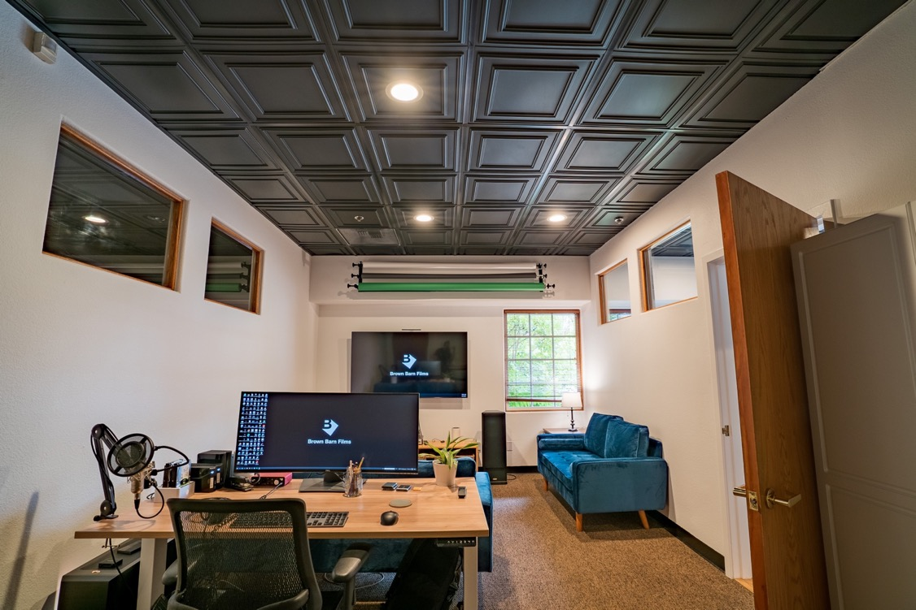
“We wanted a space that felt creative, inspiring, modern and fresh, and we didn’t want to feel like we were showing up every day to a law office.”
…more
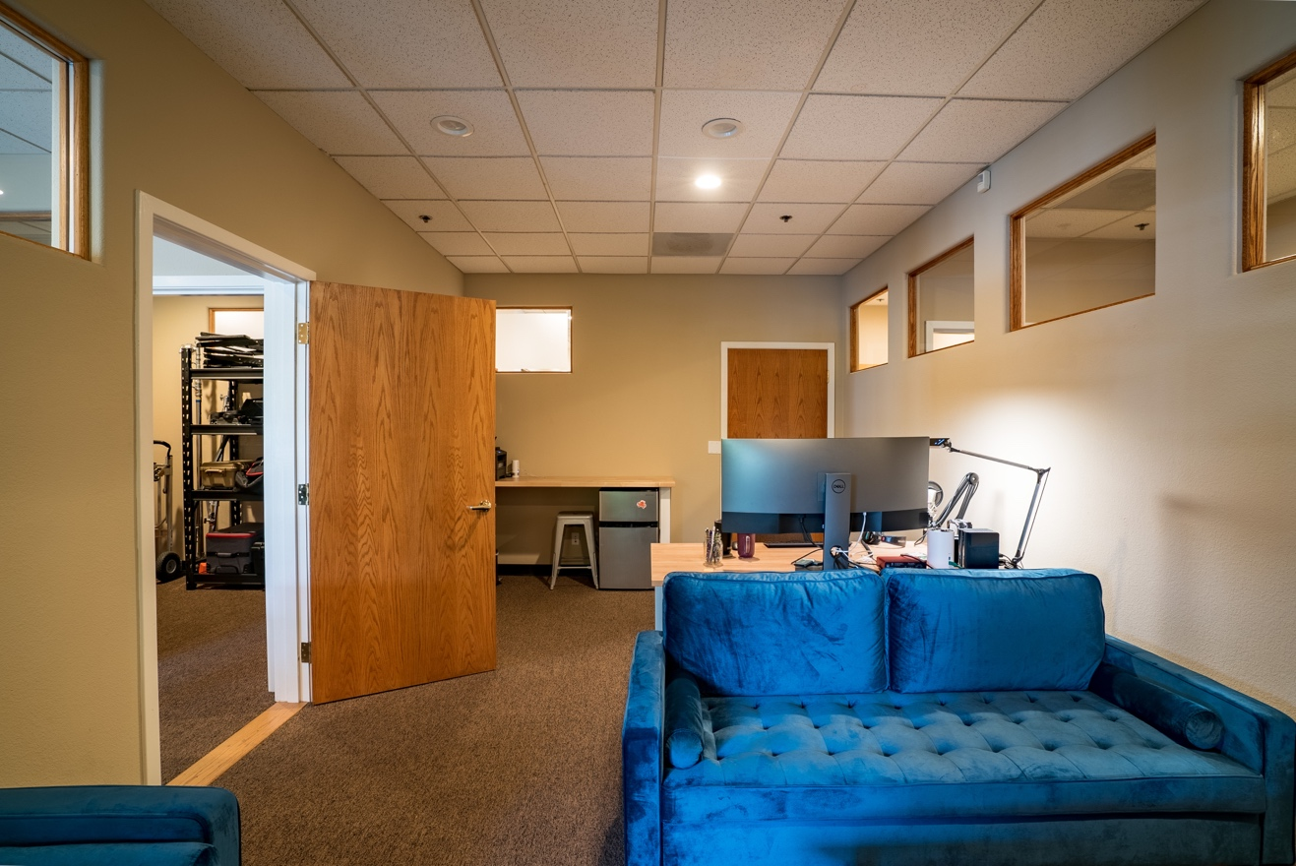
BEFORE: Beige walls and a flat white ceiling made the space nondescript and uninspiring.
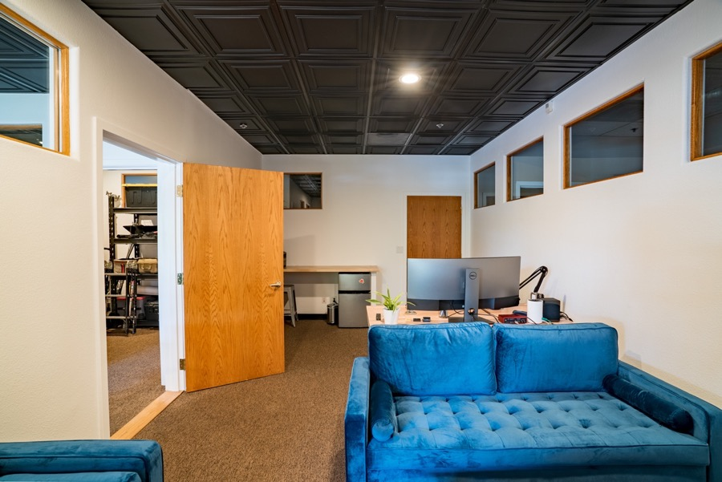
AFTER: Brighter walls and a contrasting decorative ceiling were all that was needed to make it come to life.

…more
The new ceiling was easily installed, refacing the existing mineral fiber tiles by simply slipping the new thermoformed tiles in front of them.
###

