FOR IMMEDIATE RELEASE

Case Study: A Water-Friendly Ceiling

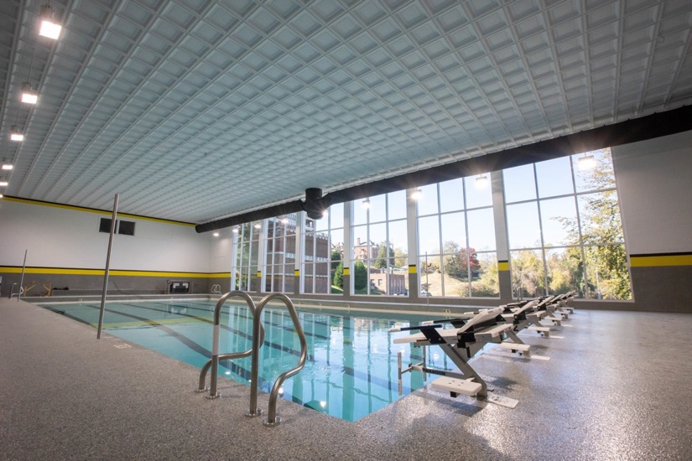
Photo courtesy of Randolph College
The revamped aquatic center at Randolph College includes a pool-friendly coffered ceiling made of Ceilume thermoformed tiles.

GRATON, CA, 2023-Oct 24 -- Humid or wet environments require the right kind of building materials, especially finishes, which are often the front line of exposure to moisture. Materials that are absorbent, prone to moisture damage, or can support the growth of mold or other microbes are usually inappropriate for damp spaces. When Randolph College in Lynchburg, VA, renovated their athletic center, they were reluctant to use mineral fiber ceiling tiles over the swimming pool. Instead, the ceiling installer suggested a lightweight thermoformed tile, resulting in a stunning coffered ceiling that eliminates all concerns about getting wet.

The Randolph Athletics and Dance (RAD) center was built in 1962, and received small updates in 1993 and 2000. In 2019, Randolph embarked on a major, $5,000,000 renovation, renaming it the Michels Athletic Center (MAC). Many aspects of the old RAD were updated and enhanced, including the addition of a new fitness center, locker rooms and training rooms, and an upgrade to the gym’s HVAC system. The final phase of the project was revamping the indoor swimming pool, the Bradley W. Bateman Aquatic Center, which was upgraded and reconfigured from five lanes to six, making it eligible to host Division III competitions.

The pool’s original suspended grid ceiling was filled with old, stained, and possibly moldy tiles (a fate often suffered by mineral fiber ceilings). It was removed entirely. The subcontractor that installed the new ceiling, IP Structures, put in all-new suspension grid. The tiles that were initially purchased to populate it were mineral fiber, a specialized type that claimed to be compatible with humidity and even steam. However, the manufacturer’s cleaning recommendations say that it should only be cleansed “using a clean, white cloth with water or a mild, detergent and wiping the panels surface,” which suggests that those tiles should not be exposed to bulk water. There was concern that exposure, such as a roof leak, might cause the ceiling to absorb moisture and collapse.

At that point, IP Structures’ manager, Peter Tacl, suggested substituting Ceilume thermoformed tiles. Made of rigid vinyl, thermoformed tiles are impermeable to water, can be washed, and fully immersed. Unlike common mineral fiber tiles, they do not support the growth of mold, mildew, or other microbes, making them a good ceiling solution in pools, locker rooms, bathrooms, showers, and other wet spaces. They are very durable, moderately flexible, and resist breakage from impacts such as a high-thrown water polo ball. Ceilume tiles are also an environmentally friendly choice - Greenguard Gold Certified to protect indoor air quality, made with recycled material, and fully recyclable at the end of their service life.

The college took advantage of this change as an opportunity to upgrade the room’s aesthetics, as well, selecting a more intriguing and dramatic look. Ceilume’s thermoformed tiles are three-dimensional, molded in both traditional and contemporary patterns to complement virtually any architectural style - 40 different styles in all. Randolph College selected a deep coffered ceiling, Ceilume’s Madison tiles in white, with a border of Ceilume’s Serenity at the room’s perimeter. Coffered ceilings have been popular since Ancient Roman times, and are still effective today, providing eye-relief and giving a bit of formality and grandeur to the space.

Working on a ceiling above a swimming pool can pose logistical problems, but in IP Structures had full platform scaffolding over the pool and thus, easy access above. Installation went easily. “It was really simple,” relates Peter Tacl. “It’s light, it’s easy to ship. And it wasn’t overpriced… I knew the budget.” Tacl adds, “It looks great.”

Brenda Edson, director of the Randolph’s College Relations Office, agrees. “The pool is amazing looking. Students love it.”

The Bradley W. Bateman Aquatic Center, with its pool-appropriate ceiling, opened in 2021.

About Ceilume
Ceilume is the leading manufacturer of thermoformed ceiling and wall tiles and panels. The company’s roots go back to the pioneers of modular ceilings, when “Mid-Century was Modern.” The family-owned business is located in California’s wine country and occupies a historic apple-packing warehouse. With an eye on the future, Ceilume’s research and development continues to improve interior finish systems to meet changing environmental, performance, and aesthetic needs. For more information, see ceilume.com/pro.

Media Contact
Steve Miller, pr@ceilume.com, 1-818-399-6596

High Resolution Images
ceilume.com/pro/press.cfm

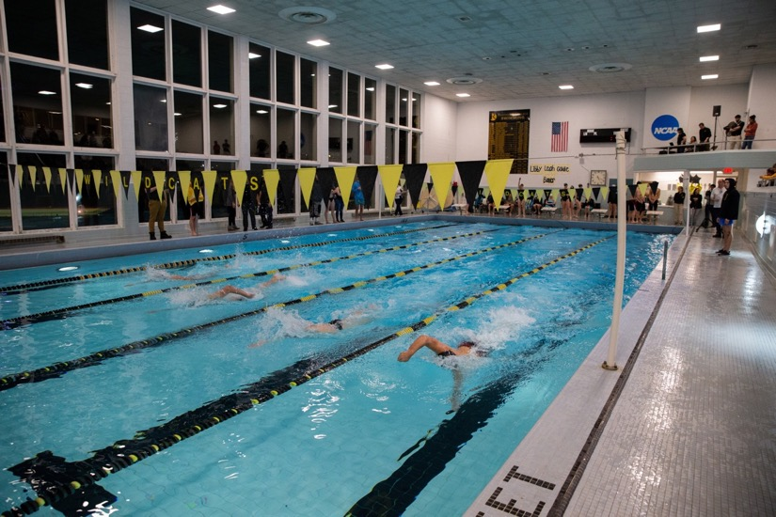
Photo courtesy of Randolph College
Before renovation, the 5-lane pool had a deeply stained, flat ceiling.
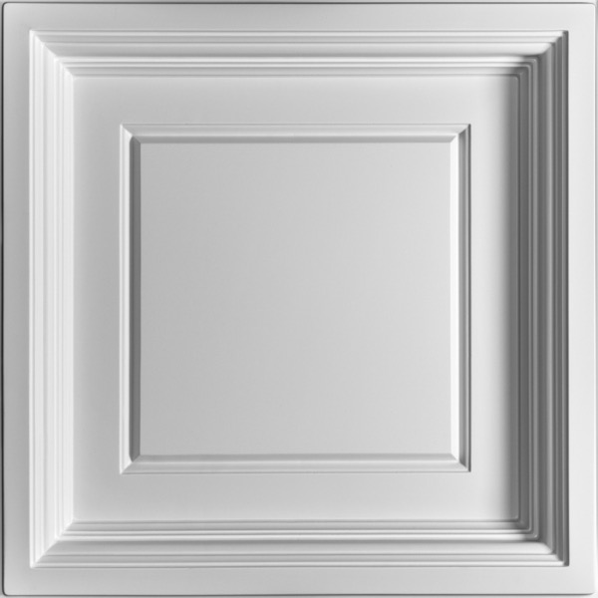
Photo courtesy of Ceilume
Ceilume's Madison tiles create a coffered ceiling, a look that has been popular since Ancient Roman times.
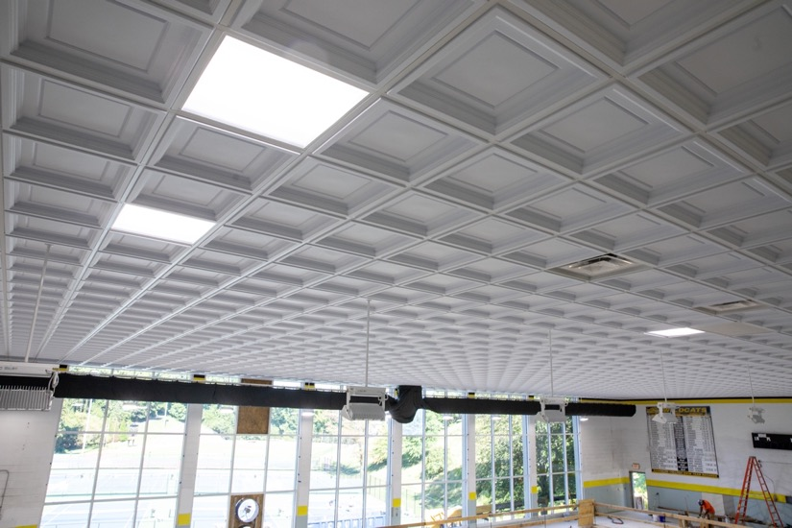
Photo by Randolph College
The new Ceilume ceiling is impermeable to water, stain resistant, durable, and attractive.
###

