FOR IMMEDATE RELEASE
Ceilume Ceilings Are Part of Island Retreat’s Ecology
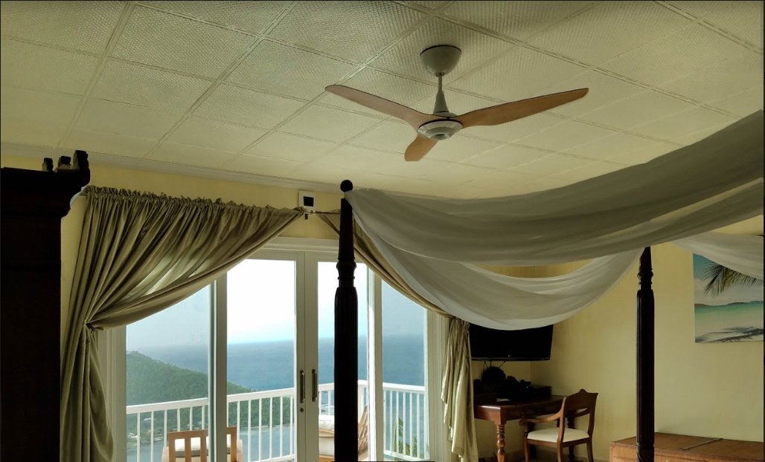
All photos courtesy of Eco Serendib
The luxurious spa suite of the Eco Serendib Villa and Spa features an environmentally friendly ceiling of Ceilume’s Rattan style Latte-colored thermoformed ceiling tiles.
GRATON, CA, 2019-05-14 -- Guests at Eco Serendib Villa and Spa in St. John, US Virgin Islands, experience true luxury in harmony with nature. The eco-friendly resort showcases how hospitality properties and ecologically-sensitive products can co-exist, reflecting owner and designer Harith Wickrema's commitment to sustainability. Wickrema, recognized as an Environmental Champion by the Environmental Protection Agency, insisted that building products used during a recent remodeling, "demonstrate it is possible to live in a smarter, more sustainable way while still enjoying modern conveniences and luxury. I hope that after experiencing Eco Serendib, visitors incorporate sustainable elements from our space into their own lives.”
Working with a select group of environmentally-committed suppliers, he decided to use Ceilume ceiling tiles in the facility's Fitness Gym and luxurious Spa Suite. The thermoformed tiles met his green goals because they contain up to 100% recycled material and are made with a proprietary process that combines manufacturing and construction scrap with recycled ceiling tiles to create new tiles that perform as well as tiles made from virgin material. “When guests arrive, we give them a tour of the property to explain our sustainability initiatives,” Wickrema says, “and we always explain that Ceilume tiles are a cradle-to-cradle product.”
The products are also Greenguard Gold certified to protect indoor air quality and are free of the irritating dust associated with mineral fiber ceiling products. Ceilume tiles further lessen the environmental burden by consuming 75% less raw material than mineral fiber ceiling panels. The impact of transporting tiles to the island is also reduced due to their low weight and nesting design that significantly reduces required cargo space.
Adding to the ceiling's sustainability, Wickrema notes, is their durability and resilience. He points out that the waterproof tiles have already survived two Category 5 hurricanes and posits, “humidity is always a problem when building in the tropics, but Ceilume's tiles are not affected by moisture and do not support mildew or mold.” He was delighted with the ease of installation of the tiles and adds that, "seven years after they were installed, the tiles still look as good new."
The Villa features Ceilume's 24" x 24" Rattan and Continental tiles, two of Ceilume's 40 wall and ceiling styles with decorative molded patterns that range from historic to contemporary designs. There are seven colors to choose from, plus stylish faux metal and wood finishes and three grades of light-transmitting material suitable for luminous ceilings.
According to Ed Davis, president of Ceilume, the company's products are Class-A rated for fire safety and can even be installed as drop-out ceilings beneath fire sprinklers to reduce construction costs and eliminate visual clutter overhead. Their stain-resistant, washable surfaces enable the tiles to comply with USDA and FDA requirements for ceilings above food preparation areas. Enhanced acoustic ratings, up to 0.85 NRC, are available, Davis adds. "Sustainability was what attracted Eco Serendib to our tiles. Good looks are what closed the deal. But it is a whole package of performance benefits that have made Ceilume ceilings a successful part of the resort."
--------------
About Ceilume: Ceilume is the leading manufacturer of thermoformed ceiling and wall tiles and panels. The company’s roots go back to when “Mid-Century was Modern” and the pioneers of modular ceilings. The family-owned business is located in California’s wine country and occupies a historic apple-packing warehouse. With an eye on the future, Ceilume’s research and development continues to improve interior finish systems to meet changing environmental, performance, and aesthetic needs. For more information, see www.ceilume.com/pro.
About Eco Serendib Villa and Spa: Eco Serendib Villa and Spa on St. John in the US Virgin Islands is an exclusive-use retreat, accepting just one reservation at a time. With eight elegant suites, a full-service spa, organic garden and all the amenities and services of an exquisite private residence, Eco Serendib offers a sumptuous, serene and green home-base for guests. Visit www.ecoserendib.com.

Sidebar:
Additional sustainable elements at Eco Serendib include:
- Solar panels that significantly reduce carbon emissions.
- An organic “Seed to Plate” garden for fresh produce and herbs; excess harvest is shared with the community. Seeds from past harvests are used to grow the next batch of vegetables. Composting of appropriate items is used for fertilizer.
- All-natural, chemical-free products plus items from onsite garden used in spa treatments.
- Re-use of old roofing tiles as terraces in the onsite organic garden.
- Water-conservation and Energy Star products throughout the villa.
- Gray water system for irrigation; drip irrigation system for water conservation.
- “Edutaining” eco-tour of the villa for guests
- Recruiting and training local staff who are in need of career opportunities.
Learn more about the property’s eco-friendly aspects at www.ecoserendib.com/our-green-effort.html.
###
These and Additional Photos: www.ceilume.com/pro/press.cfm.
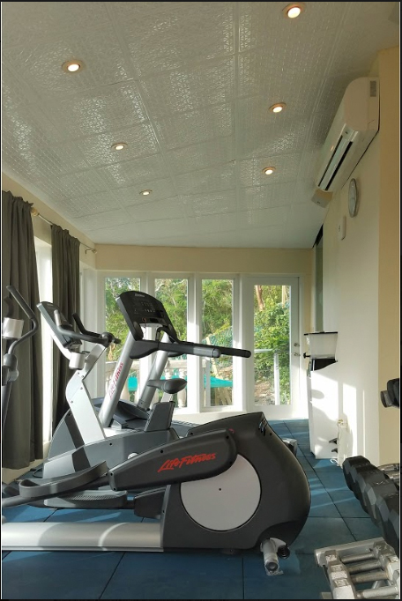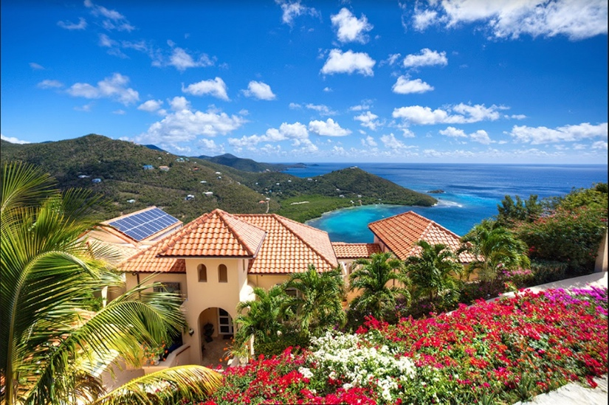
Right: At Eco Serendib, an eco-friendly luxury resort in the U.S. Virgin Islands, Ceilume thermoformed ceiling tiles fit perfectly with the resort’s sustainable philosophy, being both recycled and recylable, durable, washable, and Greenguard Gold certified to protect indoor air quality. Left: Exercise room at the Eco Serendib Villa and Spa has views of the Carribean and features Ceilume’s Continental Style, white thermoformed ceiling panels.
###

