New Thermoformed Panels for Walls and Ceilings

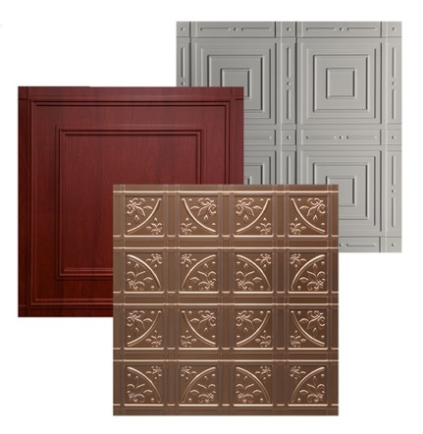
GRATON, CALIFORNIA, March 6, 2019: A new style with a traditional flair has been added to Ceilume’s line of decorative thermoformed panels. The family-owned business has manufactured thermoformed ceiling panels “Since Midcentury was Modern,” yet began producing wall panels only two years ago. The first two patterns introduced, Manchester and Nantucket, have classic motifs based on squares. The newest pattern, Lafayette, adds curves and fleurs-de-lis to complement a variety of architectural styles.

Thermoformed panels have long been used for ceilings but, until recently, were not fabricated in a way that was recommended for walls. These new panels from Ceilume, however, have unique, overlapping edges that eliminate the need for trim strips to cover gaps between panels. This makes the panels more robust so they can stand up to light- to medium-duty service as either wall coverings or ceiling tiles.

The nominal 24 x 24-inch rigid vinyl tiles are offered in a variety of solid colors as well as faux metal and wood finishes with up to 98% recycled content, and a random gray with 100% recycled content. Their 3-D molded surfaces provide relief for otherwise flat walls and ceilings. They can also be used as backsplashes and cabinet faces.

The panels are GreenGuard Gold certified for low VOCs, stain-resistant and washable, and Class A-rated for surface burning characteristics. Lightweight and easy-to-install, they can be glue-applied to drywall or other smooth substrates. Use them to create dramatic and affordable effects in either residential or commercial interiors.

# # #
Above: Lafayette, shown with a faux copper finish, brings to three the number of thermoformed wall panel options from Ceilume.
Far Left: The 3-D molded surface captures shadow and highlights on Ceilume’s new thermoformed wall and ceiling panels. These panels are the Manchester style with a copper faux metallic finish.
Left: An innovative overlapping joint simplifies installation and improves performance of Ceilume’s new wall and ceiling panels. The Nantucket style shown is made in a random gray with 100% recycled material content.
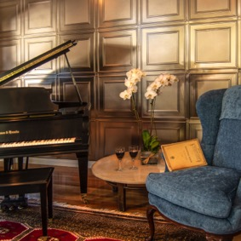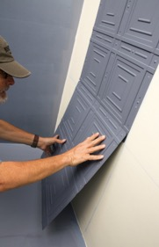

- more -

About Ceilume: Ceilume is a family-owned business based in Graton, California. The 50-year- old firm has been in business “Since Midcentury Was Modern.” Ceilume has advanced manufacturing capability, an active R+D program, and the drive to create improved ceiling and wall finishes that meet changing environmental, performance and aesthetic needs. See www.ceilume.com/pro.

High-resolution photos and Word document: www.ceilume.com/pro/press.cfm.

