FOR IMMEDATE RELEASE

Case Study: Alex and Ani Gives Some Love to the Ceiling

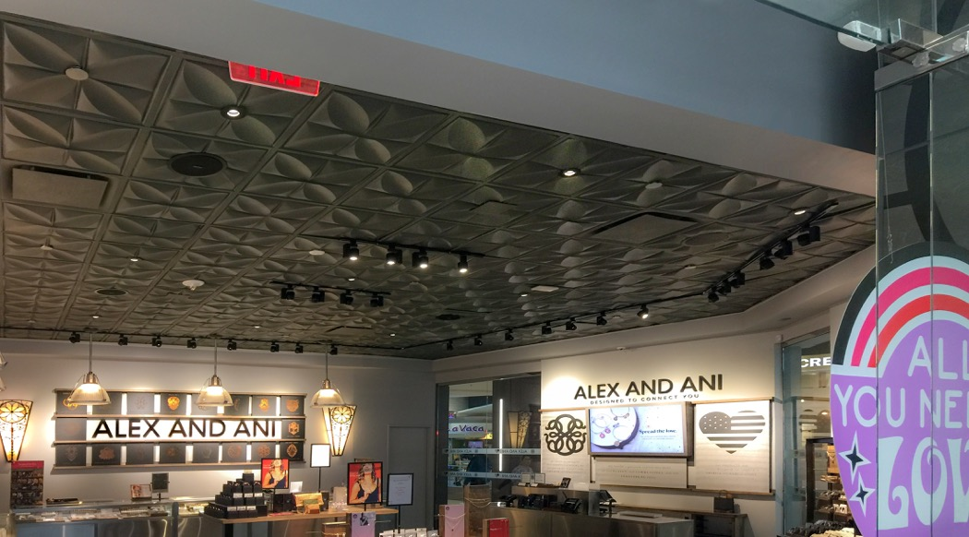

Photos courtesy of Ceilume

The wildly successful Alex and Ani stores feature consistent branding design that includes light grey walls, a display of evocative symbols, and a dimensional ceiling with a very recognizable pattern.

GRATON, CA, 2020-01-28 -- The Alex and Ani jewelry company is a study in inventive branding. They virtually created their own category of affordable adornments with personal meanings, or as the company described it, “bangle bracelets, necklaces, earrings and rings that adorn the body, enlighten the mind, and empower the spirit." Every piece is connected to a concept or emotion, defined by universal symbols that appear on their popular designs.

When Alex and Ani expanded beyond manufacturing and opened their own stores in 2009, they defined a brand look that gives consistency to their physical presence, too. No matter how different the size or shape of their individual outlets may be, they are as recognizable and, to their many devoted customers, as comfortingly familiar as their patented 14-gage wire bracelets. Light grey walls, furnishings of wood, steel and glass, a large wall display of their trademarked symbols, giant line graphics recalling Celtic knots on the exterior, and a decorative, dimensional ceiling.

Paying attention to the ceiling bespeaks the thoroughness of the company’s approach to branding. Alex and Ani’s core concept is to surround yourself with patterns and symbols that you connect to and make you feel good, and they take it seriously. The Alex and Ani ceiling is made of Ceilume thermoformed acoustic panels dropped into a conventional suspended ceiling grid. They have used the Petal pattern in most of their standalone locations. The ceiling’s repeated geometric pattern seems to commune with the symbols in the jewelry. It is painted a dark gray that is well-suited to jewelry display; it limits reflections so that the highly directional lighting used to illuminate the jewelry is sharper and makes the metals and crystals sparkle.

Company founder and CEO Carolyn Rafaelian says that “Alex and Ani is all about enlightening people through jewelry, through the essence of things that make them feel good.” Her philosophy - and business model - of surrounding yourself with things that make you feel good is fully expressed in the stores, right up to the ceiling. Their approach has been extremely successful. The company has annual revenues around a half billion dollars, and has expanded to 102 locations in the US, Canada, and Caribbean.

--------------

*About Ceilume:* Ceilume is the leading manufacturer of thermoformed ceiling and wall tiles and panels. The company’s roots go back to when “Mid-Century was Modern” and the pioneers of modular ceilings. The family-owned business is located in California’s wine country and occupies a historic apple-packing warehouse. With an eye on the future, Ceilume’s research and development continues to improve interior finish systems to meet changing environmental, performance, and aesthetic needs. For more information, see [www.ceilume.com/pro](http://www.ceilume.com/pro).

*Photos:* [www.ceilume.com/pro/press.cfm](http://www.ceilume.com/pro/press.cfm)

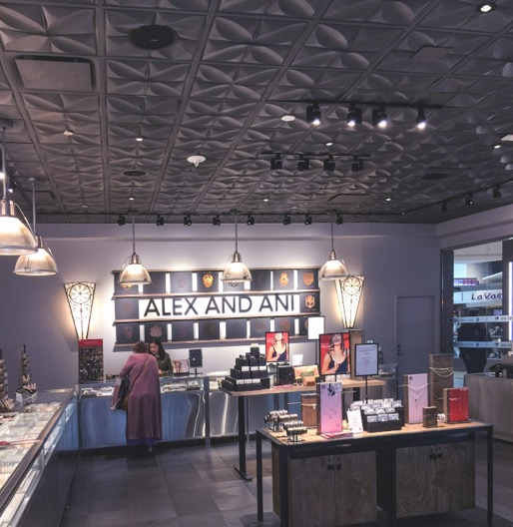 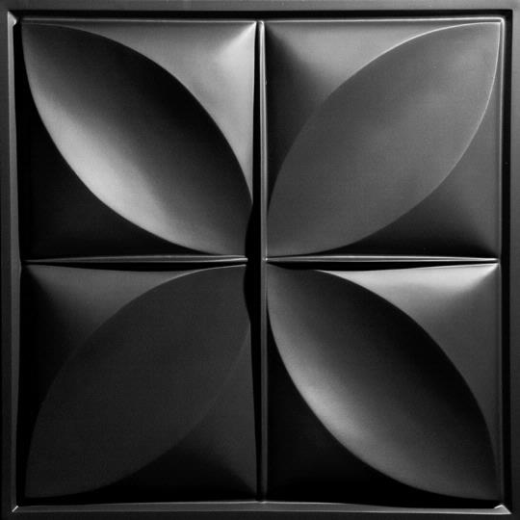

*Left:* Alternative view of a typical Alex and Ani store. *Right:* Ceilume’s Petal style panel is thermoformed from 0.013-inch thick vinyl that is lightweight and easy to install, and GreenGuard Gold certified for indoor-air quality.

###