Product News (100 words)
Chain Stores Belong Under Ceilume Ceilings
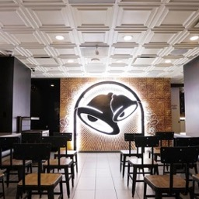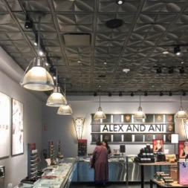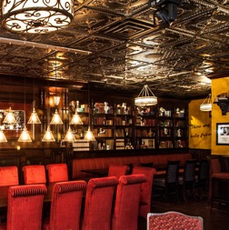
Left to Right: Taco Bell’s flagship Cantina on the Las Vegas Strip features a wedding chapel with wedding bells on the walls and an elegant coffered ceiling by Ceilume. (Image: Taco Bell.)
“Petals” one of 40 ceiling panel styles offered by Ceilume, contributes to the design narrative Alex and Ani creates in its stores and jewelry lines. (Image: Ceilume.)
Ceilume ceiling panels are part of the unique customer experience Drybar provides its hair blowout patrons. (Image: Drybar.)
Decorative ceiling panels with Ceilume’s “Better than Tin” finish create the ambiance of The Irish Pub Concept restaurants. (Image: The Irish Pub Concept)

GRATON, CA 2019-September-4 – Ceilume’s thermoformed ceiling panels contribute to visual branding of several major store chains. Taco Bell uses Ceilume panels nationwide in new store concepts and in its flagship Las Vegas “Cantina.” The panels are washable, allowing them to be installed above food preparation areas, too.
Decorative panels from Ceilume are also part of the customers’ brand experience at Drybar hair salons, Lolli and Pops sweet shops, Irish Pub Concept restaurants, and Alex and Ani jewelry stores.
Ceilume panels are easy to install, durable, lightweight, acoustical, GreenGuard Gold certified, and have up 98% recycled content. More information: www.ceilume.com/pro
--------------
About Ceilume: Ceilume is the leading manufacturer of thermoformed ceiling and wall tiles and panels. The company’s roots go back to when “Mid-Century was Modern” and the pioneers of modular ceilings. The family-owned business is located in California’s wine country and occupies a historic apple-packing warehouse. With an eye on the future, Ceilume’s research and development continues to improve interior finish systems to meet changing environmental, performance, and aesthetic needs. For more information, see www.ceilume.com/pro.
Case studies of individual store chains available upon request.
High Resolution Photos: www.ceilume.com/pro/press.cfm

