FOR IMMEDATE RELEASE
Case Study – Little Jumbo: Vintage Design, Modern Performance
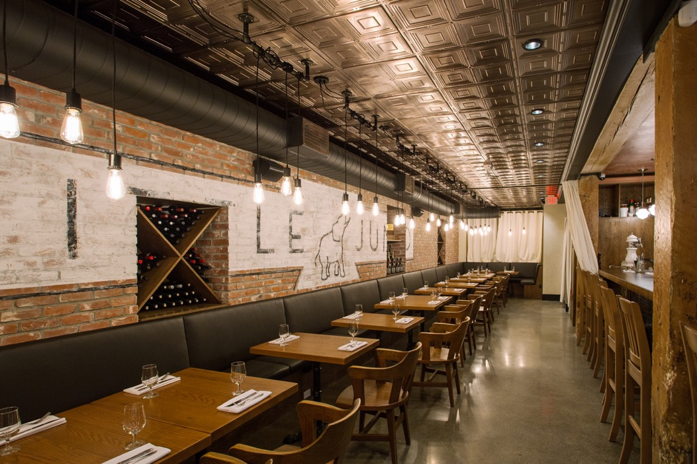
Contemporary photos courtesy of Live By Design
GRATON, CA, 2019-06-25 – The concept was “1920’s New York-style speakeasy,” with a wooden bar, exposed brick walls, old tiles in the washrooms, and a classic decorative ceiling. The solutions that brought it to life ranged from metal panels salvaged from a burnt building and brand new Ceilume thermoformed ceiling tiles that offer a vintage look with all the modern conveniences.
The Little Jumbo Restaurant in Victoria, British Columbia, started as the fulfillment of a long-held dream. Australian star-bartender Shawn Soole had often talked about opening his own cocktail bar. His friend, designer Sara Baxter, owner and principal designer of Live By Design (Vancouver, BC), partnered with him make that a reality.
The location is an historic structure, The Pacific Transfer Building, built in 1902 as the headquarters of a shipping and delivery service involved with Victoria’s bustling port. The three-story brick building, designed by prominent British Columbia architect Thomas Hooper, featured a livery stable on the first floor where horse-drawn wagons passed through. Some of the solid cedar columns still show the scars of the wagon wheels. In more recent times, the ground floor had become a Indian curry buffet restaurant.
Its transformation into Little Jumbo involved a complete strip-down and rebuild of the interior. The building’s exterior offers plenty of character: it is, according to the Canadian Register of Historic Places, “considered a significant example of the vernacular, utilitarian turn of the twentieth-century architecture.” Soole and Baxter brought some of that character inside by adding brick veneer to create an “exposed brick” wall, and had the logo painted on to look like it had been there for 90 years. The concrete sub-floor was exposed and polished. The bar top of solid western maple is complemented beneath by metal panels salvaged from a Victoria building that had burned. Exposed-filament bulbs that look like they were made by Thomas Edison hang from the ceiling.
To complete the effect, they wanted the look of “old-fashioned tin ceiling tiles,” recalls Baxter. So-called tin ceilings – actually made of steel - were originally manufactured as an affordable substitute for ornate molded plaster, and became very popular in North America starting in the late 1800’s.
Baxter found exactly the look she desired in Ceilume thermoformed tiles, and she appreciated their advantage over pressed metal options. Pressed-metal tiles are still manufactured, and they are still installed by a labor-intensive process involving furring strips and nailing, which means high installation costs. Many of Ceilume’s 39 styles replicate traditional decorative plaster patterns (and their pressed-metal imitations) but because they are lightweight vinyl, they can be installed quickly and easily using adhesives. “Not being metal,” comments Baxter, “made them much easier to install.”
For Little Jumbo, Baxter selected Ceilume’s Jackson style, a design that features four shallow coffer-like squares per 24-inch x 24-inch tile, often seen in historic buildings. The metallic-finish tiles glow in the restaurant’s warm-toned lighting. They are easy to clean, code compliant for use over food-service areas, non-corroding, and durable.
The ceiling tiles top off the design perfectly, completing what Sara Baxter calls “a cool, fun cocktail bar that really feels like a speakeasy.”
The bar was an instant popular hit, with lines out the door on Friday and Saturday nights. Over the following few years, it evolved more as a restaurant, with online reviewers raving about both the food and the ambience.
--------------
About Ceilume: Ceilume is the leading manufacturer of thermoformed ceiling and wall tiles and panels. The company’s roots go back to when “Mid-Century was Modern” and the pioneers of modular ceilings. The family-owned business is located in California’s wine country and occupies a historic apple-packing warehouse. With an eye on the future, Ceilume’s research and development continues to improve interior finish systems to meet changing environmental, performance, and aesthetic needs. For more information, see www.ceilume.com/pro.
Download high-resolution photos and Word file: www.ceilume.com/pro/press.cfm
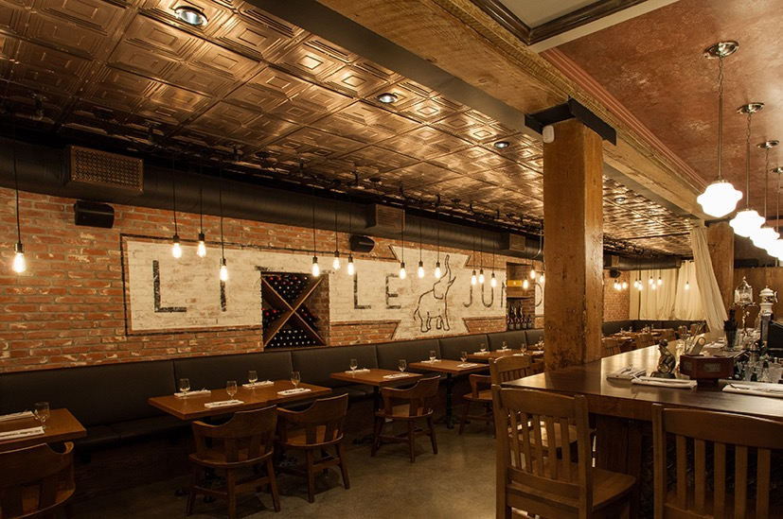
The ground level of this 1902 building was completely stripped down and remade, creating the amtosphere of a 1920’s speakeasy, including a solid wood bartop, a “stamped-tile” ceiling, and vintage-looking “Edison” style lightbulbs.
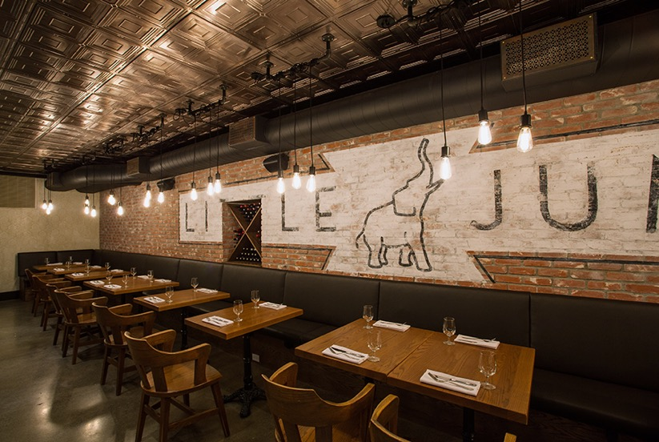
Much of the 1920’s ambience of Little Jumbo restaurant is created with modern materials, including the wall of “exposed” brick that is actually an added veneer with a carefully aged-looking painted logo, and the ceiling that is made, not of old stamped metal, but new Ceilume thermoformed tiles.
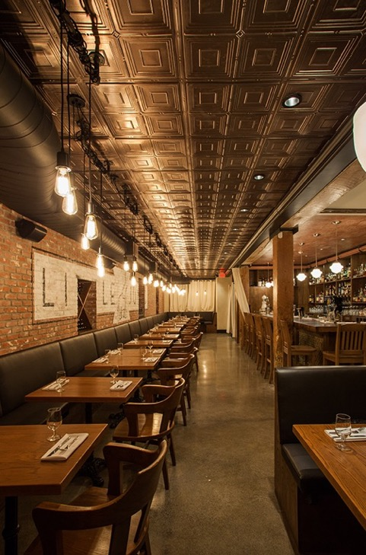

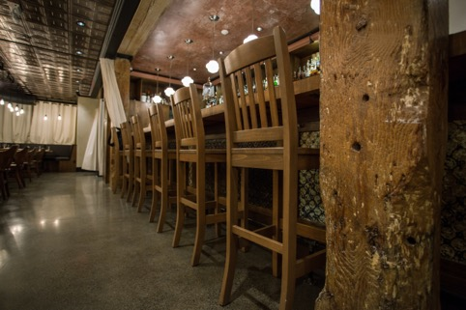
Upper Left: The lightweight ceiling tiles were glued directly to the ceiling drywall, making them far easier to install than stamped metal tiles.

Upper Right: The character of the building’s exterior, built in 1902, the brickwork and painted signs, inspired the interior redesign to create Little Jumbo Restaurant. (Photo courtesy of City of Victoria, Canada Archives)
Bottom: The solid cedar columns are original, and still bear scars from the wheels of wagons that used to pass through this former stable and shipping facility.
###

